Coastal Protected and Conserved Areas in Canada: Insights with respect to Target 3 of the Kunming-Montreal Global Biodiversity Framework

Supplemental Online Material 1: Detailed methods

Data sources:

The 2021 data from the Canadian Protected and Conserved Database (CPCAD) was used to assess the status and coverage of protected and conserved areas (ECCC, 2022). CPCAD is an authoritative database comprised of both spatial (e.g. boundary) and attribute data. CPCAD is managed by Environment and Climate Change Canada (ECCC), in collaboration with federal, provincial and territorial authorities. The database includes protected areas (PAs) and other effective area-based conservation measures (OECMs), as well as Indigenous Protected and Conserved Areas (IPCAs) if they are also recognised as a PA or OECM. The data is used for national and international reporting, including the World Database on Protected Areas (WDPA), managed by the United Nations Environment Programme’s (UNEP) World Conservation Monitoring Centre (UNEP-WCMC) and the Convention on Biological Diversity (CBD). ‘Biome’ type is also a mandatory field and describes whether a site falls within the marine or terrestrial environment (ECCC, 2023). We used both these fields to categorise the nature and extent of protection.

Canada’s diverse ecological makeup can be divided into 18 terrestrial ecozones (Figure 1), 12 marine bioregions/ecozones (Figure 2), and one freshwater bioregion/ecozone (Government of Canada, 2011; 2013). Since coastal areas include both marine and terrestrial components, we used these bioregion/ecozone classifications to assess both coastal area and length of protection. Ecosystem representation is an important conservation goal reflected in the previous Aichi Biodiversity Target 11 and the new Kunming-Montreal Global Biodiversity Framework (KM-GBF) Target 3.
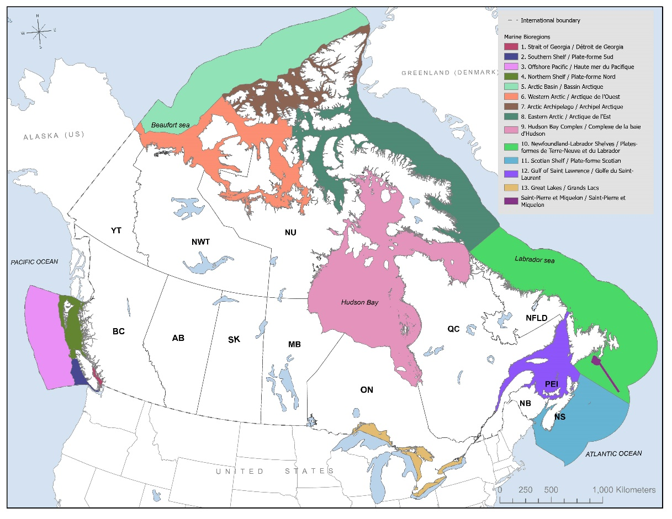
Figure 1: Terrestrial ecozones of Canada (Government of Canada, 2013).

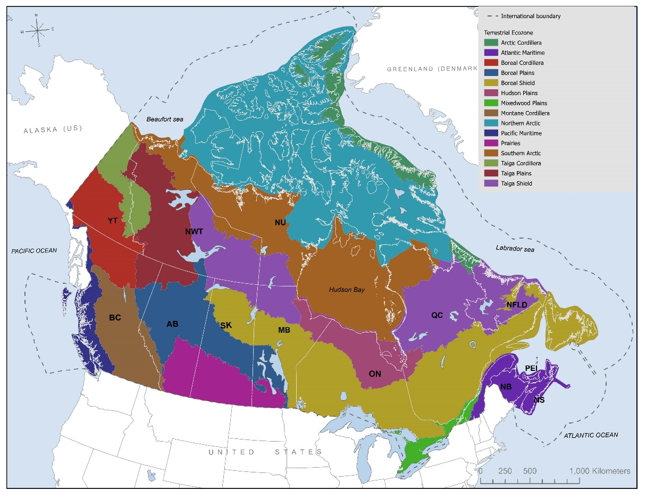
Figure 2: Marine bioregions of Canada (Government of Canada, 2011).

Two spatial datasets were used to delineate the shoreline. The CanCoast – Marine Shoreline Version 3.0 (Manson et al., 2019) was used to define the baseline for Canada’s marine regions (Pacific, Arctic and Atlantic). The shoreline layer from the Great Lakes Aquatic Habitat Framework was used to define the baseline for Canada’s Great Lakes, including islands and connecting channels (GLAHF, 2015).

Data preparation and analysis:
The methodology to measure the spatial distribution of protected areas in the coastal zones of Canada was completed in ArcGIS Pro 2.9.x. At the onset, all data inputs including polygon-based water features for the Great Lakes and provincial/territorial boundaries were re-projected into a coordinate system to which accurate areas calculations could be generated and assessed more accurately. The Canada Albers Equal Area Conic projection was used.

Since these datasets do not identify adjacent jurisdictions (e.g. province or territory name), overlay tools were used to complete the assignment. Next, the shoreline dataset underwent a weighted simplification algorithm, based on a 100-metre tolerance to remove unnecessary vertices while still preserving the essential linear shape of the shoreline data. The features then underwent a dissolve process whereby shoreline line segments were merged based on fields of significance, namely jurisdictional attributes, province/territory and the Great Lakes’ names.

A 4 km ‘coastal area’, a swath of land and water, was delineated with a 2 km inland buffer and a 2 km water buffer using the newly dissolved shoreline feature dataset. The resulting buffer zone retained key shoreline attributes (e.g. Great Lake name, terrestrial ecozone, marine bioregion and province/territorial name), and underwent similar dissolve processes as the shoreline dataset to simplify the rendering of the coastal zone by jurisdiction. An example of the buffer zone and key shoreline attributes is presented in Figure 3.

The selection of a 2 km buffer consistent with the Great Lakes Shoreline Ecosystem Inventory (ECCC & OMNRF, 2023) helped to maintain the focus on the coastline, rather than being drawn 10s if not 100s of km inland or offshore. We acknowledge that coastal area represents a complex and uncertain governance context (Banikoi et al., 2023) which would need to be adapted depending on the planning purpose or circumstance.

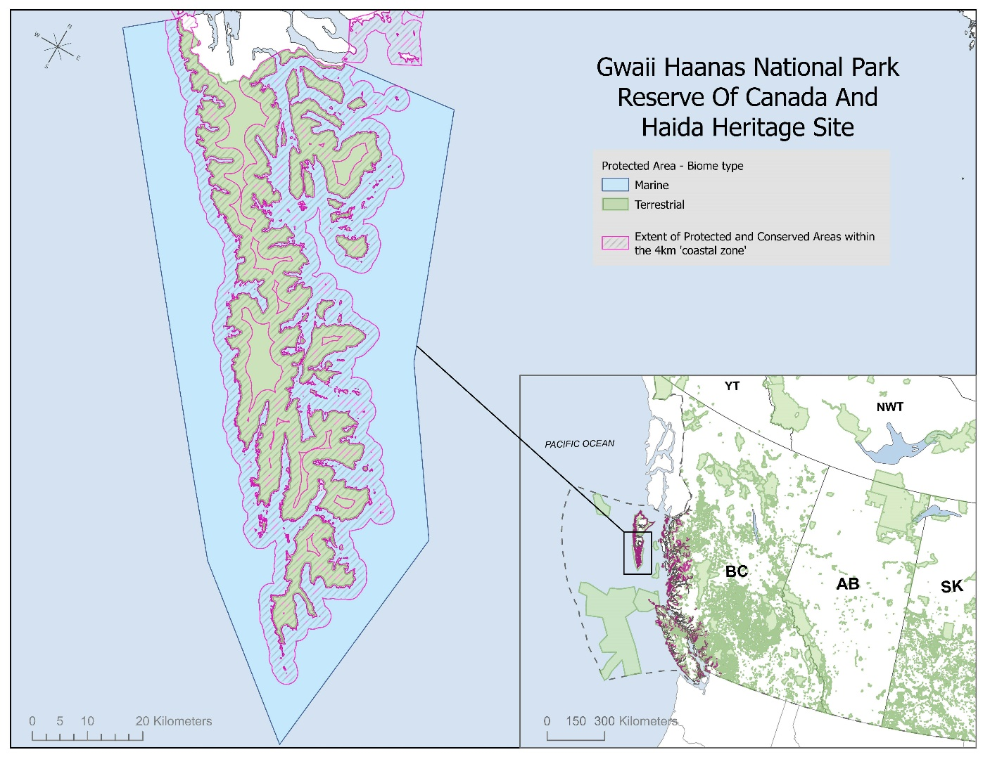
Figure 3: Example 2 km inland and 2 km water buffer zone and key shoreline attributes for Gwaii Haanas region of British Columbia, Canada.

Several overlay tools in ArcGIS Pro were used to assess the presence of protected areas in the buffer zones. To begin, the CPCAD dataset was converted from a multipart feature to a single-part dataset. Essentially this converted protected areas which are made up of many individual polygon features but are considered one record in the CPCAD dataset. This was necessary to ensure each of the individual polygons would register their own respective area values in subsequent analysis and calculations performed on the dataset.

The output of the intersection operation was a polygon feature dataset representing only the geographic extent of the CPCAD areas that occurred within the 4 km coastal zone. Each CPCAD polygon feature included inherited the attributes of the buffered shoreline features, thereby appending shoreline attributes such as the Great Lake name, terrestrial ecozone, marine bioregion, and neighboring province/territory values to the CPCAD features. Summary statistics were generated in Microsoft Excel from the attribute tables of the analysis output datasets.

Methodological limitations:
While many of the data inputs, including CPCAD and the CanCoast shoreline, identify a data standard of a 1:50,000 scale as their basis, there were notable issues with misalignment between jurisdictional boundaries, protected areas boundaries and shoreline features. In cases where this arose, 50–100 metre tolerances were used in selection processes to account for the misalignment. Also, several manual verifications were done to determine the designation of spatial features. For example, if most of an individual protected area polygon was determined to fall within the coastal zone, but a ‘sliver’ of said polygon was topologically un-assigned due to the alignment issue, that sliver would be corrected manually to be grouped with the original protected area polygon.

The highly detailed nature of the baseline shorelines, consisting of millions of linear features and a very dense distribution of vertices to provide such an exacting representation of Canada’s varied coastline, made for considerable computational processing strain. Smaller island features were removed from the subset as well as they were not considered significant given larger neighboring land masses (mainland or larger islands) would certainly capture the adjacent areas. Larger, geographically significant islands were included in the shoreline subsets with five major inhabited islands within the Great Lakes (Pelee, Wolfe, Manitoulin, Cockburn and St. Joseph) included as well. The topology and spatial relationship between the boundaries of the input datasets were the basis of this analysis. The tabular attributes of the input datasets were never altered or updated to reflect newly identified spatial values because of the spatial analysis. For example, CPCAD designations such as biome were maintained and were never altered based on the observed changes in topology.

While an important source of data, limitations for completing coastal area assessments exist within CPCAD. As mentioned, the scale and quality of the boundary layer varied, and at some sites uncertainty regarding the shoreline boundary existed. In addition, we found sites where the ‘marine’ and ‘terrestrial’ biomes did not meet precisely along the shoreline (leaving small gaps), even though the legal boundary for that area describes a seamless union. In considering coastal areas, metadata on the shoreline vector used for digitisation or some reference to the ordinary high or low water mark would be helpful. Furthermore, for the Great Lakes, which are included in the marine conservation aspirations of both Canada and the US, one cannot distinguish between terrestrial or freshwater biomes, they are grouped as one. Mapping coastal areas is inherently challenging since it is often approached from two independent and non-overlapping conventions, topographic and hydrographic cartography (Bartier & Sloan, 2007). Resolving this issue and developing maps and an understanding of coastal areas that represents a seamless land and water transition is essential. As a final note, while CPCAD includes the option for reporting by zone delineation, which could facilitate a more accurate accounting of protection levels, many sites have yet to provide such data.

References:

Banikoi, H., Schluter, A., & Manlosa, A. O. (2023). Understanding transformations in the marine coastal realm: The explanatory potential of theories of institutional change. Marine Policy, 155. doi:10.1016/j.marpol.2023.105791.

Bartier, P. M., & Sloan, N. A. (2007). Reconciling maps with charts towards harmonizing coastal zone base mapping: A case study from British Columbia. Journal of Coastal Research, 23(1), 75–86. doi:10.2112/05-0526.1.

ECCC. (2022). Canadian Protected and Conserved Areas Database 2021. Environment and Climate Change Canada. https://www.canada.ca/en/environment-climate-change/services/national-wildlife-areas/protected-conserved-areas-database.html

ECCC. (2023). Canadian Protected and Conserved Areas Database (CPCAD) User's Manual. Environment and Climate Change Canada. https://www.canada.ca/en/environment-climate-change/services/national-wildlife-areas/protected-conserved-areas-database.html

ECCC, OMNRF. (2023). Canadian Great Lakes Baseline Coastal Habitat Survey. https://data-donnees.ec.gc.ca/data/sites/scientificknowledge/canadian-great-lakes-baseline-coastal-habitat-survey/?lang=en.

GLAHF. (2015). Great Lakes Aquatic Habitat Framework Shoreline Database. http://glahf.org/.

Government of Canada. (2011). National Framework for Canada’s Network of Marine Protected Areas. Fisheries and Oceans Canada, Ottawa. 31 pp.

Government of Canada. (2013). National Ecological Framework for Canada. sis.agr.gc.ca/cansis, Canadian Soil Information Service, Agriculture and Agri-Food Canada.

Manson, G. K., Couture, N. J, & James, T. S. (2019). CanCoast 2.0: data and indices to describe the sensitivity of Canada’s marine coasts to changing climate; Geological Survey of Canada, Open File 8551, 1 .zip file. https://doi.org/10.4095/314669

