SUPPLEMENTARY MATERIAL

Anti-personnel mines affect tree diversity in the Selva de Florencia National Natural Park, Colombia

Yeny A. Benavides-Ossa, Jessica I. Ramírez-Sanabria, Natalia Castaño-Rubiano, Carolina Feuillet-Hurtado, Gabriel J. Castaño-Villa and Natalia Aguirre-Acosta

Table S1. Total morphospecies registered in Selva Florencia National Natural Park for non-mined and mined zones.

Family | Species | non-mined zone | mined zone | IUCN category | Timber Use
Actinidiaceae | Saurauia cuatrecasasiana |  | x |  | Firewood
Actinidiaceae | Saurauia ursina |  | x |  | Firewood
Annonaceae | Annona rensoniana | x |  | Least Concern | Construction
Annonaceae | Guatteria crassipes | x | x | Least Concern | Construction
Apocynaceae | Lacmellea panamensis | x |  |  | Without any known local use
Apocynaceae | Tabernaemontana heterophylla | x |  | Least Concern | Without any known local use
Araliaceae | Dendropanax arboreus | x |  |  | Firewood
Arecaceae | Geonoma concinna | x |  |  | Tool and crafts manufacturing
Arecaceae | Bactris setulosa |  | x | Near Threatened | Without any known local use
Arecaceae | Prestoea pubens | x |  | Least Concern | Construction
Arecaceae | Pholydostachys sp. | x
Arecaceae | Wettinia kalbreyeri | x |  | Least Concern | Construction
Arecaceae | Prestoea decurrens | x | x |  | Construction
Arecaceae | Arecaceae |  | x
Arecaceae | Pholidostachys synanthera | x |  |  | Construction
Bignoniaceae | Handroanthus chrysanthus subespecie pluvicola | x |  |  | Construction
Boraginacee | Cordia bicolor | x | x | Least Concern | Firewood
Capparaceae | Sloanea brevispina | x |  |  | Firewood
Chloranthaceae | Hedyosmum racemosum |  | x | Least Concern | Without any known local use
Clusiaceae | Garcinia sp | x
Clusiaceae | Clusia dixonii | x | x |  | Firewood
Clusiaceae | Tovomita choisyana | x |  | Least Concern | Without any known local use
Clusiaceae | Garcinia sp | x
Clusiaceae | Tovomita weddelliana | x | x |  | Tool and crafts manufacturing
Clusiaceae | Clusia monantha | x |  |  | Firewood
Clusiaceae | Clusiaceae sp2 | x
Clusiaceae | Tovomita stylosa | x | x | Least Concern | Without any known local use
Clusiaceae | Chrysochlamys dependens |  | x |  | Firewood
Cyatheaceae | Alsophila sp |  | x
Erythorxlaceae | Erythroxylum aff. plowmanianum |  | x
Euphorbiaceae | Acalypha |  | x
Euphorbiaceae | Tetrorchidium | x
Euphorbiaceae | Tetrorchidium macrophyllum |  | x | Least Concern | Without any known local use
Euphorbiaceae | Euphorbiaceae sp | x
Euphorbiaceae | Alchornea sp | x
Euphorbiaceae | Acalypha macrostachya |  | x | Least Concern | Firewood
Euphorbiaceae | Mabea | x
Fabaceae | Fabaceae sp |  | x
Fabaceae | Inga sp. |  | x
Fabaceae | Inga sp. | x
Fabaceae | Inga sp. | x
Fabaceae | Dussia cf. | x
Fabaceae | Inga sp. |  | x
Fabaceae | Inga macrophylla | x | x | Least Concern | Construction
Gesneriaceae | Besleria solanoides |  | x | Least Concern | Without any known local use
Gesneriaceae | Besleria hirsuta |  | x |  | Without any known local use
Indeterminada | Indeterminada sp. | x
Indeterminada | Indeterminada sp1 | x
Indeterminada | Indeterminada sp4 | x
Indeterminada | Indeterminada sp6 | x
Indeterminada | Indeterminada sp8 | x
Indeterminada | Indeterminada sp9 | x
Indeterminada | Indeterminada sp10 | x
Indeterminada | Indeterminada sp11 | x
Indeterminada | Indeterminada sp12 | x
Indeterminada | Indeterminada sp13 | x
Indeterminada | Indeterminada sp17 | x
Indeterminada | Indeterminada sp22 | x
Indeterminada | Indeterminada sp24 | x
Indeterminada | Indeterminada sp25 | x
Indeterminada | Indeterminada sp26 | x
Indeterminada | Indeterminada sp27 | x
Indeterminada | Indeterminada sp28 |  | x
Indeterminada | Indeterminada sp29 |  | x
Indeterminada | Indeterminada sp31 | x
Indeterminada | Indeterminada sp35 |  | x
Indeterminada | Indeterminada sp36 |  | x
Indeterminada | Indeterminada sp37 |  | x
Indeterminada | Indeterminada sp38 | x
Indeterminada | Indeterminada sp39 | x
Indeterminada | Pteridofito sp4 | x
Lauraceae | Nectandra sp2 |  | x
Lauraceae | Lauraceae sp 2 | x
Lauraceae | Ocotea sp1 |  | x
Malvaceae | Spirotheca rosea | x |  | Least Concern | Without any known local use
Malvaceae | Matisia obliquifolia | x | x | Least Concern | Without any known local use
Melastomataceae | Graffenrieda cucullata |  | x | Least Concern | Firewood
Melastomataceae | Miconia affinis |  | x | Least Concern | Firewood
Melastomataceae | Melastomataceae sp9 |  | x
Melastomataceae | Melastomataceae sp2 | x
Melastomataceae | Melastomataceae sp3 | x
Melastomataceae | Melastomataceae sp4 |  | x
Melastomataceae | Melastomataceae sp5 |  | x
Melastomataceae | Melastomataceae sp7 |  | x
Melastomataceae | Melastomataceae sp23 |  | x
Melastomataceae | Melastomataceae sp30 | x
Melastomataceae | Melastomataceae sp31 | x
Melastomataceae | Melastomataceae sp34 | x
Melastomataceae | Miconia caudata |  | x | Least Concern | Firewood
Melastomataceae | Graffenrieda weddellii | x |  |  | Firewood
Meliaceae | Cupania | x
Meliaceae | Guarea glabra | x | x | Least Concern | Construction
Moraceae | Ficus apollinaris |  | x |  | Construction
Moraceae | Moraceae sp1 | x
Moraceae | Ficus sp | x
Moraceae | Perebea sp | x
Moraceae | Ficus sp. | x
Moraceae | Moraceae sp. | x
Moraceae | Ficus sp | x
Moraceae | Ficus | x
Myrtaceae | Myrcia paivae | x | x | Least Concern | Construction
Myrtaceae | Myrtaceae sp1 | x
Myrtaceae | Myrtaceae sp4 | x
Myrtaceae | Myrtaceae sp5 | x
Myrtaceae | Myrtaceae sp6 | x
Piperaceae | Piper sp. nov | x |  |  | Without any known local use
Piperaceae | Piper daniel-gonzalezii | x |  | Least Concern | Without any known local use
Piperaceae | Piper divulgatum | x |  |  | Without any known local use
Piperaceae | Piper munchanum | x |  |  | Without any known local use
Poaceae | Chusquea latifolia | x |  |  | Without any known local use
Polygalaceae | Polygalaceae sp. |  | x
Polygalaceae | Polygalaceae sp1 |  | x
Polyganaceae | Coccoloba sp | x
Primulaceae | Myrsine sp2 | x
Primulaceae | Geissanthus bogotensis | x | x |  | Without any known local use
Primulaceae | Myrsine sp1 | x
Proteaceae | Roupala montana | x |  | Least Concern | Firewood
Rubiaceae | Coussarea grandifolia | x |  |  | Without any known local use
Rubiaceae | Palicourea quadrilateralis | x |  | Least Concern | Firewood
Rubiaceae | Palicourea guianensis |  | x |  | Firewood
Rubiaceae | Palicourea sp3 |  | x
Rubiaceae | Isertia laevis |  | x | Least Concern | Without any known local use
Rubiaceae | Psychotria angustiflora | x | x | Least Concern | Without any known local use
Rubiaceae | Joosia umbellifera |  | x |  | Without any known local use
Rubiaceae | Palicourea | x
Rubiaceae | Elaeagia utilis | x | x | Least Concern | Without any known local use
Rubiaceae | Rubiaceae sp. | x
Rubiaceae | Palicourea | x
Salicaceae | Casearia | x
Sapotaceae | Micropholis cf. guyanensis duckeana | x |  |  | Without any known local use
Sapotaceae | Chrysophyllum cainito | x |  |  | Construction
Siparunaceae | Siparuna aspera |  | x | Least Concern | Without any known local use
Solanaceae | Solanum arboreum |  | x | Least Concern | Without any known local use
Urticaceae | Cecropia garciae |  | x | Least Concern | Without any known local use
Urticaceae | Pourouma cf aspera | x |  |  | Construction

Table S2. Tree density in study area.
Localisation | Trees (DBH>10 cm) | Small trees (1>DBH<10 cm)
Non-mined zone | 59 | 92
Mined zone | 123 | 33
 | Individual with use (construction, tool manufacturing, or firewood) | Individuals no known use
Non-mined zone | 22 | 16
Mined zone | 17 | 15

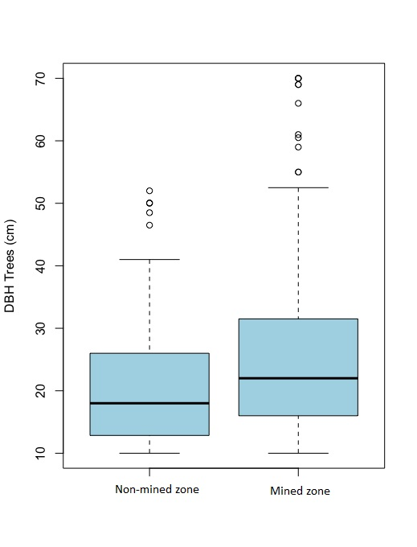
Figure S1. Diameter at breast height (DBH) for (A) Small trees (1>DBH<10 cm) and (B) Trees with DBH ≥ 10 cm in the non-mined and mined zones of Selva de Florencia National Natural Park.

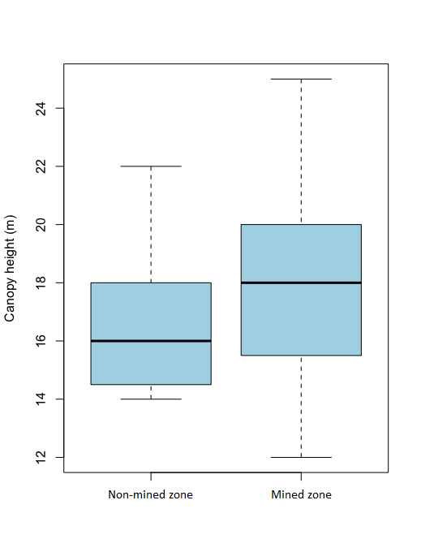
Figure S2. Canopy height in non-mined and mined zones in Selva de Florencia National Natural Park.

