Supplementary Material for

Management effectiveness and deforestation in protected areas of the Brazilian Amazon

Angela Pellin*, Letícia Dias, Neluce Soares and Fabiana Prado.
* Corresponding author: angela@ipe.org.br
Institute for Ecological Research (IPÊ)

Text S1

In Brazil, protected areas are classified into five categories: conservation units (CUs), Indigenous lands, quilombola territories, permanent preservation areas and legal reserves, as per Decree 5.758/2006, which established the National Strategic Plan for Protected Areas (Plano Estratégico Nacional de Áreas Protegidas). Permanent preservation areas and legal reserves are defined within the Forest Code and serve mainly to connect natural fragments and protected areas themselves. Conservation units represent the majority of Brazilian protected areas, including approximately 18 per cent of the continental area and more than 26 per cent of the coastal and marine zones (CNUC, 2022). Indigenous lands cover approximately 13 per cent of Brazil’s territory and, although they are formally protected areas, they have as their main objective the conservation of native cultures (ISA, 2022). Despite contributing to the conservation of biodiversity, they and quilombola territories are governed by specific legislation outside environmental policy.

The National System of Nature Conservation Units (SNUC, in Portuguese) regulates CUs and was established in 2000 with Law 9.985. SNUC’s objectives include: the maintenance of biological diversity and genetic resources; the protection of endangered species; the preservation, restoration and recovery of natural and degraded ecosystems; human contact with nature through public use; and the subsistence of traditional populations that depend on the direct use of natural resources (Brazil, 2000). SNUC defines twelve CU categories, divided into two main groups: integral protection and sustainable use. Each category has its general objectives, permitted and restricted uses of the biodiversity it harbours. Categories of integral protection have the broad objective of preserving nature and only permit the indirect use of natural resources. Sustainable use CUs, on the other hand, have as their main objective making nature conservation compatible with the sustainable use of a part of the natural resources. Therefore, depending on the category, they allow the collection of wood and non-timber products as long as they are managed in an orderly manner (Brazil, 2000). In addition to biodiversity conservation, other CU objectives include scientific research, sustainable exploitation of minerals, wood and non-timber products, public use (visitation, environmental education and recreation) and the subsistence of traditional populations (Brazil, 2000).

The Management Analysis and Monitoring System (SAMGe) is a Brazilian tool for management effectiveness assessment developed in 2016 by the Chico Mendes Institute for Biodiversity Conservation (ICMBio), a national agency. It consists of a virtual platform populated annually by managers with data on protected areas’ conservation target status, conservation goals, management actions taken and the perceived impacts of those actions, and multiple uses of natural resources by society (ICMBIO, 2019). It encompasses six indicators: context, planning, inputs, processes, results, and outputs and services. The indicators are calculated based on the relationship indicated by the managers following the conceptual diagram below (Figure S1). Table S1 compares SAMGe with the IUCN management effectiveness indicators.

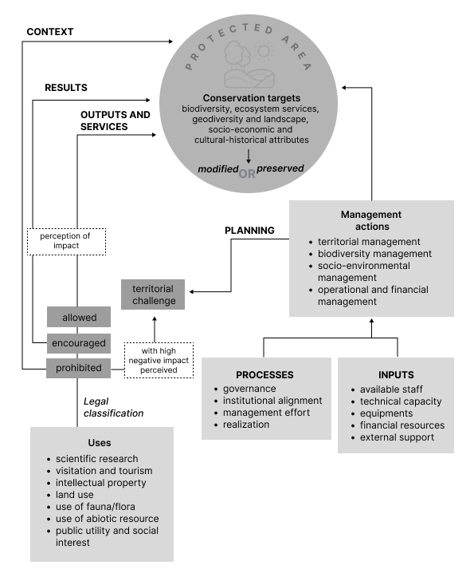
Figure S1. Conceptual diagram of the evaluation logic of SAMGe describing data provided by managers during the assessment. Capitalised texts are the indicators calculated by the tool.

Table S1. Comparative table between IUCN and SAMGe indicators, translated from ICMBIO, 2021.
 |  | Context | Planning | Inputs | Process | Outputs | Outcome/  Results
IUCN | Evaluation focus | Assessment of the importance, threats and environmental policies | Assessment of the design/ shape and planning of protected areas | Assessment of the resources needed to carry out the management | Assessment of the way management is carried out | Evaluation of the implementation of management programmes and actions (delivery of products and services) | Evaluation of results and extent of objectives achieved
 | Questions | Where are we now? | Where do we want to go and how are we going to get there? | What do we need? | How do we do? | What did we do and what products and services were generated? | What have we achieved?
 | Criteria | Significance/ values  Threats  Vulnerabilities  Stakeholders  National context | Legislation and policies for protected areas  Design/ shape of protected areas according to the system  Management planning | Resources available to the agency  Resources available for the protected area | Adequacy of management processes and the extent to which established or accepted processes are being implemented | Results of management actions  Outputs and services | Impacts: effects of management in relation to objectives
SAMGe | Evaluation focus | Analysis of uses that are contrary to the category and their resulting impact | Analysis of the relationship between management actions and territorial management challenges | Analysis of the resources needed to carry out the proposed management actions | Analysis of governability and institutional response to management actions proposed to territorial management challenges | Analysis of the quality of products and services delivered to society | Analysis of the quality of attributes and expected uses delivered to society
 | Questions | What are the main challenges to unit consolidation? | How does my planning relate to territorial management challenges? | Do we have the resources for actions related to territorial management challenges? | Are the processes well aligned between the unit and the managing body? | What is the status of products and services delivered to society? | What is the status of the expected results of public policy?
 | Criteria | Threats  Vulnerabilities  Opportunities  Category inadequacy  Design/shape inadequacy  Status of prohibited uses occurring in the area | Existence of management instruments  Adequacy of management actions present in the instruments to management challenges  Effectiveness of management actions | Existing resources (financial, human, technical capacity, and equipment) for carrying out management actions | Main processes related to management actions  Governability of the areas for each process  Adequacy of priorities between territorial challenges of management and processes | Threats  Vulnerabilities  Opportunities  Category inadequacy  Inadequacy of design/shape  Status of allowed uses occurring in the area | Attributes  Threats  Vulnerabilities  Opportunities  Category inadequacy  Inadequacy of design/shape  Status of encouraged uses occurring in the area

The MapBiomas Project is a “multi-institutional initiative to map land cover and land use transformations from automatic classification cloud processing applied to satellite imagery” (MapBiomas, 2022). The MapBiomas Alerta is a system for validating and refining deforestation alerts for native vegetation in Brazil and processes alerts provided by eight sources, including the National Institute for Space Research (INPE) and the Institute of Man and the Environment of the Amazon (Imazon). The system began in 2019, so it does not provide deforestation data prior to this. Among its limitations is that deforestation in grassland vegetation is monitored only in the Cerrado biome (the Brazilian savanna), therefore deforestation in non-woody vegetation is not consistently identified.

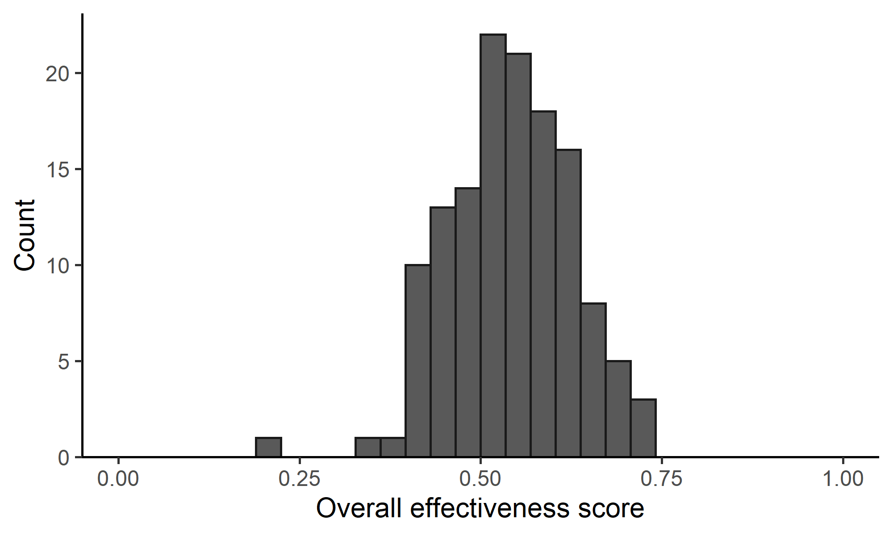
Figure S2. Distribution of overall management effectiveness scores for the 133 protected areas sampled.

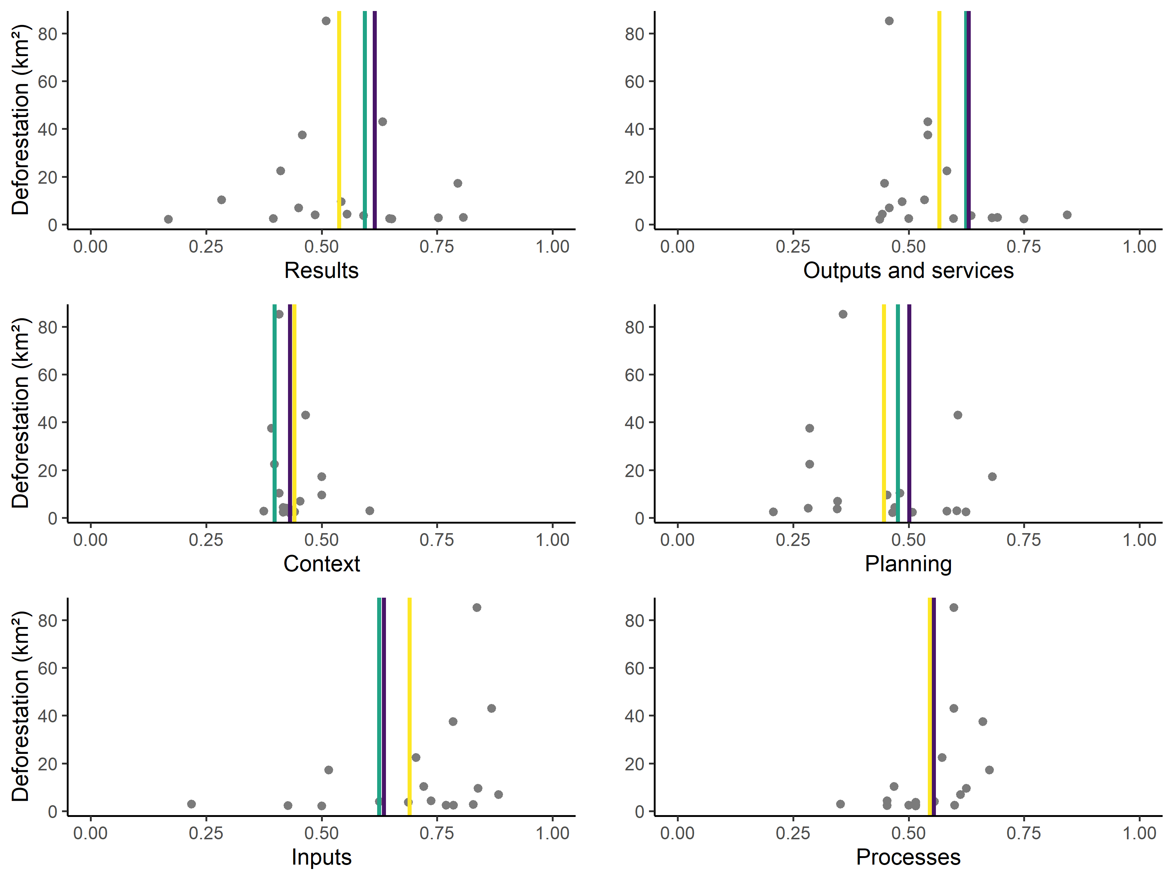

Figure S3. Relationship between management indicators and deforestation in Amazon protected areas. Points refer to the 17 areas with deforestation above the average, the red line indicates the average value of the indicator for those areas, the yellow line indicates the average of the areas with below average deforestation (n = 40) and the purple line the average for areas without deforestation (n = 76).

REFERENCES

Brazil. (2000). Environmental Ministry. SNUC – National System of Nature Conservation Units: Law no. 9.985, of 18 July 2000.
CNUC (National Registry of Conservation Units) (2022). Downloading geographic data http://mapas.mma.gov.br/i3geo/datadownload.htm (Accessed: 26 September 2022).
ICMBIO (Chico Mendes Institute for Biodiversity Conservation) (2019). SAMGe Sistema de Análise e Monitoramento de Gestão: Manual de Aplicação (SAMGe Management Analysis and Monitoring System: Application Manual). Brasília: MMA.
ICMBIO (Chico Mendes Institute for Biodiversity Conservation) (2021). Relatório de Aplicação do Sistema de Análise e Monitoramento de Gestão SAMGe – Ciclo 2020 (Application Report of the SAMGe Management Analysis and Monitoring System – 2020 Cycle). Brasília: MMA. http://samge.icmbio.gov.br/uploads/relatorio/2021_08_18/Relatorio_Consolidado_SAMGe_Ciclo_2020-20210818155657.pdf (Accessed: 29 September 2022).
ISA (Socio-environmental Institute) (2022). Terras indígenas no Brasil (Indigenous Lands in Brazil) https://terrasindigenas.org.br/ (Accessed: 26 September 2022).
MapBiomas (2022). MapBiomas Alerta: About. http://alertas.mapbiomas.org/sobre-o-projeto?tab=o-projeto (Accessed: 12 September 2022).

