Supplementary tables, figures and species information

Table 1. Comparison among small mammal communities across different protection levels in the NHNP system and outside. Each diversity variable (column 1) was analyzed for each year independently (top 2015, bottom 2016) by Kruskal-Wallis Test. Mean$±$standard error is indicated in each cell. * indicates statistical significance.
 | Outside NHNP | National Reserve | National Park | Strict Reserve | KW chi² | DF | P-value
A. hirta | 23.4$±$4.69  15.2$±$4.37 | 13.0$±$5.98  10.6$±$4.65 | 25.0$±$4.46  22.2$±$7.27 | 30.0$±$4.57  19.8$±$2.11 | 4.1562  2.9045 | 3,16  3,16 | 0.2451  0.4066
O. longicaudatus | 12.2$±$2.59  0.6$±$0.4 | 2.2$±$0.97  1.2$±$1.2 | 1.6$±$1.12  2.6$±$1.78 | 9.4$±$8.66  3.6$±$3.6 | 7.1228  0.5515 | 3,16  3,16 | 0.0681  0.9074
D. gliroides | 0.8$±$0.49  No capture | 1.2$±$0.49  1.8$±$1.32 | 7.6$±$2.99  9.4$±$3.95 | 7.6$±$3.07  8.4$±$4.16 | 5.7734  8.417 | 3,16  3,16 | 0.1232  0.0381*
A. olivacea | 3.4$±$2.13  1.2$±$0.8 | No capture  0.8$±$0.37 | 0.6$±$0.6  0.4$±$0.24 | 0.8$±$0.58  4.8$±$2.85 | 2.3911  1.4184 | 3,16  3,16 | 0.4953  0.7012
G. valdivianus | 0.4$±$0.4  No capture | 0.4$±$0.24  0.6$±$0.24 | 1.4$±$1.16  0.2$±$0.2 | 0.2$±$0.2  0.6$±$0.4 | 0.8742  4.3244 | 3,16  3,16 | 0.8316  0.2285
C. macronyx | No capture  No capture | 0.4$±$0.24  No capture | No capture  No capture | No capture  No capture | 6.3333  - | 3,16  - | 0.0965  -
I. tarsalis | 0.4$±$0.4  0.2$±$0.2 | No capture  No capture | 0.4$±$0.4  0.2$±$0.2 | 3.4$±$3.4  0.4$±$0.4 | 1.1333  0.1333 | 3,16  3,16 | 0.7690  0.7690
L. micropus | 1.2$±$0.58  0.2$±$0.2 | No capture  0.4$±$0.4 | No capture  0.8$±$0.8 | No capture  No capture | 9.9805  1.1385 | 3,16  3,16 | 0.0187*  0.7678

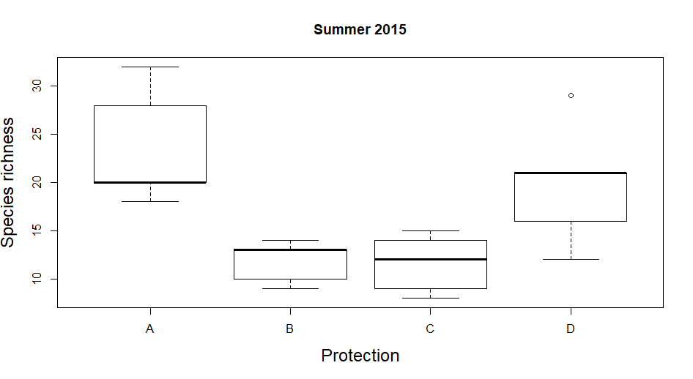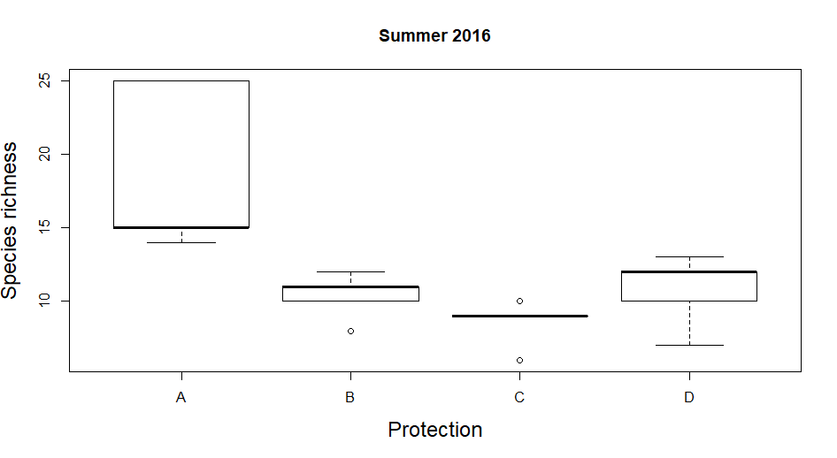
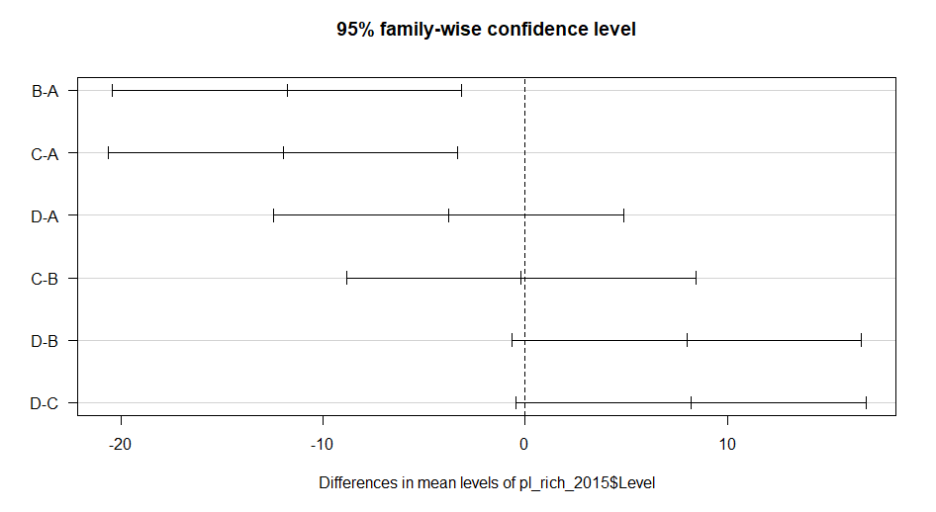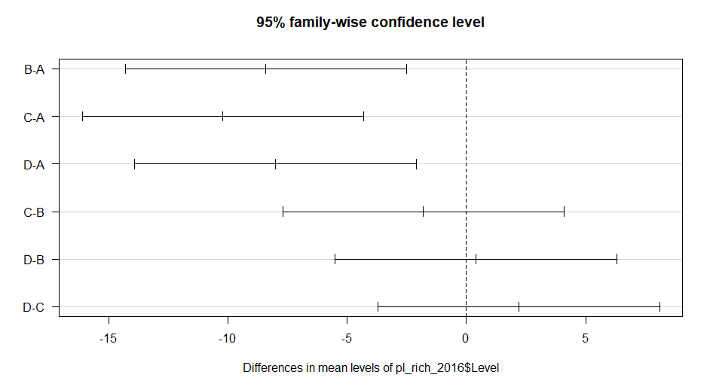
Figure 1. Plant species richness in sites with different protection levels in NHNP. Top left corresponds to 2015, top right to 2016. (A) outside PA, (B) National Reserve, (C) National Park, (D) Strict Reserve. Results from Tukey’s HSD test at bottom for each year. Differences between group A and B (Outside PA and National Reserve) and A and C (Outside PA and National Park) occurred both years (A-B p=0.0063 for 2015 and p=0.0044 for 2016, A-C p=0.0055 for 2015 and p=0.0007 for 2016). Also, differences between groups A and D (Outside PA and Strict Reserve) were found in 2016 (p=0.0065).

Table 2. Principal Component Analysis based on five environmental variables: vegetation cover, plant species composition, tree density, tree basal area and arthropods abundance. The first three components account for more than 80 percent of the variation.
 |  | PC1 | PC2 | PC3 | PC4 | PC5
2015 | Standard Deviation | 1.3347 | 1.0880 | 1.0229 | 0.7352 | 0.6693
 | Proportion of Variance | 0.3563 | 0.2368 | 0.2093 | 0.1081 | 0.0896
 | Cumulative Proportion | 0.3563 | 0.5930 | 0.8023 | 0.9104 | 1.0000
2016 | Standard Deviation | 1.3097 | 1.2275 | 0.9013 | 0.8440 | 0.50316
 | Proportion of Variance | 0.3431 | 0.3014 | 0.1625 | 0.1424 | 0.05063
 | Cumulative Proportion | 0.3431 | 0.6444 | 0.8069 | 0.9494 | 1.0000

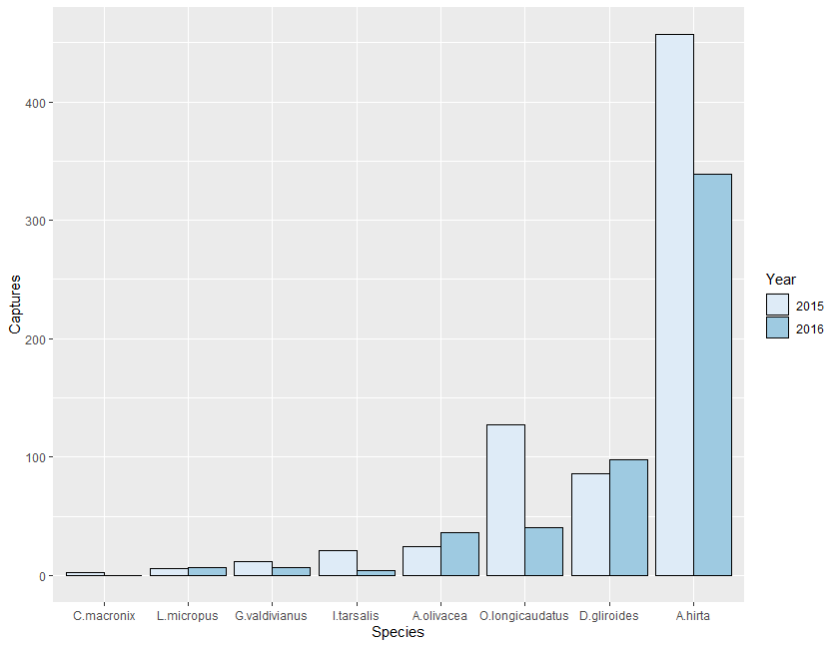
Figure 2. Number of small mammals trapped, per species, during sampling seasons 2015 and 2016.

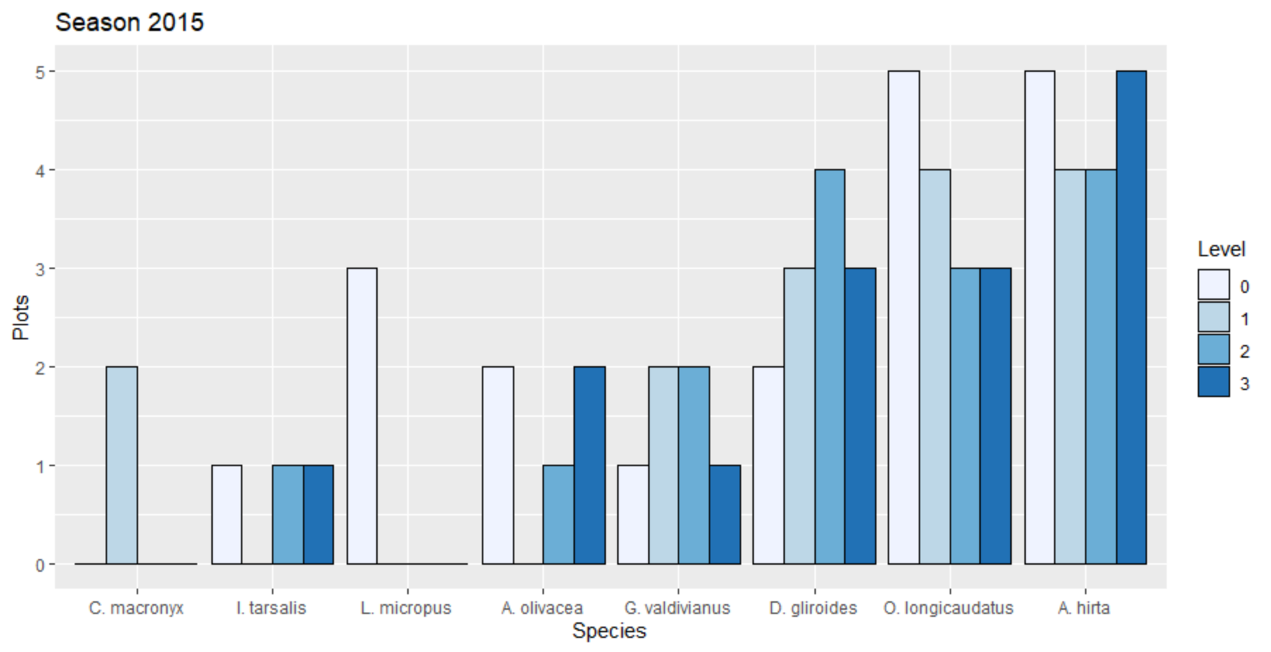

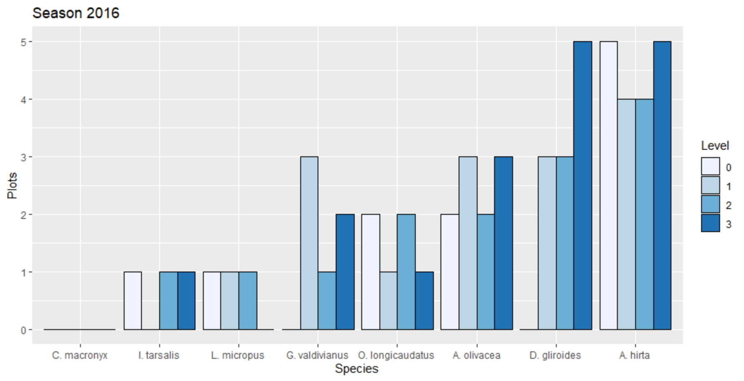
Figure 3. Number of plots per level of protection where the species were trapped. Top: Season 2015. Bottom: Season 2016. Level of protection 0: Outside PA, 1: National Reserve, 2: National Park, 3: Strict Reserve.

Species Less Frequently Trapped
Abrothrix olivacea inhabits areas with thick grass, marshes, and forest with sufficient ground cover (Pearson, 1983), preferring microhabitats with vegetation cover from above (Murua et al., 1986). All of our plots had good ground cover; nevertheless, the species was undetected in most of them in 2015 but doubled in occurrence and abundance in 2016 (Fig. 3). This change highlights the importance of long-term studies and also of looking more closely at variables that might affect the occurrence of this species, beyond protection level.
Irenomys tarsalis occupies dense forest with understory dominated by bamboo Chusquea culeou (Pearson, 1983). Plots with bamboo as a dominant species had flowered in 2010 (Herrero, 2013). Chusquea culeou usually grows vegetatively, but after 50-70 years, it flowers synchronously, produces a massive amount of seeds, then dies. Recovery is slow (Giordano et al., 2009; Marchesini et al., 2009). This could account for our low capture rate (n= 21 in 2015 and n=4 in 2016). Nonetheless, the presence/absence variation among plots between years (Fig. 3) cannot be explained with our current data.
Geouxus valdivianus is the only species whose diet consists solely of invertebrates (Pearson, 1983). Invertebrate abundance across protection levels did not differ (chi-squared= 1.1102, DF 3, p=0.7746 and chi-squared=5.7657, DF=3, p=0.1236, for 2015 and 2016 respectively). The species is widely distributed, although in low abundance.
Loxodontomys micropus is mainly herbivorous and prefers forest with sufficient ground vegetation. (Pearson, 1983). Despite the apparently suitable condition of our plots, we trapped only six individuals in 2015, all outside PAs. A study in Chile in mature and second growth forest reported ten individuals with a trapping effort of 1936 traps/night (Garcia et al., 2013). Further studies are needed to determine the reason for the low abundance we recorded with a total trapping effort of 41,600 traps/night.
Finally, Chelemys macronyx has been found mainly in lenga forest (N. pumilio) (Garcia et al., 2013). The species has not been detected previously in N. dombeyi forest (Pearson, 1983). Although we detected the species only in 2015, this study provides novel information regarding habitat preference/suitability for this species. We detected the species in our northernmost samples, in the National Reserve category. This area was still blanketed by volcanic ash (from the June 2011 Cordon Caulle eruption). Research on ash effect on arthropods has demonstrated its insecticidal action (Buteler et al., 2011). Although C. macronyx is omnivorous, invertebrates constitute most of its diet (Sage et al., 2007), so it is interesting that we found them only in that particular area. To increase capture probability, traps must be set near their burrow entrances instead of randomly distributed in a grid as we did (Ojeda R., personal communication).

References
Buteler, M., Stadler, T., Lopez Garcia, G. P., Lassa, M. S., Trombotto Liaudat, D., D'Amamo, P., Fernandez-Arhex, V., 2011. Propiedades insecticidas de la ceniza del complejo volcánico Puyehue-Cordón Caulle y su posible impacto ambiental. Rev. Soc. Entomol. Argent. 70, 149-156.
Garcia, K. P., Ortiz Zapata, J. C., Aguayo, M., D'Elia, G., 2013. Assessing rodent community responses in disturbed environments of the Chilean Patagonia. Mammalia 77, 195-204, doi:10.1515/mammalia-2011-0134.
Giordano, C. V., Sanchez, R. A., Austin, A. T., 2009. Gregarious bamboo flowering opens a window of opportunity for regeneration in a temperate forest of Patagonia. New Phytologist 181, 880–889, doi:10.1111/j.1469-8137.2008.02708.x.
Herrero, E. R., 2013. Evaluacion del Efecto de la Ratada como consecuencia de la Floracion Masiva de la Cana Colihue (Chuesquea culeou), en la Provincia de Rio Negro, Argentina. Periodo 2010-2012. Facultad de Ciencias Veterinarias, Vol. Especializacion en Salud Publica Veterinaria. Universidad de La Pampa, pp. 77.
Marchesini, V. A., Sala, O. E., Austin, A. T., 2009. Ecological consequences of a massive flowering event of bamboo (Chusquea culeou) in a temperate forest of Patagonia, Argentina. Journal of Vegetation Science Volume 20, 424–432
Murua, R., Gonzalez, L. A., Meserve, P. L., 1986. Population Ecology of Oryzomys longicaudatus philippii (Rodentia: Cricetidae) in Southern Chile. Journal of Animal Ecology 55, 281-293.
Pearson, O. P., 1983. Characteristics of a Mammalian Fauna from Forests in Patagonia, Southern Argentina. Journal of Mammalogy 64, 476-492.
Sage, R. D., Pearson, O. P., Sanguinetti, J., Pearson, A. K., 2007. Ratada 2001: Rodent outbreak following the flowering of bamboo (Chusquea culeou) in Southwestern Argentina. University of California Publications in Zoology, University of California.

