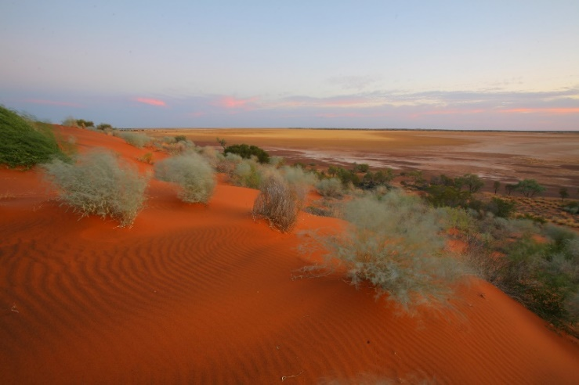
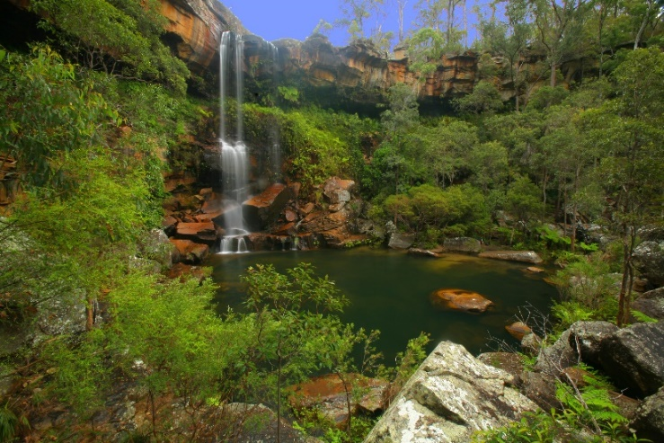
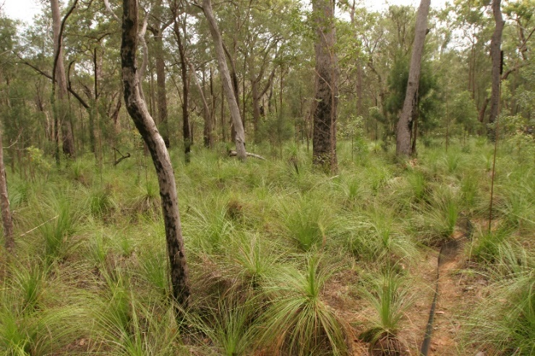
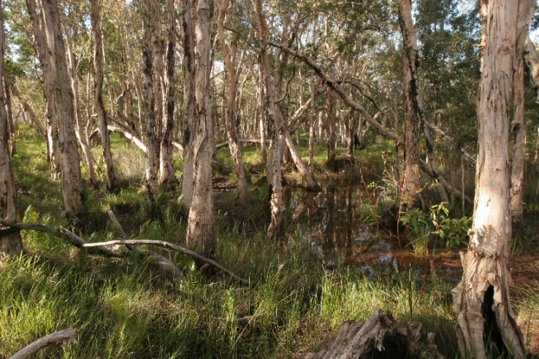
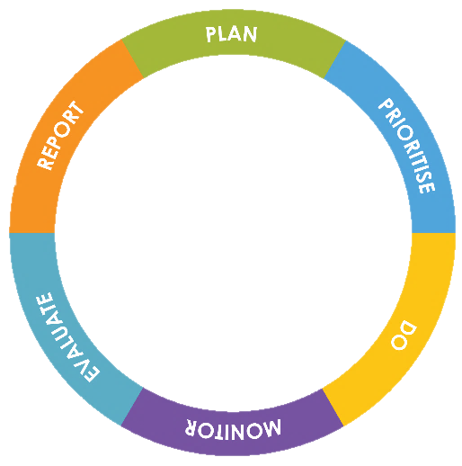
July 2019
Natural Values Health Checks
A guide to undertaking Health Checks for key natural values
Version 1.6

Prepared by: Ecological Assessment Unit, Queensland Parks and Wildlife Service & Partnerships, Department of Environment and Science

© State of Queensland, 2019.

July 2019
Front cover photographs: Blackdown Tableland National Park © J. Augusteyn; Byfield National Park © J. Augusteyn; Byfield National Park © J. Augusteyn; Diamantina National Park © J. Augusteyn

The Queensland Government supports and encourages the dissemination and exchange of its information. The copyright in this publication is licensed under a Creative Commons Attribution 3.0 Australia (CC BY) licence.
Under this licence you are free, without having to seek our permission, to use this publication in accordance with the licence terms.
You must keep intact the copyright notice and attribute the State of Queensland as the source of the publication.
For more information on this licence, visit http://creativecommons.org/licenses/by/3.0/au/deed.en

ISSN (delete if not required)
ISBN (delete if not required)
CCI job number
Disclaimer
This document has been prepared with all due diligence and care, based on the best available information at the time of publication. The department holds no responsibility for any errors or omissions within this document. Any decisions made by other parties based on this document are solely the responsibility of those parties.
If you need to access this document in a language other than English, please call the Translating and Interpreting Service (TIS National) on 131 450 and ask them to telephone Library Services on +61 7 3170 5470.
This publication can be made available in an alternative format (e.g. large print or audiotape) on request for people with vision impairment; phone +61 7 3170 5470 or email <library@des.qld.gov.au>.
Citation
Melzer R. 2019. Natural Values Health Checks. A guide to undertaking Health Checks for key natural values. Version 1.6, July 2019. Ecological Assessment Unit, Queensland Parks and Wildlife Service & Partnerships, Department of Environment and Science, Queensland Government.
Acknowledgements
Thanks to Sylvia Millington and John Atkinson (Pest and Fire Team, Operational Support); Bridget Armstrong and Julie Dutoit (Tech. Support, Great Barrier Reef and Marine Park Region); Mark Parsons (Tech. Support Northern Region); Col Dollery (Senior Ranger Cape York, Nth Region); James Altaffer (Planning Nth Region); Haylee Mlikota (Tech. Support Nth Region); Lea Ezzy (NRM Ranger, Savannah, Central Region); Peter Thompson (Tech. Support, Central Region); Rod Hobson (NRM Ranger, South West Region); Rowena Thomas (Tech. Support, Southeast Region); John Esdaile and George Krieger (Tech. Support, Coast and Islands Region); Dr Paul Williams (ecologist); Dr Alistair Melzer (CQUniversity); Harry Hines, Dr Graham Hemson, Andrew McDougall, Michael Smith and John Olds, (Ecological Assessment Unit, Operational Support); Dr Teresa Eyre and Dr Bill McDonald (Qld Herbarium) for valuable discussions and contributions; and participants in the February 2017 and June 2018 Health Check training workshops. Particular thanks to Harry Hines, John Olds, Mick Smith, Steve Peck and Rowena Thomas for discussions around this version. Thanks to Kym Thomson (Ecological Assessment Unit) for editorial support and to Susan Tilgner (Planning Unit) for formatting.

Contents
Introduction 1
How to do Health Checks and complete the record sheets 3
New or emerging issues noticed (anywhere on the park) while undertaking an inspection 6
References 7
Attachment 1 Health Check Indicators 8
1. Ecosystem-changing pest plants 8
2. Pest plants other than ecosystem-changers 8
3. Risk of future invasion by ecosystem-changing pest plant not already present 9
4. Rainforest invasion 10
5. Woody thickening (other than by rainforest species) 11
6. Over-grazing or over-browsing by feral animals, stray stock or native animals 12
7. Trampling, digging or rooting by feral or native animals, stray stock, horse-riding or trampling by visitors 13
8. Impacts on wetlands 14
9. Vehicle impacts 15
10. Dumping 15
11. Ground cover 16
12. Fire damage to fire-sensitive ecosystems and ecosystems that are not fire-dependent 17
13. Fire damage to peat-based ecosystems 18
14. Age class distribution in fire-adapted ecosystems in zones where the primary purpose of fire management is conservation 19
15. Severe wildfire in fire-adapted wooded ecosystems 22
16. Severe storm, cyclone or tornado in wooded ecosystems 24
17. Overtopping, erosion and impacts resulting from tidal inundation, major flooding, storm, cyclone, tsunami, land slip or other erosional processes. 25
18. Tree/shrub health & dieback 26
19. Key features for faunal biodiversity in terrestrial ecosystems 28
20. Recruitment of canopy species 29
Attachment 2 Record sheet: Natural Values Health Checks 31

Introduction
Queensland’s parks, forests and reserves are places we want to protect for future enjoyment and wellbeing. What makes these places special are the presence and diversity of natural, cultural, social and economic values. These areas experience natural cycles—they live and breathe—and therefore our management needs to be dynamic too. The Queensland Parks and Wildlife Service and Partnerships (QPWS&P), within the Department of Environment and Science (DES), applies a contemporary management process that is based on international best practice and targets management towards the most important features of each park: their key values.
VALUES-BASED MANAGEMENT FRAMEWORK
The Values-Based Management Framework (VBMF) is an adaptive management cycle that incorporates planning, prioritising, doing, monitoring, evaluating and reporting into all areas of our business. This enables the agency to be more flexible and proactive and to improve management effectiveness over time.
By assessing the condition of an area’s key values, QPWS&P can prioritise management efforts, balancing the importance of values and threats with our custodial obligations. Monitoring the condition of values and evaluating our performance is integral to closing the loop on the adaptive management process.
Health Checks are tools for efficiently and routinely assessing the condition of key park values¹. They use simple visual ‘cues’ and require no specialist skills or equipment and have been designed to work state-wide. Health Checks, in conjunction with other basic monitoring associated with routine on-ground actions (e.g. planned burning and pest management), are the basis for the evaluation of the condition of natural values through time for the majority of estate managed by Queensland Parks and Wildlife Service & Partnerships (hereafter ‘park’ regardless of tenure) (Fig. 1). Where highly significant values require management intervention on a high priority park, detailed, targeted monitoring or research may be warranted (Melzer 2015), and is identified in the Monitoring and Research Strategy for that park.
The key values on which to undertake Health Checks are selected and defined² during a Key Values Assessment (QPWS&P, 2019). The current condition and desired condition for each key value is determined along with the strategic direction for its management. Health Checks are subsequently undertaken during park inspections by local staff³. Health Checks are undertaken annually on our ‘Top 50’ priority parks; elsewhere their frequency is guided by the park’s Levels of Service (i.e. management standard) and magnitude of the greatest risk to the key value from threats (Fig. 2), and observations and outcomes of recent Health Check assessments. Over time the information from Health Checks will provide a good indication of the trend in condition, and hence alignment with the stated desired condition for the key value, and so help determine whether the current management approach is appropriate. The trend in condition (‘health’) for the key values on a park are ‘rolled up’ for high level management evaluation and reporting purposes (e.g. State of the Parks Report).
Health Checks provide a critical opportunity for the management unit to regularly review the effectiveness of their management in maintaining or recovering key values. The Health Checks must be reviewed by the management unit upon completion to determine whether, for example: current management actions are appropriate or need adjusting; urgent intervention is required; and additional funds are needed. In-line managers (to whatever level is appropriate) must be alerted to concerns about the condition of a value (whether at a specific site or across the whole park), or an emerging issue on the park, and a decision on a response – which may be to do nothing – must be made and documented. Relevant results should be discussed in forums such as the Fire and Pest Referral Group meetings.
- In the context of Health Checks a key natural value is an ecosystem or plant community.
- What constitutes the key value must be defined clearly in the Values Assessment to ensure that data can be rolled up for regional and state-wide reporting. As a guide, a key value (or at least sub-key value) should not incorporate regional ecosystems that span more than one Broad Vegetation Group (Neldner et al. 2019) at the 1:2million scale.
- Members of local bushwalking clubs and the like may also be willing/keen to undertake Health Check assessments in locations that are time consuming to access but are part of the clubs program of activities. Appropriate training and oversight by QPWS&P staff is required.
This document provides: a) guidelines for undertaking Health Checks for natural values; b) descriptions of the Health Check Indicators (Attachment 1) and; c) a record sheet (Attachment 2). Note that the Heath Check component of a Monitoring and Research Strategy must be developed prior to undertaking Health Checks. This enables questions about timing and site selection (e.g. number of sites, location) to be workshopped and appropriate guidance (or specifications) to be documented in the Strategy, as well as approval by line managers.

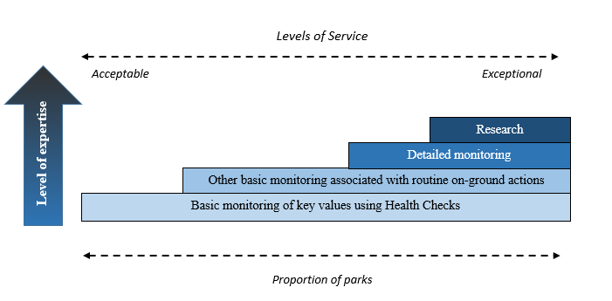

Figure 1. Hierarchical framework for monitoring and research on QPWS& estate.

 | Highest overall threat rating
Level of Service | Low | Moderate | High | Very High
Exceptional | Every 3 years | Every year | Every year | Every year
Very high | Every 3 years | Every year | Every year | Every year
High | Every 3 years | Every 2 years | Every year | Every year
Medium | Every 5 years | Every 2 years | Every 2 years | Every year
Acceptable | Every 5 years | Every 3 years | Every 2 years | Every year

Figure 2. Risk matrix used to guide the minimum frequency of Health Checks. Note that Health Checks are undertaken annually in our ‘Top 50’ priority parks.

How to do Health Checks and complete the record sheets
- Determine the most appropriate time period or season of the year to assess the health/condition of the key value. Endeavour to undertake the assessment in the same time period or season each year and when weeds are most recognisable. Note that where important, the timing for Health Checks is specified in the Monitoring and Research Strategy for the park.
- The inspection should ideally be undertaken by at least two observers. It may be advantageous, but is not mandatory, for one of the observers to have participated in the previous year. A copy of the previous year’s Health Checks, including photographs from permanent sites, should be carried with you for reference.
- Selecting sites
The number and location of sites, particularly permanent sites, are best determined during development of the Monitoring and Research Strategy. No less than three sites should be assessed per key value, unless the value is unique (e.g. one spring) or very small (< 50ha). More sites should be done if a value is extensive and/or widely distributed.
For some key natural values there will be little, if any, choice when it comes to selecting sites because the value is unique (e.g. the only mound spring on a park) or only occurs in a few small patches (e.g. four isolated patches of vine thicket). When this is not the case – choose sites that are most likely to be useful in informing on-ground management. Also consider accessibility – if a site is too difficult to get to then the Health Checks are unlikely to get done. It may be valuable to use sites for which there is historic data.
Where the key value is extensive, and accessible by vehicle, drive around/through as much of it as possible to get an ‘overview’ of the condition. Ensure that you look beyond the road edge! It is also necessary to get out of the vehicle and walk into the key value in a range of ‘representative sites’ to get as true perspective of its condition as possible and to do a Health Check. A site should be relatively ‘uniform’ (e.g. within the same ecosystem but don’t include a south and north facing slope or a ridgeline and a valley in one site).
The size of each ‘representative site’ (i.e. the area you include in your inspection) must be recorded on the record sheet (e.g. 2500m2, 50x50m) and will depend on factors such as the area the key value covers at that location and its uniformity.
In some circumstances (e.g. wetlands across a vast and largely inaccessible area), aerial inspection may be the most effective option for evaluating condition across the landscape but will obviously be limited to funded priority projects.
- It is not mandatory to go back to exactly the same site/s each year unless of course the key value is very small and/or your options are limited. However, it will usually be highly beneficial to have some permanent sites that are revisited each year and to incorporate standard photo-monitoring points into your Health Checks. Instructions on how to set up a photo-monitoring point are available on the Conservation Monitoring Pages or from the Ecological Assessment Unit.
In many cases it will not be necessary to precisely define the boundary of your site in order to ensure that the next time you (or a colleague) do the Health Checks you use exactly the same area…..a few metres either side will not be a problem. However, in some circumstances the definition of your site will be important. Ask yourself – Is it likely that someone else coming to do the Health Checks in future could be confused about what might or might not be included in the site I am establishing? If the answer is yes, then provide clear details about your site and its boundary on the first page of the record sheet (Attachment 2).

- A record sheet (Attachment 2) has to be completed for each key value. The standard record sheet allows up to five sites per key value (Table 2.1, Attachment 2). If more than five sites are required to get an adequate representation of condition (only likely for extensive key values with complex management issues) add extra columns.
- Health Check Indicators (described in Attachment 1) are used to assess the condition of the key value. For natural key values they are based on disturbances and features that provide a good indication of condition. Table 1.1 lists Health Check Indicators appropriate to various types of key values – every Health Check Indicator that applies to your key value MUST be used in your site assessment.
Use the tables in Attachment 1 to determine the Condition Class, from Good to Critical, for each Health Check Indicator. Ensure that you read the information and instructions provided for each Health Check Indicator every time! Do not assume you’ve remembered them correctly from last time! Some additional visual assessment aids (e.g. stylised pictures of percentage ground cover) are provided.
- For each Health Check Indicator, the Condition Class that you determine for each site must be recorded on the record sheet.
- Your general impression of the condition of the key value across the park for each Health Check Indicator is also recorded (unless the value occurs at only one site). Note that this general impression IS NOT an ‘average’ of the Condition Classes you recorded at each site. It IS your considered opinion about the state of the key value across the park based on the site results AND your observations as you drive, walk, paddle or fly between sites!
- Where it is relevant (refer box 1), provide information in Table 2.3 of the record sheet about factors contributing to the Condition Class assigned to the key value at an inspection site, and in Table 2.4 for your general impression for a Health Check Indicator.
- When you have completed your inspection of a key value (i.e. assessments at all Health Check sites and your general impression across the park) record the Overall Condition Class (Table 1.2; note that this table is repeated on the record sheet for your convenience as Table 2.2) based on all of the Health Check Indicators.
Make sure that you make this decision on the day of the inspection or at least within a few days of it. It is intended to be a ‘considered opinion’ guided by the site results and your other observations.
Common sense must also prevail. For example, if the key value had a Condition Class of Good for ground cover but the ground cover consisted almost entirely of a pest plant (i.e. key value's Condition Class is Significant Concern or Critical with respect to pest plant density) - the latter Condition Class over-rides the former.
Box 1 Make good use of notes!
Notes are important! For some Health Check Indicators there is a specific instruction in Attachment 1 about what to record in Table 2.3 (e.g. Record the ecosystem-changing pest plants that are at your inspection site/s).
But don’t limit yourself to those instructions. Ask yourself, for example – “Will it be obvious to someone reading this record sheet (or to me in 12 months’ time) why I have assigned a ‘General Impression’ of Significant Concern to the Health Check Indicator Impacts on wetlands; or why I have assigned Significant Concern as the Overall Condition Class for the value?” If it’s not – then make some detailed notes on the record sheet.

Table 1.1 List of Health Check Indicators and the types of Key Values (ecosystems) to which they are applied¹.
Indicator | Key Values (ecosystems)
1. Ecosystem-changing pest plants | All
2. Pest plants other than ecosystem-changers | All
3. Risk of future invasion by significant pest plants not already present | All
4. Rainforest invasion | All non-rainforest ecosystems. Do not use where the ecosystem was previously rainforest and the goal is rainforest recovery.
5. Woody thickening (other than by rainforest species) | All
6. Over-grazing/over-browsing by feral animals, stray stock or natives | All
7. Trampling, digging or rooting by feral or native animals, stray stock, or horse-riding, or trampling by visitors | All (not mandatory for wetlands)
8. Impacts on wetlands | Wetlands
9. Vehicle impacts | All
10. Dumping | All
11. Ground cover | All except mobile dunes (i.e. unconsolidated sediments) and salt pans. Gibber plains & similar are included. Do not use if your key value is nesting habitat for turtles.  Also use as an indicator for healthy wetland ecosystems (e.g. good ground cover surrounding the wetland will minimise soil erosion and runoff into the wetland).
12. Fire damage to fire-sensitive ecosystems and ecosystems that are not fire-dependent | All ecosystems not adapted to fire and all those that are not fire-dependent and are not usually planned to be burnt. Do not use for ecosystems that ‘simply’ require long fire intervals.
13. Fire damage to peat-based systems | Peat-based ecosystems (e.g. sedgelands, wet heaths, fens)
14. Age class distribution in fire-adapted ecosystems in zones where the primary purpose is conservation | All fire-adapted ecosystems in zones where the primary purpose is conservation.
15.Severe wildfire in fire-adapted wooded ecosystems | All fire-adapted ‘wooded’ ecosystems including open woodlands, mallee and low to tall shrublands.
16. Severe storm, cyclone or tornado in wooded ecosystems | All ‘wooded’ ecosystems including open woodlands, mallee and low to tall shrublands.
17. Overtopping, erosion & associated impacts resulting from tidal inundation, major flooding, storm, cyclone, tsunami or other erosional processes. | All
18. Tree/shrub health and dieback | All ‘wooded’ ecosystems including open woodlands, mallee and low to tall shrublands.
19. Key features for faunal biodiversity in terrestrial ecosystems | Terrestrial ecosystems. Aquatic ecosystems and ecosystems subject to tidal inundation are not included.
20.Recruitment of canopy species | Woodlands to closed forests other than those where recruitment is known to be naturally rare or episodic and results in even-aged stands. Do not use for shrublands.
      - Do not be concerned if an Indicator you are required to apply to your key value does not seem applicable (e.g. rainforest invasion for a saltmarsh or gibber plain herbland). The rationale is to reduce the need for the assessor to have to decide if an Indicator is applicable in circumstances where there may be uncertainty. If rainforest invasion (for example) is not applicable, then your value will ‘fit’ the condition description GOOD and you will record G (i.e. good) not NA (not applicable) on the record sheet.

Table 1.2 Overall Condition Class – what the categories mean.
(from IUCN 2012 & Osipova et al. 2014)
Good | The Key Value is in good condition and is likely to be maintained for the foreseeable future, provided that current conservation measures are maintained.
Good with some concern | The Key Value is likely to be essentially maintained over the long-term with minor additional conservation measures to address existing concerns.
Significant concern | The Key Value is threatened by a number of current and/or potential threats. Significant additional conservation measures are required to preserve the value over the medium to long-term
Critical | The Key Value is severely threatened. Urgent additional large-scale conservation measures are required or the value may be lost.

New or emerging issues noticed (anywhere on the park) while undertaking an inspection
When you are undertaking the inspection you may notice localised disturbances (point source or linear), biosecurity breaches or issues that require attention to prevent degradation and significant resource input in the future (e.g. a new infestation of an ecosystem-changing weed; illegal dumping; graffiti at a cultural site, pollution event; erosion; tree-fall across a track resulting in new tracks), or pose risk to life and property, or significantly impact on visitor experience (e.g. overcrowding, excessive noise, conflict amongst user groups). Table 2.5 is provided as part of the record sheet to note relevant information.
Your in-line manager/s must be alerted to the issue as soon as possible after the inspection and a decision made about the management response to be undertaken.
This table must be taken on future inspections so that the effectiveness of the management response can be evaluated.

Abbreviations used in Attachment 1
< Less than
> Greater than

References
(References used in the Guidelines and Attachment 1)
Eyre TJ, Kelly AL, Neldner VJ, Wilson BA, Ferguson DJ, Laidlaw MJ & Franks AJ. 2015. BioCondition: A condition assessment framework for terrestrial biodiversity in Queensland. Assessment manual. Version 2.2. Queensland Herbarium, Department of Science, Information Technology, Innovation and Arts, Brisbane.
Grimes RF. 1978. Crown assessment of natural spotted gum, ironbark forest. Qld Department of Forestry Technical Paper No. 7.
IUCN 2012. Conservation Outlook Assessments - guidelines for their application to natural World Heritage Sites Version 1.2 (final).
Kutt AS & Gordon IJ. 2012. Variation in terrestrial mammal abundance on pastoral & conservation land tenures in north-eastern Australian tropical savannas. Animal Conservation 15: 416-425.
Meat & Livestock 2012. Biodiversity Condition Toolkit for Grazed Lands.
Melzer R. 2015. QPWS Monitoring Framework. Ecological Assessment Unit, Operational Support, Queensland Parks and Wildlife Service, Department of National Parks, Sport and Racing.
Neldner VJ, Niehus RE, Wilson BA, McDonald WJF, Ford AJ & Accad A. 2019. The Vegetation of Queensland. Descriptions of Broad Vegetation Groups. Version 4.0. Queensland Herbarium, Department of Environment and Science.)
Osipova E, Shi Y, Kormos C, Shadie P, Zwahlen C & Badman T. 2014. IUCN World Heritage Outlook 2014: A conservation assessment of all natural World Heritage sites. Gland, Switzerland: IUCN. 64pp.
O’Sullivan G. 2008. Ground cover standards for Central Queensland grazing lands. Fitzroy Basin Association Inc.
Phelps D. 2012. Best bet practices for managing Mitchell grasslands of Queensland. A technical guide of options for optimising animal production, profitability & land condition. Department of Employment, Economic Development & Innovation.
Queensland Department of Primary Industries and Forestry (DPI&F) 2004. Stocktake – balancing supply & demand. A monitoring package that ‘takes stock’ of your grazing resources & points to improved management decisions. Queensland Department of Primary Industries & Fisheries.
Queensland Parks and Wildlife Service & Partnerships (QPWS&P) 2019. Planning User Guide: Values-Based Management Framework Version 2 Planning Unit, Parks Services, Queensland Parks and Wildlife Service & Partnerships, Department of Environment and Science, Queensland Government.
Smith CS, Howes AL, Price B & McAlpine CA. 2007. Using a Bayesian belief network to predict suitable habitat of an endangered mammal – the Julia Creek dunnart (Sminthopsis douglasi). Biological Conservation 2007: 333-347.
Stol J. 2006. Assessment system for measuring state of tree health & level of dieback (BioAssess Project, Holbrook). CSIRO Sustainable Ecosystems.
Turton SM. 2008. Landscape-scale impacts of Cyclone Larry on the forests of northeast Australia, including comparisons with previous cyclones impacting the region between 1858 & 2006. Austral Ecology 33: 409-416.

Attachment 1 Health Check Indicators

1. Ecosystem-changing pest plants
(Use for all ecosystems)
An ecosystem-changing pest plant is a non-native species, or a native species outside its natural range, that has the potential to substantially & permanently alter the structure &/or composition of your ecosystem by direct (e.g. competition) &/or indirect (e.g. changed fire regimes) means. Examples include gamba grass, buffel grass, Guinea grass, cat’s claw, rubbervine, bitou bush, Pinus spp., Madeira vine. A plant that is an ecosystem-changing pest plant in one part of Queensland may not be an ‘ecosystem changer’ in another.
Separate parameters are provided for three ‘groups’ of weeds: those in the ground stratum; shrubs/trees; climbing vines.
Record (Table 2.3 on your record sheet) the ecosystem-changing pest plants that are at your inspection site/s.
Note: Prohibited & Restricted plants must be reported to Biosecurity Qld as soon as possible.
Level of invasion | Description | Condition Class
None | Pest species are absent including on the margins. | Good
Inconspicuous | Native species dominate; pest species inconspicuous/mainly on margins.  - Pest spp. in ground stratum – comprise up to 5% of cover &/or  - Pest shrubs/trees – comprise up to 5% of stems or cover &/or  - Pest climbers – cover up to 5% of canopy | Good with Some Concern
Conspicuous | Pest species are a conspicuous component of the vegetation.  - Pest spp. in ground stratum – comprise 5-25% of cover &/or  - Pest shrubs/trees – comprise 5-25% of stems or cover &/or  - Pest climbers – cover 5-25% of canopy | Significant Concern
Dominant | Pest species dominate  - Pest spp. in ground stratum – comprise >25% of the cover &/or  - Shrubs/trees – comprise >25% of stems or cover &/or  - Pest climbers – cover >25% of canopy | Critical

Pest plants other than ecosystem-changers
(Use for all ecosystems)
Although these are pest plants that don’t typically lead to radical ecosystem change (or their impact can be readily addressed by implementing a management action) they do reflect the level of disturbance (e.g. over-grazing by stock, feral grazers or native grazers; too frequent burning; flooding).
If your Key Value is the habitat of a significant species use this indicator to capture information about non-native or native plants that may have a significant impact on the habitat of the species (e.g. Cenchrus echinatus Mossman River grass or Bidens pilosa cobbler’s pegs in seabird nesting habitat on cays; couch grass forming a mat on foredunes can impede hatchling turtles).
Native species that may become ‘over-abundant’ with too short or too long fire intervals (e.g. dodder Cassytha spp.) are dealt with in other indicators (e.g. 14).
Use the table above to determine the Condition Class for this Health Check Indicator.

3. Risk of future invasion by ecosystem-changing pest plant not already present
(Use for all ecosystems)
Consider what ecosystem-changing pest plants, or pest plants that have a severe impact on an important species or its habitat (e.g. Mossman River grass in nesting habitat of coastal birds) are most likely to arrive and become a threat to the ecosystem you are inspecting. Are there sources along roadsides leading to the park or in the park, in headwaters above the park, or in neighbouring properties? When considering whether a source is sufficiently close to the ecosystem to become a problem in the near future think about the vectors that may transport the propagules & the distance over which they may carry them.
Note: Species already present at the site or in the immediate surrounds are not included in the assessment.
Record relevant details (e.g. species you are concerned about, its current location, potential vectors) in Table 2.3 on record sheet.

Risk | Description | Condition Class
Very low | No sources of propagules¹ are close enough for invasion to be likely &/or no vectors¹ | Good
Low | Sources of propagules¹ are close enough for invasion to be possible but there are few or no vectors¹ &/or the sources are being eradicated, contained or controlled &/or the risk of establishment is low. | Good with Some Concern
Moderate | There are sources of propagules¹ close enough for invasion & suitable vectors¹ & conditions for establishment. | Significant Concern
High | Pest plants are common to abundant immediately adjacent to the ecosystem (e.g. along roadsides). | Critical
      - Propagules include seeds, spores & other plant parts that can grow into a new plant. Vectors include wind, vehicles (e.g. soil on tyres), water, animals including humans, birds & bats (e.g. on clothing or fur; via droppings).

4. Rainforest invasion
(Use for all non-rainforest ecosystems. Do not use where the ecosystem was previously rainforest and the goal is rainforest recovery)
Use the descriptions in the table to get a ‘best fit’ – not all parameters may be relevant or exactly ‘fit’ your site. For example, some ecosystems may have a ground stratum dominated by herbaceous species other than grasses but remain readily ‘burnable’ – their condition would be Good or Good with Some Concern depending on other parameters.

Level of invasion | Description | Condition Class
None-rare | - Grasses & functionally equivalent herbaceous species (e.g. Gahnia aspera) are more abundant than other species (e.g. shade-loving sedges & ferns) & leaf litter combined.  - Rainforest saplings & lianes are absent or occur as rare or isolated plants (regardless of stratum).  - Field of view at eye level is open (e.g. can see through the forest for about 200m).  - Ecosystem will readily carry fire, or is not susceptible to fire (e.g. gibber plain, mangroves). | Good
Light/scattered | - Grasses & functionally equivalent herbaceous species (e.g. Gahnia aspera) occur in similar proportion or abundance as other species (e.g. sedges & ferns) & leaf litter combined.  - Rainforest seedlings/suckers are sparse in the ground stratum (<15% cover).  - Rainforest saplings & lianes are sparse; can readily walk through the community without dodging many rainforest saplings.  - Sapling crowns are well separated, providing very sparse cover  - Field of view at eye level is fairly open (e.g. can see through the forest for about 50-100m).  - Ecosystem will readily carry fire. | Good with Some Concern
Moderate | - Grasses & functionally equivalent herbaceous species (e.g. Gahnia aspera) account for ca. 25% of the ground layer; other species (e.g. sedges & ferns) & leaf litter combined account for the remainder.  - Rainforest seedlings/suckers are encountered every few steps.  - Rainforest saplings moderately dense & lianes may be conspicuous in the canopy; a walk through the community involves dodging rainforest saplings every few metres.  - Sapling crowns are clearly separated to slightly separated providing sparse to mid-dense cover  - Field of view at eye level is interrupted (e.g. it is difficult to see beyond ca. 25m).  - The ecosystem will soon be, or already is, difficult to burn. | Significant Concern
Dense | - Grasses & functionally equivalent herbaceous species (e.g. Gahnia aspera) account for < 25% of the ground layer.  - Rainforest saplings are dense/abundant & lianes may be conspicuous to abundant in the canopy; a walk through the community involves encountering rainforest saplings every few steps; sapling crowns are slightly separated to touching or overlapping providing mid-dense to dense cover; OR  - Rainforest seedlings/suckers are so abundant in the ground stratum that they are encountered nearly every step.  - Field of view at eye level is limited (e.g. can see no further than ca. 20m).  - The ecosystem is very difficult, if not impossible, to burn; will probably require a series of burns to progressively ‘open it up’ or burning after a wildfire creates the opportunity to reinstate planned burns. | Critical

5. Woody thickening (other than by rainforest species)
(Use for all ecosystems)
Woody thickening is defined here as an ecosystem being transformed by a native species becoming ‘unnaturally’ overabundant. Examples of ecosystems that may be at risk of woody thickening include semi-arid & arid woodlands; cypress and eucalypt communities; grasslands; and wetlands.
Examples include:
- Melaleuca invading a wetland or grassland and transforming it into a Melaleuca shrubland or forest.
- Dodonaea, Eremophila and Senna species invading grassland and transforming it into shrubland.
- Acacia species invading the mid-stratum of a grassy woodland or forest.
Seek advice before considering addressing apparent ‘thickening.’ It may be natural or part of long-term cycles and recovery processes and may not be likely to lead to ecosystem transformation or loss. Furthermore, if some patches of an ecosystem have a ‘thickened’ stratum and others do not, it is providing potentially very important structural diversity (and therefore fauna habitat) across the landscape. Not all ‘thickening’ is bad – ecosystems are dynamic.
Use the description to get a ‘best fit’ – not all parameters may be relevant or exactly ‘fit’ your site.
Record (Table 2.3 on your record sheet) the species (the ‘thickener species’) causing or potentially causing the woody thickening at your inspection site/s.

Level of invasion | Description | Condition Class
None-rare | - No obvious thickening occurring.  - ‘Thickener species¹’ absent or occurs as isolated plants or small isolated clumps. | Good
Light/scattered | - Seedlings/suckers of ‘thickener species¹’ are sparse/scattered in the ground stratum (<15% cover).  - Stems of adults/sub adults of ‘thickener species’ are sparse/scattered; can readily walk through the community without dodging many of their stems.  - Crowns of ‘thickener species’ are well separated, providing very sparse cover.  - Little or no obvious impacts on the ecosystem through shading or competition. | Good with Some Concern
Medium | - Seedlings/suckers of ‘thickener species¹’ are encountered every few steps.  - Stems of adults/sub adults of ‘thickener species’ are conspicuous/ moderately dense; a walk through the community involves dodging them every few metres.  - Crowns of ‘thickener species’ are clearly separated to slightly separated, providing sparse to mid-dense cover.  - Obvious signs of shading or competitive exclusion (e.g. Xanthorrhoea sp. dying because of shading by Acacia or Callitris shrubs/trees). | Significant Concern
Dense | - Seedlings/suckers of ‘thickener species¹’ are encountered nearly every step.  - Stems of adults/sub adults of ‘thickener species’ are abundant/dense; a walk through the community involves encountering them every few steps.  - Crowns of ‘thickener species’ are slightly separated to touching or overlapping, providing mid-dense to dense cover.  - Significant shading or competitive exclusion. | Critical
1. The native species causing thickening or that has the potential to cause thickening.

6. Over-grazing or over-browsing by feral animals, stray stock or native animals
(Use for all ecosystems)
Record (Table 2.3 on your record sheet) the pest/problem species impacting your inspection site/s.
Use the description to get a ‘best fit’ – not all parameters are relevant to all grazers/browsers and ecosystems.

Level of impact | Description | Condition Class
None | No signs of disturbance or no more than expected from native fauna in ‘normal’ densities (e.g. rare wallaby pads & droppings). | Good
Minor | Ecosystem intact; amenity little impaired:  - some signs of grazing (e.g. tops of grass tussocks eaten) &/or occasional pruning of shrubs/trees but no obvious browse line or canopy damage  - occasional &/or minor pads or bare patches  - weeds &/native species typical of over-grazed landscapes present but not common  - dung occasional | Good with Some Concern
Moderate | Impacts obvious to substantial; amenity impaired:  - ground stratum lawn-like or nearly so, at least in places  - pads &/or other bare patches are common  - browse line or canopy damage becoming obvious  - ring-barking &/or excavation of rhizomes becoming obvious  - weeds &/native species typical of over-grazed landscapes are common  - dung occasional to common | Significant Concern
Major | Extensive disturbance; amenity significantly impaired:  - ground stratum heavily grazed (may be little left to see)  - pads &/or other bare patches are abundant & extensive  - browse line marked or canopy damage substantial  - ring-barking &/or excavation of rhizomes common  - Weeds &/native species typical of over-grazed landscapes form a substantial proportion of the ground stratum  - dung common to abundant | Critical

7. Trampling, digging or rooting by feral or native animals, stray stock, horse-riding or trampling by visitors
(Mandatory for all ecosystems other than wetlands. If it is helpful to include this Indicator when assessing a wetland (e.g. you have included the adjacent terrace in your site) then do so.
Record (Table 2.3 your record sheet) the cause/s of the impact (e.g. human trampling; the pest/problem species impacting your inspection site/s). If there is more than one causal agent (e.g. cattle & pigs) indicate, if possible, the primary agent.

Level of impact | Description | Condition Class
None | No signs of disturbance or no more than expected from native fauna in ‘normal’ densities (e.g. rare wallaby pads). | Good
Minor | Ecosystem mostly intact; amenity little impaired  - >1-10% of soil surface has been visibly disturbed¹ &/or  - Little or no disturbance to, or loss of, typical target species² | Good with Some Concern
Moderate | Impact obvious; amenity impaired  - >10-25% of soil surface has been disturbed¹ &/or  - Disturbance to, or loss of, typical target species is obvious² | Significant Concern
Major | Extensive disturbance; amenity significantly impaired  - >25% of soil surface has been disturbed &/or  - Disturbance to, or loss of, typical target species is extensive² | Critical
1. Eroded/bare from trampling – includes cattle, goat or wallaby tracks etc.; dug over; pugging.
2. Example of ‘typical target species’: goats – Imperata cylindrica (blady grass) rhizomes; pigs – palm seedlings/hearts; bunya pine seedlings.

8. Impacts on wetlands
Wetlands include, for example, rivers, creeks, streams, swamps, saltmarsh, sedgelands, wet heaths, lakes, waterholes and springs. They may be permanently, seasonally or occasionally wet.
Record (Table 2.3 your record sheet) the cause/s of the impact (e.g. human trampling; pest/problem animal species causing impact; source of effluent/elevated nutrients). If there is more than one causal agent (e.g. cattle & pigs) indicate, if possible, the primary agent.
Use the description to get the ‘best fit’ – not all parameters are relevant in all circumstances. Note that healthy inland waterways (those west of the Great Dividing Range) are often naturally turbid¹.

Level of impact | Description | Condition Class
None | Ecosystem intact; amenity not impaired:  - No signs of physical disturbance²  - Water quality/clarity good (e.g. no murkiness or turbidity¹)  - No evidence of altered stream flow (other than expected from natural seasonal fluctuations)  - No disturbance to aquatic, semi-aquatic or fringing vegetation &/or typical target species³  - No obvious/likely source/s⁴ of un-natural nutrient input (e.g. effluent) nor signs⁵ | Good
Minor | Ecosystem mostly intact; amenity little impaired:  - Some disturbance around the margins/ banks (<25% of margins)  - 1-10% of substrate elsewhere (where no open water) has been physically disturbed²  - Water quality/clarity good (e.g. no murkiness or turbidity¹) except in the immediate vicinity of the disturbance  - Little or no disturbance to aquatic, semi-aquatic or fringing vegetation &/or typical target species³  - Little or no evidence of altered stream flow (other than expected from natural seasonal fluctuations)  - No obvious/likely source/s⁴ of substantially elevated levels of un-natural nutrient input; minor input possible (e.g. swimmers, feral animals); no obvious signs⁵ | Good with Some Concern
Moderate | Impact obvious; amenity impaired:  - Substantial disturbance around the margins/banks (25-75% of margins)  - >10-25% of substrate elsewhere (where no open water) has been physically disturbed²  - Water quality/clarity impacted (e.g. areas of murkiness or turbidity¹) beyond the immediate vicinity of impacted points/ margins  - Disturbance/ destruction of aquatic, semi-aquatic or fringing vegetation &/or typical target species³ obvious or substantial proportion of the vegetation appears unhealthy  - Altered stream flow and/or ponding beyond that expected from natural seasonal fluctuations.  - Likely source/s⁴ of substantially elevated levels of un-natural nutrient input; may be obvious signs⁵ | Significant Concern
Major | Extensive disturbance; amenity significantly impaired:  - Most or all of the margins/banks are disturbed (>75%)  - >25% of substrate (where no open water) has been physically disturbed²  - Water quality/clarity very poor throughout  - Most or all aquatic, semi-aquatic or fringing vegetation &/or typical target species³ damaged/destroyed/appears unhealthy  - Greatly reduced stream flow beyond that expected from natural seasonal fluctuations and/or stream diverted or level of disturbance is such that the length of time that water will be available will be severely curtailed - a usually permanent waterbody will dry up  - Known source/s⁴ of substantially elevated levels of un-natural nutrient input; may be obvious signs⁵ | Critical
1. Turbidity – cloudiness due to large numbers of particles (often microscopic) suspended in it (like smoke in air).
2. Eroded/bare from trampling by humans or animals (e.g. cattle, goats or wallabies) or boat wash; dug over; pugging.
3. Example of ‘typical target species’: pigs – Eleocharis dulcis (bulkaru) (tubers).
4. Examples of sources – leaching from septics; large feral animal population.
5. Examples of signs of elevated levels of un-natural nutrient input – scum, sludge, algal blooms, odour, excessive & unusual plant growth.

9. Vehicle impacts
(Use for all ecosystems)
(e.g. tracks across salt pans, saltmarsh, dunes, beaches, wetland margins)
Vehicles include all forms of transportation (e.g. bicycle, side-by-side, 4WD and helicopter) except watercraft. The latter are not included here because their impacts are covered in ‘Impacts on wetlands’.
Vehicles can have direct (e.g. disturbance, ‘roadkill’, nest destruction) & indirect impacts (e.g. vehicle ruts can be an impediment to turtle hatchlings; expose areas to soil erosion and runoff) on ecosystem heath and function. Designated roads, tracks/trails and parking areas are excluded from this criterion.
Level of impact | Description | Condition Class
None | No signs of vehicle tracks. | Good
Minor | Ecosystem mostly intact; amenity little impaired:  - 1-10% of the soil surface is disturbed. | Good with Some Concern
Moderate | Ecosystem integrity under threat; amenity impaired:  - >10-25% of soil surface is disturbed. | Significant Concern
Major | Ecosystem integrity & amenity significantly impaired:  - >25% of soil surface disturbed. | Critical

10. Dumping
(Use for all ecosystems)
Dumping, in this Indicator, does not include ‘normal’ littering but is instead a pre-meditated action of going to ‘the bush,’ rather than the rubbish dump, to get rid of waste. Dumping can have direct physical impacts on an ecosystem and/or indirect impacts (e.g. leaching of chemicals) and or be sources of invasive species.
Use the description to get a ‘best fit’ – not all parameters are relevant to all circumstances.
Level of impact | Description | Condition Class
None | - No dumping | Good
Minor | Minor dumping with no signs¹ of toxic or dangerous materials/liquids  - Site can be quickly and easily cleaned up during a routine patrol  - Damage to ecosystem is limited; involves only physical impacts; ecosystem expected to recover rapidly | Good with Some Concern
Moderate | Conspicuous but not extensive dumping &/ some signs¹ of toxic or dangerous materials/liquids  - Clean up will be time consuming and/or some bulky/heavy items require removal and/or input from experts may be required with respect to removal of toxic materials/liquids  - Substantial physical damage to the vegetation at the dump site and/or dieback present but not extensive  - Recovery expected though may be slow | Significant Concern
Major | Extensive dumping &/ signs¹ of substantial or highly toxic or dangerous materials/liquids  - Clean up will require a major, coordinated effort and/or heavy equipment and/or experts to deal with toxic materials/liquids  - Extensive dieback apparently associated with the dumping  - Recovery may be impeded or very slow; remedial rehabilitation works may be required | Critical
1. Examples of signs include labels listing or indicating (skull and cross-bones) toxic materials/liquids, oil slicks, yellowing/dying vegetation. Dangerous materials include sheets of broken glass, barbed wire or sharp edged metals, or materials potentially containing asbestos.

11. Ground cover
(Use for all ecosystems except mobile dunes and saltpans)
Do not use if your key value is turtle nesting habitat
Ground cover plays a very important role in maintaining healthy ecosystems. Good ground cover significantly reduces runoff (& hence erosion & nutrient loss) & evaporation. Used here, it includes anything covering the ground (to a height of 50cm) that will ‘break’ rainfall. It includes living & dead plants, plant litter, cryptogam crusts (biological soil crusts composed of organisms such as lichens, fungi & algae), stones/rocks & dung. The most effective ground cover is attached organic matter (e.g. grass tussocks).
Whether the species that constitute the plant component of the ground cover are native or exotic is irrelevant for this performance indicator. It is solely about soil protection and habitat structure. The issue of weediness is addressed elsewhere.
The criteria used in the table below are informed by DPIF 2004, O’Sullivan 2008, Smith et al. 2007 and Kutt and Gordon (2012). The amount of ground cover required to enhance fauna diversity is greater than that recommended for maintaining healthy pasture for stock grazing (e.g. Kutt & Gordon 2012).
If your site includes sand/gravel banks (e.g. riparian ecosystem) just exclude those from the estimate. Otherwise score what you see. If native fauna such as brush turkeys, orange-footed scrub fowl and nesting turtles, have bared the soil over some, or all, of your site (and your key value is not turtle nesting habitat) still score what you see (e.g. if a turkey has bared more than 70% of the ground in your site the condition class will be C – critical) and simply provide an explanatory note in Table 2.3. Similarly if your site has been recently burnt – score what you see, and provide an explanatory note.
Percentage ground cover | Condition Class
>70% | Good
51-70% | Good with Some concern
30-50% | Significant Concern
<30% | Critical
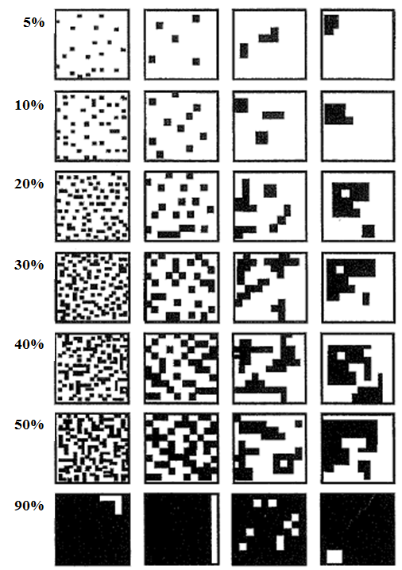
Figure 3. Photo standards from O’Sullivan (2008) Figure 4. Stylised standards from Eyre et al. (2015)
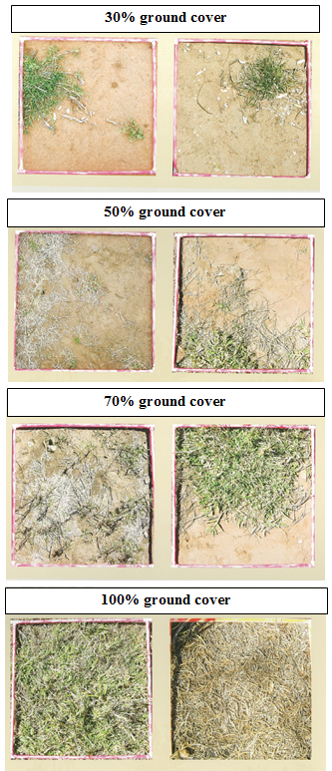

12. Fire damage to fire-sensitive ecosystems and ecosystems that are not fire-dependent
(Use for all ecosystems that are not adapted to fire and the desired regime is fire exclusion {e.g. semi-evergreen vine thicket SEVT, gidgee forest, mangroves, Casuarina equisetifolia communities on foredunes, Pisonia grandis on cays}. Also use for all ecosystems that are not fire-dependent & are not usually planned to be burnt {e.g. Casuarina glauca, saltmarsh/samphire}. Do not use this table for ecosystems that require long fire intervals {e.g. Acacia shirleyi – lancewood; montane heaths} – these are covered in criterion 14).
Note: It is common to have a transitional zone between a fire-sensitive community & adjacent fire-adapted community (e.g. between SEVT & eucalypt open forest) with a degree of ‘ebb & flow’ over time with respect to where the ‘boundary’ of each ecosystem sits. For the purpose of the evaluation consider the ‘boundary’ of the fire-sensitive community to be where the composition is dominated by species of the fire-sensitive community.
Be aware of the future risk of fire damage if high biomass grasses, or other weeds that can promote fire (e.g. lantana), occur on the margins or nearby. You will have identified this risk by completing the HCI – Risk of future invasion by significant pest plants but record relevant details in Table 2.3 on the record sheet for this HCI also (e.g. “While there is currently no evidence of fire there is a high risk of fire because of the large body of Guinea grass abutting the ecosystem.”). Complete Table 2.5 on the record sheet if you think there is a serious risk of weed-promoted fire now or in the future if action is not taken.
Use the description to get a ‘best fit’ – not all parameters may be relevant or exactly ‘fit’ your site especially as the ecosystem recovers.
Level of impact | Description | Condition Class
None-very minor | - No evidence of fire; or  - Only very minor & transitory impacts to the margins; or  - Evidence of ‘historic’ fire barely perceptible. | Good
Minor | - Minor & largely transitory impacts to the margins only.  - Occasional death (at least of the above-ground parts) of trees or shrubs (from either recent or ‘historic’ fire) but little or no penetration beyond the margins.  - Recovery not, or minimally, impacted by pest species (e.g. high biomass grasses or lantana) or changed/lost substrate¹.  - Ecosystem nearing pre-burn state in terms of structure & composition of species that are typical of the ecosystem. | Good with Some Concern
Moderate | - Significant scorch along a substantial portion of the margins causing death (at least of the above-ground parts)  - Fire has penetrated beyond the margins causing death or loss of the above-ground parts of trees or shrubs in up to 15% of the patch.  - Recovery underway but the ecosystem is nowhere near its pre-burn state in terms of structure & composition of species that are typical of the ecosystem.  - Recovery at risk without input of resources because of invasion by pest species (e.g. high biomass grasses or lantana) or changed/lost substrate¹. | Significant Concern
Major | - Extensive burning beyond margins causing death (at least of the above-ground parts)  - Fire has burnt into ecosystem causing death (at least of the above-ground parts of trees or shrubs) in >15% of the patch.  - Minor, if any recovery; ecosystem or large parts thereof appear permanently altered.  - Recovery unlikely or significantly impeded without substantial input of resources because of invasion by pest species (e.g. high biomass grasses or lantana) or changed/lost substrate¹. | Critical
1. The substrate may be markedly altered in terms of structure/chemistry or lost as a result of wind/water erosion because of the removal of cover. You won’t be able to see a change in chemistry but a change in structure may be evident (e.g. soil surface appears baked).

13. Fire damage to peat-based ecosystems
(Use for ecosystems with peat substrate e.g. fens, wet heaths, sedgelands)
Level of impact | Description | Condition Class
None | - No loss of or degradation to peat.  - Species reliant on vegetative reproduction & in particular regeneration from underground organs (e.g. bulbs, rhizomes) are common to abundant throughout. | Good
Minor | - Some minor loss or degradation of the surface peat only.  - Species reliant on vegetative reproduction & in particular regeneration from underground organs (e.g. bulbs, rhizomes) are common to abundant across most of the ecosystem.  - Species not typical of the peat-based system may occur in small patches. | Good with Some Concern
Moderate | - Peat degraded or destroyed in up to 15% of the site with associated loss of the species. | Significant Concern
Major | - Peat degraded or destroyed in >15% of the site with associated loss of the species. | Critical

14. Age class distribution in fire-adapted ecosystems in zones where the primary purpose of fire management is conservation
(Use for all fire-adapted ecosystems in zones where the primary purpose for fire management is conservation.
This criterion cannot be used for ecosystems that are not fire dependent and are therefore not usually planned to be burnt and so have no guidelines for fire intervals – these are covered in criterion 12)
Note: This Health Check Indicator uses different information and criteria to determine condition class at a site (Table 14a) versus the general impression (Table 14b).
Whether fire regimes (fire frequency, intensity, season, type) are appropriate, in areas where the primary purpose of management is conservation (hereafter conservation zone), will be evident to some extent from the presence of key biodiversity/ habitat features & plant species. Some of these are addressed in other indicators (e.g. rainforest invasion; key features for faunal biodiversity in terrestrial ecosystems; recruitment of canopy species). Here, we are focusing on fire frequency as it pertains to fire intervals/ burn ages.
Creating a mosaic of burn ages across a landscape to maintain a varied vegetation age class distribution (including young to mid to old age classes) is an important ‘tool’ for helping to provide the wide range of niches required for the plant & animal species reliant on an ecosystem. Many fauna species are reliant on particular age-classes or stages of habitat development post-fire.
The complexity of the mosaic (in space and time) builds as one burn overlaps another (refer appendix 2 in your Planned Burn Guidelines for details & diagrams).
Patches that are burnt relatively frequently at, or near, the minimum recommended fire interval for an ecosystem are often common in the landscape because of management practices in neighbouring lands &/or fire regimes required in Protection & Wildfire Mitigation Zones. It is therefore important in conservation zones to cater for the balance of the fire frequency ‘spectrum’, so that there is good representation of the mid to longer recommended fire intervals for an ecosystem.
Fire history maps¹ are an essential ‘tool’ for this Indicator – particularly for determining the General impression-condition class. It is necessary to refer to them before &/or during your inspection & to know the recommended minimum & maximum fire intervals for your ecosystem. Local knowledge, and your drive/walk/fly around inspection, will be particularly important if fire history maps lack detail.
At each Health Check site use the criteria described in Table 14a to determine condition class.
For the General impression use the criteria described in Table 14b to determine condition class. These criteria rely on fire history mapping however, your site inspections & drive/walk/fly around are important for assessing the detail and accuracy of the fire history mapping, and informing your determination.
1. Spatial Services staff can assist you in developing age class distribution maps for your park.
Table 14a. Criteria for determining condition class at Health Check sites for Indicator 14
Unless otherwise stated, use the description to get a ‘best fit’ – not all parameters are relevant to all ecosystems. Exclude impacts from other disturbances (e.g. past logging practices may have caused a long-term shift in forest structure such that there are few mature trees).
Alignment to ecological requirements | Description | Condition Class
Very close | - Characteristic# tree & shrub species show no signs of senescing* & juveniles are present.  - Populations of key indicator species¹ are healthy, with a high proportion of mature individuals, or are recovering well.  - Ground stratum is rich (i.e. contains a wide range of species) & healthy.  - Ground stratum is dominated by perennials.  - No ‘fire weeds’² present.  - No sign of ‘dominator species’³ becoming prevalent.  - Mallee form not common in trees that can develop single trunks.  - No sign that the margin/patch is contracting. | Good
Close/reasonable | - Characteristic# tree & shrub species show some early signs of senescing* & may have few juveniles.  - Populations of key indicator species¹ are reasonably healthy/some signs of decline; mature individuals occasional to common.  - Ground stratum contains at least a few different perennial species; dead material layer may be starting to suppress plant growth/ recruitment.  - Annuals are starting to become obvious in the ground stratum  - ‘Fire weeds’² occasionally encountered.  - ‘Dominator species’³ occasional to common.  - Mallee form common in trees that can develop single trunks  - Minor evidence that the margin is contracting (e.g. lancewood); <5% reduction in patch size. | Good with Some Concern
Inadequate | - Characteristic# tree & shrub species are senescing* & lack juveniles.  - Populations of key indicator species¹ are in significant decline; may be few mature individuals.  - Ground stratum is largely dominated by 1 or 2 perennial species or by annuals or is suppressed by accumulated dead material.  - ‘Fire weeds’² common to abundant  - ‘Dominator species’³ common to abundant; suppression evident  - Predominantly mallee form in trees that can develop single trunks  - Moderate evidence that the margin is contracting (e.g. lancewood); 5-15% reduction in patch size. | Significant Concern
Very inadequate | - Characteristic# tree & shrub species are dead or mostly so & juveniles are absent.  - Populations of key indicator species¹ have disappeared, or almost so, from the above-ground community.  - Ground stratum completely dominated by 1 or 2 perennial species or by annuals or ‘choked’ by dead material  - ‘Fire weeds’² abundant to dominant.  - ‘Dominator species’³ dominate.  - Exclusively mallee form in trees that can develop single trunks.  - Major evidence that the margin is contracting (e.g. lancewood); >15% reduction in patch size. | Critical
# Species that characterise (e.g. Banksia in banksia heath; lancewood) the vegetation community. They are usually the dominant/co-dominant species in the canopy or midstratum.
* Declining/ aging/ dying.
1. Examples include: obligate seeders – those species that are typically killed by fire & regenerate only from seed (e.g. Ac. shirleyi lancewood, Banksia plagiocarpa blue banksia, Boronia bipinnata rock boronia, Callitris intratropica coast cypress pine & Jacksonia ramosissima to name a few!) & therefore need sufficient time between fires to reach maturity & produce seed; species, other than obligate seeders, that are typical/characteristic of the ecosystem and known to require particular fire intervals to thrive (e.g. Heteropogon triticeus giant speargrass population may decline if intervals stretch beyond about 4 yrs).
2. Weeds promoted by short fire intervals (fire weeds) (e.g. Praxelis clematidea, Themeda quadrivalvis grader grass, Leonotis nepetifolia lion’s tail).
3. Native species known to have the potential to form dense swards, stands or cover with short or long fire intervals (e.g. Imperata cylindrica blady grass, Acacia hilliana hilltop wattle, Cassytha spp. dodder).
Table 14b. Criteria for determining the General impression-condition class for Indicator 14, based on fire history mapping.

Your evaluation is based on the entire extent of the ecosystem in the conservation zone.
Note: If the ecosystem you are assessing consists of one small patch on the park (e.g. sedge swamp), such that creating a mosaic is impossible, say so in the notes and leave the General Impression blank.
Fire Age Class Definitions:
- Young age class – up to and including the minimum fire interval recommended for the vegetation type.
- Mid age class – whatever period falls between young and old age classes.
- Old age class – includes the last fifth of the period between 0 and the upper recommended fire interval (e.g. if upper fire interval is 20 years then 16-20 years) and somewhat beyond the upper fire interval recommended providing the vegetation type is stable (i.e. it is not transitioning to another vegetation type e.g. eucalypt forest to rainforest; grassland to shrubland).

Alignment to ecological requirements | Description | Condition Class
Very close | - Each age class (young, mid, old) is represented; &  - The majority (>50%) of the ecosystem is represented by the mid to old age classes; &  - No patch is burnt at the same/similar frequency every time; &  - No patch has been burnt so frequently that the fire interval is too short to allow recovery & sexual reproduction of key indicator species (in the case of obligate seeders – at least two seed crops). | Good
Close/reasonable | - One age class (young, mid or old) is missing or poorly represented but redress is readily achievable (e.g. a burn will provide the young age class; fire can be effectively excluded for long enough to enable the mid or old age class to develop); &/or  - The majority (>50%) of the ecosystem is represented by the young age class but redress is readily achievable (as above); &/or  - Some patches are burnt at the same/similar frequency every time.  - No patch has been burnt so frequently that the fire interval is too short to allow recovery & sexual reproduction (in the case of obligate seeders – at least one seed crop). | Good with Some Concern
Inadequate | - Little variation in age classes.  - One or two age classes are missing or poorly represented & redress is difficult (e.g. difficult to burn to provide young age class; fire difficult to exclude for long enough to enable the mid or old age class to develop) &/or  - The majority (>50%) of the ecosystem is represented by the young age class & redress is not readily achievable; &/or  - Most/all patches are burnt at the same/similar frequency every time. | Significant Concern
Very inadequate | - Very little to no variation in age class.  - One or two age classes are missing and redress is impossible or nearly so and/or  - Most (>90%) or all is either recently burnt (i.e. early phase of young age class) or is in, or exceeding, the old age class and redress is impossible or nearly so.  - Most/all patches are burnt very frequently and completely all the time.  - Ecosystem at risk of permanent transformation. | Critical

15. Severe wildfire in fire-adapted wooded ecosystems
(Ratings informed by Grimes 1978).
{Use for ‘wooded’ ecosystems including open woodlands, mallee, low to tall shrublands. Do not use for peat-based ecosystems as these are covered elsewhere}.
The condition of an ecosystem will obviously change with time since a severe wildfire. Your first assessment may occur in the immediate aftermath or several years after it occurred. The descriptions below attempt to cover those circumstances.
Wildfire here includes a fire that started as a planned burn but resulted in unplanned, major impacts typical of a severe wildfire.
Note: Infrequent severe disturbance is a natural component of the ecology of some ecosystems. The ratings given in the table below are based on ‘face-value’ – that is, what the ecosystem looks like after a wildfire and do not take into account whether canopy loss (for example) may be critical to recruitment and the long-term survival of such ecosystems. Contextual notes can be provided in Table 2.3 of the record sheet and for higher level reporting.
Refer to the diagrams (next page) to determine the extent of epicormic growth throughout the canopy.
Record relevant details in Table 2.3 on your record sheet including when the fire occurred.
Unless otherwise stated, use the description to get a ‘best fit’ – not all parameters may be relevant or exactly ‘fit’ your ecosystem especially as it recovers. Exclude impacts from other disturbances (e.g. standing dead trees from thinning/logging practices, non-fire related dieback) from your determination of the condition class.
Level of impact | Description | Condition Class
None  (All criteria must be met) | No obvious signs of impact from wildfire:  - No signs of crown¹ fire (e.g. canopy¹ structure appears ‘normal’).  - No to slight epicormic growth in the canopy¹.  - Very few dead trees, or in the case of shrublands – long-lived shrubs, (no more than you would expect in a natural healthy example of the ecosystem.  - Ecosystem has reached pre-disturbance state (regardless of the initial level of impact) in terms of structure & dominant woody species – latter being typical of the ecosystem. | Good
Minor | Minor signs of damage due to wildfire:  - Some signs of crown¹ fire damage  - Slight epicormic growth in the canopy¹.  - Very few dead trees, or in the case of shrublands – long-lived shrubs, (no to slightly more than you would expect in a natural healthy example of the ecosystem).  - Ecosystem nearing pre-fire state (regardless of the initial level of impact) in terms of structure & dominant woody species – latter being typical of the ecosystem. | Good with Some Concern
Moderate | Significant signs of damage due to wildfire:  - Commonly signs of crown¹ fire damage.  - Moderate epicormic growth in the canopy¹; some may be present on stems.  - Dead trees, or in the case of shrublands – long-lived shrubs, are present (slightly to many more than you would expect in a natural healthy example of the ecosystem).  - Recovery underway but the ecosystem is well off its pre-fire state at least in terms of structure. | Significant Concern
Major | Severe signs of damage due to wildfire:  - Widespread & severe crown¹ fire damage.  - Severe epicormic growth in the canopy¹ &/or stems.  - Dead trees, or in the case of shrublands – long-lived shrubs, are common to abundant.  - No recovery evident &/or expected to require many years. | Critical
1. Crown and canopy here refer to the upper layer of the tallest, dominant woody stratum.
Figure 5. Crown diagrams (from Grimes 1978) – extent of epicormic regrowth
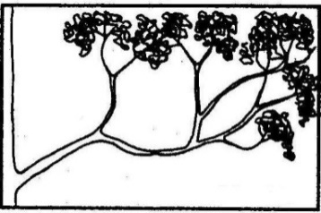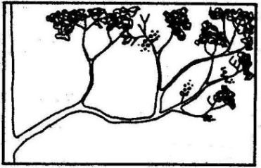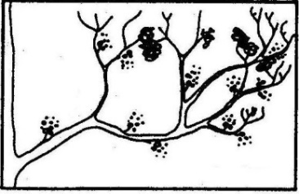
a. None b. Slight c. Moderate d. Severe

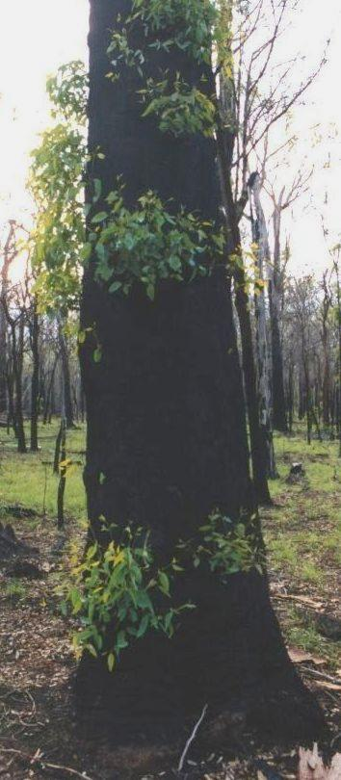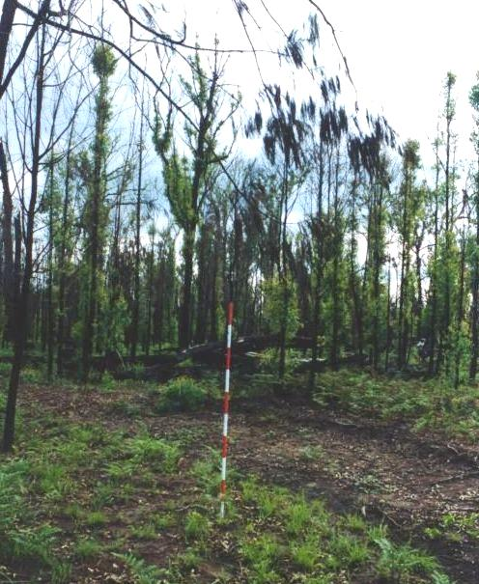
Examples of epicormic shoots. The shoots grow from buds that are protected deep within the bark of trunks, stems and branches. They usually remain dormant unless the actively growing shoots at the top of the plant are damaged or lost. (Photographs: R. Melzer)

16. Severe storm, cyclone or tornado in wooded ecosystems
(Ratings informed by Grimes 1978 & Turton 2008).
(Use for all ‘wooded’ ecosystems including open woodlands, mallee and low to tall shrublands)
The condition of an ecosystem will obviously change with time since disturbance. Your first assessment may occur in the immediate aftermath or several years after it occurred. The descriptions below attempt to cover those circumstances.
Note: Infrequent severe disturbance is a natural component of the ecology of some ecosystems. The ratings given in the table below are based on ‘face-value’ – that is, what the ecosystem looks like after a disturbance and do not take into account whether canopy loss (for example) may be critical to recruitment and the long-term survival of such ecosystems. Contextual notes can be provided in Table 2.3 and for higher level reporting.
Refer to the diagrams to determine the extent of epicormic growth throughout the canopy (Figure 5).
Record relevant details in Table 2.3 on your record sheet including whether the impact was due to storm, cyclone or tornado, and when the event occurred.
Unless otherwise stated, use the description to get a ‘best fit’ – not all parameters may be relevant or exactly ‘fit’ your site especially as the ecosystem recovers. Exclude impacts from other disturbances (e.g. crown fire damage, standing dead trees from thinning/logging practices, non-fire related dieback) from your determination of the condition class.
Level of impact | Description | Condition Class
None  (All criteria must be met) | No obvious signs of impact:  - No obvious defoliation; the canopy¹ looks ‘leafy’.  - Very few dead trees, or in the case of shrublands – long-lived shrubs, (no more than you would expect in a natural healthy example of the ecosystem).  - No or very few broken branches or stems.  - No to slight epicormic growth in the canopy¹. | Good
Minor | - For recent disturbance: partial defoliation of the canopy¹.  - Very few dead trees, or in the case of shrublands – long-lived shrubs, (no to slightly more than you would expect in a natural healthy example of the ecosystem).  - Occasional broken branches &/or stems but rarely tree falls.  - Slight epicormic growth in the canopy¹.  - Ecosystem nearing pre-disturbance state (regardless of the initial level of impact) in terms of structure & dominant woody species – latter being typical of the ecosystem. | Good with Some Concern
Moderate | - For recent disturbance: substantial & widespread defoliation; the canopy¹ looks sparse to very sparse.  - Dead trees, or in the case of shrublands – long-lived shrubs, present (slightly to many more than you would expect in a natural healthy example of the ecosystem).  - Broken branches common.  - Broken stems may be common; occasional tree falls.  - Moderate epicormic growth in the canopy¹; some may be present on stems.  - Recovery underway but the ecosystem is well off its pre-disturbance state at least in terms of structure. | Significant Concern
Major | - For recent disturbance: canopy¹ severely to completely defoliated.  - Dead &/or fallen trees, or in the case of shrublands – long-lived shrubs, are common.  - Stems or crowns of many trees, or in the case of shrublands – long-lived shrubs, are broken, smashed or wind-thrown.  - Severe epicormic growth in the canopy¹ &/or stems.  - No recovery evident &/or expected to require many years. | Critical
1. Canopy here refer to the upper layer of the tallest, dominant woody stratum.

17. Overtopping, erosion and impacts resulting from tidal inundation, major flooding, storm, cyclone, tsunami, land slip or other erosional processes.
(All ecosystems)
The impacts of wind and water on beaches, spits, estuarine ecosystems, cays and islets, and of major floods in riparian systems and floodplains are natural disturbances (though climate change is expected to increase their frequency and severity). They may however, impact on key ecosystems or habitat whose condition we have reason to evaluate over time.
‘Other erosional processes’ cover circumstances where an event such as a landslip may not be able to be attributed to any of the other causal agents listed here.
Note: Dieback resulting from saltwater or freshwater intrusion is covered in the HCI – Tree/shrub health & dieback. Any mention of saltwater/freshwater impacts in the table below is simply to help describe a ‘typical scenario.’
Use the description to get a ‘best fit’ – not all parameters are relevant to every ecosystem, situation or stage of recovery.
Level of impact | Description | Condition Class
No impact | - No obvious shift in the debris or pumice line above usual high tide line, wet season waterline or terrace.  - No sign of recent deposition or movement of large debris¹.  - No roots and tubers appear recently exposed on woody species.  - No other signs of recent erosion or inundation.  - Erosion appears in balance with accretion.  - No signs of plant death/loss from saltwater/ freshwater inundation.  - Few, if any, abandoned unbroken eggs or dead chicks. | Good
Temporary or minor impact  (e.g. rare tidal inundation or overtopping of cay by low severity cyclone) | - Minor debris or pumice present above usual high tide line, wet season waterline or terrace.  - May be signs of recent deposition or movement of large debris¹.  - Minor erosion; few, if any, roots and tubers exposed on woody species.  - Uprooted trees rare.  - Plant death/loss from saltwater/freshwater inundation may be widespread but organic matter largely remains in situ.  - Abandoned unbroken eggs, strewn broken eggs, or dead chicks may be present.  - Vegetation recovery is expected or is well underway. | Good with Some Concern
Mid to long-term; mod to high impact  (e.g. Occasional tidal inundation or overtopping of cay by moderate – severe cyclone) | - Evidence of recent deposition of large debris¹ beyond usual high tide line, wet season waterline or terrace.  - Substantial erosion; widespread exposure of roots and tubers on woody species.  - Uprooted trees occasional to common.  - Erosion appears out of balance with accretion.  - Widespread to complete plant death/loss from saltwater/freshwater inundation.  - Little or no organic matter remains.  - Abandoned unbroken eggs, strewn broken eggs, or dead chicks may be present.  - Vegetation recovery is expected to be slow; may be underway but is poor. | Significant Concern
Long-term to permanent; major impact  (e.g. regular tidal inundation or overtopping of cay by severe cyclone; extreme flood event) | Regular tidal inundation (cay/islet/spit):  - Debris or pumice across the area.  - Severe erosion.  - No evidence of live vegetation; recovery not expected.  - Profile so low as to provide very few, if any, potential nesting sites.  Major flood/ severe storm/ cyclone/ tsunami/ other erosional processes:  - Debris (including large debris¹) strewn across entire area.  - Severe erosion exposing or removing root systems &/or exposing rock across most/all of the area.  - Uprooted trees common to abundant.  - No accretion evident.  - Widespread to complete plant death/loss from saltwater/freshwater inundation.  - Most/all vegetation and organic matter stripped away.  - Abandoned unbroken eggs, strewn broken eggs, or dead chicks may be present.  - Recovery not expected or will require long timeframe (e.g. decades) | Critical
1. For example, large pieces of coral, clams, logs, trees, boulders.

18. Tree/shrub health & dieback
(Use for all ‘wooded’ ecosystems including open woodlands, mallee, low to tall shrublands)
(Ratings informed by Grimes 1978 & Stone 2006)
Dieback is the premature & relatively rapid decline in vigour that may end in the death of trees and shrubs. It can be caused by a wide range of factors which are often interacting. Examples include insect attack, pathogens, salinisation, freshwater intrusion (e.g. mangroves), nutrient enrichment, soil acidification, over-browsing by arboreal mammals, changes in the water table (water logging or water deficit), drought, herbicide overspray & soil-borne pathogens (e.g. phytophthora) (Stol 2006). Bell miner associated dieback occurs in southern Qld (& NSW & Vic) – it is associated with a combination of factors including disturbance that opens up the canopy, dense shrubby understorey (often invaded by lantana), moist soils, reduced fire frequency & the presence of bell miners & psyllids. Significant loss of Pisonia grandis forest occurred on Tryon Island as a result of dieback due to scale insect infestation in the 2000’s. The same outcome was avoided on Wilson Island by the timely release of scale predators (ladybirds). North Qld leaf hopper (Jamella australiae) causes dieback in Pandanus spp. Myrtle rust may cause substantial dieback, and possibly extinction, in the case of some myrtaceous species.
Death, or epicormic regrowth occurring in response to the loss of branches/crowns, caused by storm, cyclone or intense fire is not dieback & is covered elsewhere.
When assessing your ecosystem, be aware of deciduous (winter or dry season) tree species such as poplar gum (E. platyphylla) & yellow-wood (Terminalia oblongata) & of understorey species that appear dead in some seasons (e.g. Cycas spp.).
Note: the term ‘canopy’ in the table is referring to the canopy of the whole ecosystem NOT the canopy of an individual tree. The term ‘leaves’ is used for true leaves, phyllodes (e.g. acacia) & branchlets (e.g. casuarina, cypress). ‘Large’ is relative to the canopy species dominating your community (e.g. a large branch in an acacia forest would be a small branch in a eucalypt forest).
Record relevant details in Table 2.3 sheet including the symptoms (e.g. sooty mould/rust) and/or suspected cause/s of the dieback.

Use the description to get a ‘best fit’ – not all parameters may be relevant or exactly ‘fit’ your site especially as the ecosystem recovers.
Refer to the diagrams to determine the extent of branch death & epicormic growth throughout the canopy.
Tree & shrub health | Description | Condition Class
Very healthy | - No or very few dead trees &/or long-lived shrubs (no more than you’d expect in a healthy ecosystem).  - No or very few dead small or large branches or branchlets in the canopy.  - For eucalypt communities – nil to slight epicormic growth in the canopy.  - No obvious insect or pathogen damage to foliage (i.e. you have to ‘look’ to notice it); few dead or discoloured leaves; little or no honeydew, sooty mould or rust.  - No obvious defoliation; the canopy looks ‘leafy.’  - No ‘unusual’ deaths in the understorey (e.g. dead or yellowing grass trees, macrozamias, Proteaceae). | Good
Healthy | - Very few dead trees &/or long-lived shrubs (no to slightly more than you’d expect in a healthy ecosystem).  - No or very few dead large branches. Some dead branchlets & small branches present here & there throughout the canopy; they may be obvious but don’t give the impression that there is any significant effect on the canopy.  - For eucalypt communities – slight epicormic growth in the canopy.  - Some obvious insect or pathogen damage; honeydew, sooty mould or rust, may be present but overall impression is of a healthy canopy; few dead/ discoloured leaves.  - No obvious defoliation; the canopy looks ‘leafy.’  - No or rare ‘unusual’ deaths in the understorey (e.g. dead or yellowing grass trees, macrozamias, Proteaceae). | Good with Some Concern
Unhealthy | - Dead trees &/or long-lived shrubs present (slightly to many more than you’d expect in a healthy ecosystem).  - Dead large branches as well as small branches & branchlets are common.  - For eucalypt communities – moderate epicormic growth in the canopy; some may be present on stems.  - Insect or pathogen damage; honeydew, sooty mould or rust, widespread & conspicuous; foliage may appear ‘tatty’; leaf death &/or discolouration may be common.  - Some to considerable defoliation; the canopy looks sparse to very sparse AND/OR  - ‘Unusual’ deaths in the understorey (e.g. dead or yellowing grass trees, macrozamias, Proteaceae) are common in patches or widespread | Significant Concern
Very unhealthy | - Dead trees &/or long-lived shrubs are common to abundant.  - Many large branches are dead.  - For eucalypt communities – severe epicormic growth in canopy &/or stems.  - Insect or pathogen damage is widespread & severe; may be heavy honeydew ‘rain’ &/or abundant sooty mould or rust; leaf death widespread & very common to complete.  - Canopy severely to completely defoliated AND/OR  - Most or all individuals of understorey taxon group (e.g. grass trees, macrozamia, Proteaceae) are dead or dying. | Critical
Crown diagrams (from Grimes 1978)
Figure 6. 1a-d Extent of dead branches; 2a-d Extent of epicormic regrowth
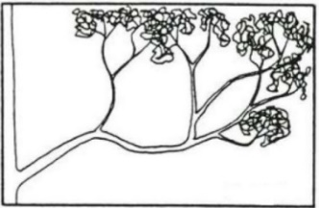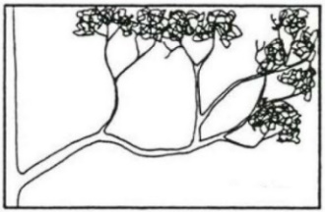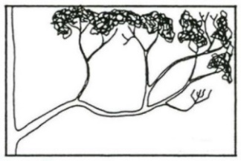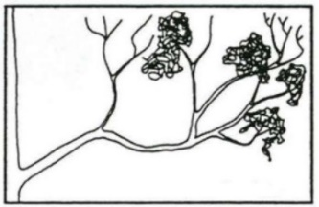
1a. No dead branches 1b. Branchlets dead 1c. Small branches dead 1d. Main branches dead
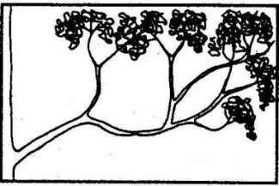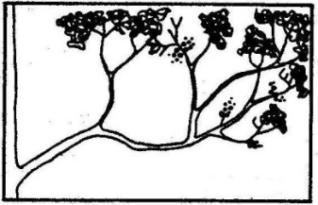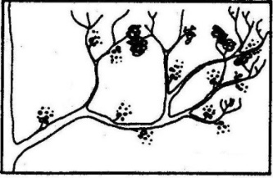
2a. None 2b. Slight 2c. Moderate 2d. Severe

19. Key features for faunal biodiversity in terrestrial ecosystems
(Use for all terrestrial ecosystems – aquatic ecosystems and ecosystems subject to tidal inundation are not included)
Most of the following information is from Meat & Livestock (2012).
Large trees, particularly those with hollows, take a long time to develop & provide essential habitat for many species. In southwest Qld a eucalypt tree can take over 100 years to develop hollows. Non-eucalypts such as mulga & brigalow don’t usually form hollows but they do develop deep cracks or crevices. It can take up to 60 years for them to get to a sufficient size to develop cracks/crevices that are useful shelter for vertebrate fauna.
Shrubs provide critical foraging habitat (e.g. insects, nectar, gums) for mammals such as gliders, small birds & reptiles, sentry sites for ground foraging birds & shelter from predators & aggressive species.
Woody debris (e.g. logs, branches) provides important habitat for many species of plants & animals as well as playing a key role in nutrient accumulation, nutrient cycling & soil protection. They provide sites for seedling establishment, shelter, nesting & foraging. They are a rich substrate for insects, fungi & microorganisms which in turn provide a rich source of food for insects & other lower order fauna, which in turn provide a resource for organisms higher up the food chain.
Leaf litter cover helps protect the soil, is a valuable source of nutrients, particularly for shallow rooted herbs & provides shelter, nesting sites & food resources (e.g. abundant invertebrates) for many fauna species (e.g. legless lizards, fossorial skinks, geckos, blind snakes). Litter helps retain moisture, keeps soil friable to facilitate easy burrowing & provides a relatively constant environment for the incubation of reptile eggs. Where would bush turkeys & orange-footed scrub fowl be without it!
Native perennial ground stratum species – these are typically grasses but in some communities other native perennial herbs may be prevalent (e.g. sedges such as Gahnia aspera). They provide food directly for granivores & herbivores as well harbouring other food resources such as insects. Large grass & sedge tussocks provide shelter for species such as bettongs, dunnarts & reptiles & nesting sites for species such as squatter pigeon & button-quail.
Note: Use the description to get a ‘best fit’– not all parameters are relevant to every ecosystem (e.g. if the ecosystem is naturally devoid of a shrub layer don’t ‘mark it down’ for not having shrub cover). BUT every feature (dot point) that is relevant to your ecosystem must be present to achieve a Condition Class of GOOD.
USE ONLY the last two dot points in each description when assessing grasslands and other non-wooded ecosystems (e.g. herblands) and open shrublands or open woodlands. The latter two naturally have very sparse canopy cover (<10%) and very low stem density. Don’t assess the leaf litter layer in very recently burnt sites.
Description | Condition Class
- Large old trees (size is relative to the species) are common (relative to the overall number of trees typical for the ecosystem)  - Sufficient shrub cover to provide a good resource for feeding & sheltering for small mammals &/or birds & reptiles.  - Woody debris is common to abundant.  - Leaf litter layer is well developed providing good ground cover & sufficient depth/biomass to help retain moisture & provide shelter, nesting & foraging resources.  - Ground stratum is dominated by native perennial species (even if naturally sparse), with exotic or annual species absent or rare. | Good
- Large old trees occur occasionally.  - Sufficient shrub cover to provide a reasonable resource for feeding & sheltering for small mammals &/or birds & reptiles.  - Woody debris is occasionally encountered.  - Leaf litter layer reasonably well developed.  - Ground stratum is dominated by native perennial species (even if naturally sparse), with exotic or annual species occasional to common. | Good with Some Concern
- Large old trees are rare.  - Little shrub cover.  - Woody debris is rarely encountered.  - Leaf litter layer not well developed/sparse.  - Ground stratum dominated by exotic or annual species or substantially lost. | Significant Concern
- Large old trees are absent.  - Little or no shrub cover.  - Woody debris is absent or very rare.  - Leaf litter layer absent or very sparse.  - Ground stratum a monoculture or near monoculture of exotic or annual species or missing. | Critical

20. Recruitment of canopy species
(Use for woodlands to closed forests other than those where recruitment is known to be naturally rare or episodic¹ and results in even-aged stands. Do not use for shrublands)
(Information & methodology modified from Eyre et al. 2011).
The canopy is here defined as the tallest tree layer in the ecosystem plus the sub-canopy &/or emergent trees if they contribute a significant amount of biomass (e.g. Eucalyptus robusta swamp mahogany in swamps/wet heaths; E. orgadophila mountain coolibah in bluegrass downs).
Recruitment is essential to the sustainability of any ecosystem, although in some cases it is naturally rare or episodic¹ & results in even-aged stands; a lack of juveniles of the canopy species is not a sign of an unhealthy ecosystem in such cases. For example, communities where the dominant canopy species are readily killed by fire & regeneration is from seed (e.g. Acacia shirleyi lancewood) or they are killed to the rootstock & resprout (e.g. Acacia harpophylla brigalow). Such ecosystems – e.g. the Acacia-dominated ecosystems; heathlands with fire killed canopy species – are not assessed here.
Some land management practices (e.g. burning, lack of burning, grazing) & natural processes (e.g. drought) can affect the processes required for natural regeneration. Some species may be impacted more than others (e.g. E. tereticornis - Qld bluegum seedlings are highly palatable compared to many other eucalypt species).
Non-rainforest ecosystems: To assess recruitment scan your site to see whether the dominant /co-dominant species have juveniles. Juveniles are defined here as individuals with a dbh (diameter at breast height) of <5cm (measure the largest stem if individuals are multi-stemmed). If you are uncertain about the species name simply determine whether the main ‘types’ have juveniles. For example, in the case of eucalypts – if ironbarks & bloodwoods are the main types present are there juvenile ironbarks & bloodwoods? The presence of seedlings is not used as an indicator because of the potential problems with identification & survivorship but if you are able to identify them - record their presence in Table 3.
Rainforest ecosystems: You are not expected to determine whether juveniles of canopy species (the canopy may be very diverse & multi-layered!) are present. Instead look to see if there are: seedlings of woody plants (regardless of species) – hereafter called woody seedlings; juveniles (regardless of species); juveniles of characteristic emergent species (i.e. emergent trees that are a ‘feature’ of a particular community e.g. bottle trees, hoop pines, bunya pines & palms in various rainforest types). Juveniles of some characteristic emergent species (e.g. hoop pine) will typically be confined to the margins of the ecosystem.

1. Episodic – infrequently; only sometimes and not regularly; requiring particular sequence of events. For example, flowering, fruiting, germination and seedling establishment in some species requires weather events to occur in an appropriate sequence…and that sequence rarely occurs. For example, mass flowering and fruiting of brigalow typically only occurs when there is a wet winter; and germination and seedling establishment requires follow-up spring rains.

Use the description to get a ‘best fit’.
Level of recruitment | Description | Condition class
Sustainable | Non-rainforest  - Juveniles of the dominant & co-dominant canopy species/types are present (frequently/ commonly encountered).  Rainforest  - Woody seedlings are common to abundant.  - Juveniles are common to abundant.  - Juveniles of characteristic emergents frequently/commonly encountered. | Good
Probably sustainable | Non-rainforest  - Juveniles of the dominant & co-dominant canopy species/types are present (occasionally/infrequently encountered) or;  - Juveniles of only some co-dominant canopy species/types are present &/or;  - Juveniles of dominant/co-dominant canopy species/types are absent from the site but occur nearby (near enough for future recolonisation).  Rainforest  - Woody seedlings are occasionally encountered  - Juveniles are occasionally encountered  - Juveniles of characteristic emergents are occasionally encountered. | Good with Some Concern
May not be sustainable | Non-rainforest  - Juveniles of dominant & co-dominant canopy species/types are absent or very rare on-site or nearby but there is little or no sign of the canopy senescing (dying of old age).  Rainforest  - Woody seedlings are rare/uncommon  - Juveniles are rare/uncommon  - Juveniles of characteristic emergents are rare/uncommon. | Significant Concern
Probably unsustainable | Non-rainforest  - Juveniles of dominant & co-dominant canopy species/types are absent or very rare on-site or nearby & the canopy is senescing (dying of old age).  Rainforest  - Woody seedlings are absent or very rare  - Juveniles are absent or very rare  - Juveniles of characteristic emergents are absent or very rare | Critical

Attachment 2 Record sheet: Natural Values Health Checks
Park name (& section):
Recorder/s:
Value¹:
Site Details (for permanent and non-permanent sites):
Site Id. |  | GPS Location  (Datum: ) | Permanent site & photo point established (Y/N) | Approx. site area | Date assessed  (d/m/y)
1
2
3
4
5
Site & photo point definition
In many cases it will not be necessary to precisely define the boundary of your sites in order to ensure that the next time you (or a colleague) do the Health Checks you use exactly the same areas…..a few metres either side will not be a problem. However, in some circumstances the definition of your sites will be important. Is it likely that someone else coming to do the Health Checks in future could be confused about what might or might not be included in the site you are establishing? If so, then provide clear details about your site and its boundary below.
Details about why you chose the site may also be useful.
For permanent sites describe how the photos were/are to be taken. Record photo numbers here also.
Site 1
Site 2
Site 3
Site 4
Site 5

- Use the name provided in the management plan/statement (or Values Assessment & Assessment & Monitoring Strategy if no plan)
Condition class summary
Record: the Condition Class that you determine for the value (ecosystem, vegetation community, habitat) at each inspection site for each Health Check Indicator (HCI); your general impression of the condition of the value across the park for each HCI (based on site results and other observations – note that the Condition Class you record as your general impression IS NOT an ‘average’ of the Condition Classes at each site. It IS your considered opinion about the state of the value across the park based on the site results and your observations as you drive/walk/fly between sites); and the overall condition of the value across the park based on the IUCN definitions (Table 2.2). Where it is relevant, provide information on factors contributing to the Condition Class assigned to an inspection site, in Table 2.3. Details relevant to your determination of the General Impression and Overall Condition Class can be recorded in Table 2.4 and the notes field below Table 2.4, respectively.
If a new location for a significant pest species is found during the inspection it must be recorded in the relevant departmental databases (e.g. Pest Management System, WildNet) and a specimen lodged with Qld Herbarium.
Table 2.1 Record of the Condition Class for a key ecosystem/habitat.
Key: G = good; GC = good with some concerns; SC = significant concern; C = critical; NA = not applicable.
Health Check Indicator | Condition Class |  |  |  |  |  | General impression
 | Site 1 | Site 2 | Site 3 | Site 4 | Site 5 |  | Not an ‘average’!
- Infestations of ecosystem-changing pest plants
- Infestations of pest plants other than ecosystem-changers
- Risk of future invasion by significant pest plants not already present
- Rainforest invasion
- Woody thickening (other than by rainforest species)
- Overgrazing/browsing by feral animals, stray stock or natives
- Trampling, digging or rooting ….. or trampling by visitors
- Impacts on wetlands
- Vehicle impacts
- Dumping
- Ground cover
- Fire damage to fire-sensitive and non fire-dependent ecosystems
- Fire damage to peat-based ecosystems
- Age class distribution in fire-adapted ecosystems in conservation….
- Severe wildfire in fire-adapted wooded ecosystems
- Severe storm, cyclone or tornado in wooded ecosystems
- Overtopping, erosion and associated impacts resulting……… from……
- Tree/shrub health and dieback
- Key features for faunal biodiversity in terrestrial ecosystems
- Recruitment of canopy species
Overall Condition Class (refer Table 2.2)

Table 2.2 Overall Condition Class – what the categories mean
Good | The Key Value is in good condition and is likely to be maintained for the foreseeable future, provided the current conservation measures are maintained.
Good with  some concern | The Key Value is likely to be essentially maintained over the long-term with minor additional conservation measures to address existing concerns.
Significant concern | The Key Value is threatened by a number of current and/or potential threats. Significant additional conservation measures are required to preserve the value over the medium to long-term.
Critical | The Key Value is severely threatened. Urgent additional large-scale conservation measures area required
Trigger for management response: |  | Maintain effort | Minor attention required | Requires prompt decision &/or planned course of action | Requires urgent decision re course of action
Table 2.3 Information, including key issues/threats, relevant to determining the condition of the value at Site/s ______
Health Check Indicator | Notes  If you don’t use a separate notes page for each site then record the relevant site number below against each set of notes
- Ecosystem-changing pest plants
- Pest plants other than ecosystem-changers
- Risk of future invasion by significant pest plants
- Rainforest invasion
- Woody thickening (other than by rainforest species)
- Over-grazing/over-browsing by feral animals, stray stock or native animals

- Trampling, digging or rooting … or trampling…
- Impacts on wetlands
- Vehicle impacts
- Dumping
- Ground cover
- Fire damage to fire-sensitive & non fire-dependent ecosystems
- Fire damage to peat-based ecosystems
- Age class distribution in fire-adapted ecosystems…
- Severe wildfire in fire-adapted ecosystems
- Severe storm, cyclone, tornado
- Overtopping, scouring & assoc. impacts resulting …
- Tree/shrub health and dieback
- Key features for faunal biodiversity in terrestrial
- Recruitment of canopy species

Table 2.4 Information relevant to the determination of the General Impression for a Health Check Indicator.
Health Check Indicator | Notes
- Ecosystem-changing pest plants
- Pest plants other than ecosystem-changers
- Risk of future invasion by significant pest plants
- Rainforest invasion
- Woody thickening (other than by rainforest species)
- Over-grazing/over-browsing by feral animals, stray….
- Trampling, digging or rooting ….or trampling by…
- Impacts on wetlands
- Vehicle impacts
- Dumping
- Ground cover
- Fire damage to fire-sensitive & non fire-dependent eco…
- Fire damage to peat-based ecosystems
- Age class distribution in fire-adapted ecosystems…
- Severe wildfire in fire-adapted ecosystems
- Severe storm, cyclone, tornado
- Overtopping, scouring & assoc. impacts resulting…
- Tree/shrub health and dieback
- Key features for faunal biodiversity in terrestrial ecosystems
- Recruitment of canopy species
Notes relevant to the determination of the Overall Condition Class:
New or emerging issues noticed (anywhere on the park) while undertaking an inspection
Make a note in Table 2.5 of localised disturbances, biosecurity breaches or issues that require attention to prevent degradation and significant resource input in the future (e.g. a new infestation of an ecosystem-changing weed; illegal dumping; graffiti at a cultural site; pollution event; erosion; tree-fall across a track resulting in new tracks) or pose risk to life and property, or significantly impact on visitor experience (e.g. overcrowding; excessive noise; conflict amongst user groups).
Determine, with your in-line managers, an agreed management response and desired outcome – record these in Table 2.5 (or in a separate project plan if warranted). During future inspections evaluate the effectiveness of the management response in achieving the stated desired outcome – use the ratings below to do so.
Effectiveness of management response | Rating
Desired outcome achieved | 1
Heading towards desired outcome | 2
Situation static | 3
Heading away from desired outcome | 4
Table 2.5 Details of localised disturbances/issues requiring attention and effectiveness of management response.
Y = yes; N = no; P = partially
ISSUE 1
Date of initial record (d/m/yr): |  | GPS location (including datum):
Issue & current condition:
Agreed management response (AMR):
Desired outcome:
 | Follow-up inspections
Date (d/m/yr)
AMR implemented (Y/N/P)
Rating:
ISSUE 2
Date of initial record (d/m/yr): |  | GPS location (including datum):
Issue & current condition:
Agreed management response (AMR):
Desired outcome:
 | Follow-up inspections
Date (d/m/yr)
AMR implemented (Y/N/P)
Rating:
ISSUE 3
Date of initial record (d/m/yr): |  | GPS location (including datum):
Issue & current condition:
Agreed management response (AMR):
Desired outcome:
 | Follow-up inspections
Date (d/m/yr)
AMR implemented (Y/N/P)
Rating:

