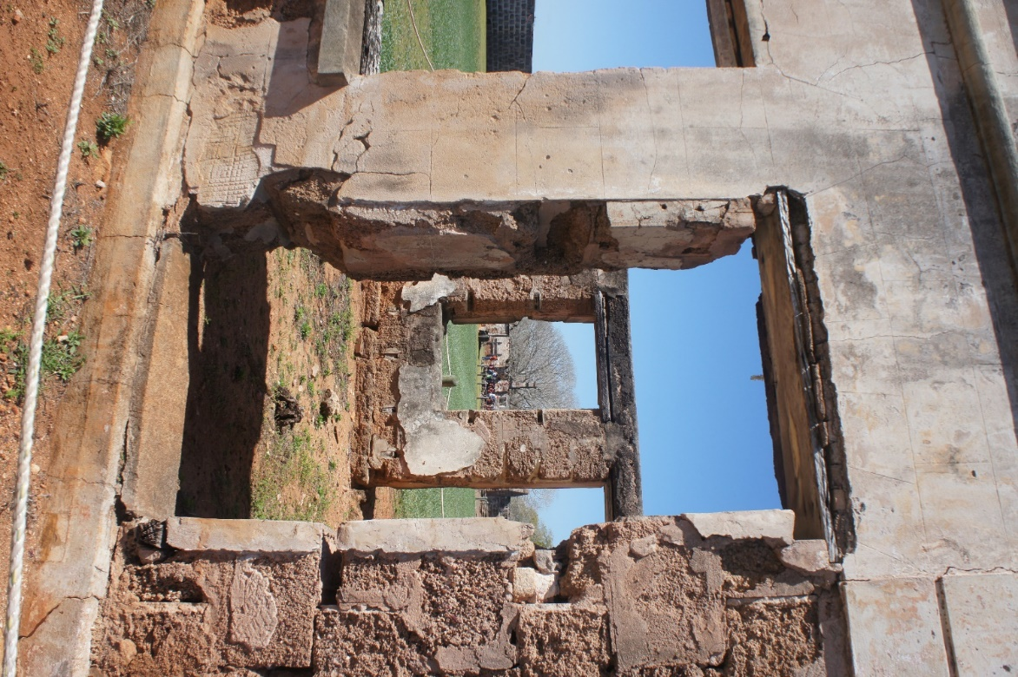

July 2019
Historic Values Health Checks
A guide to undertaking Health Checks for key historic values
Version 1.5

Environment and Science

© State of Queensland, 2019.

July 2019
Front cover photographs: St Helena Island National Park © J. Smith

The Queensland Government supports and encourages the dissemination and exchange of its information. The copyright in this publication is licensed under a Creative Commons Attribution 3.0 Australia (CC BY) licence.
Under this licence you are free, without having to seek our permission, to use this publication in accordance with the licence terms.
You must keep intact the copyright notice and attribute the State of Queensland as the source of the publication.
For more information on this licence, visit http://creativecommons.org/licenses/by/3.0/au/deed.en

ISSN (delete if not required)
ISBN (delete if not required)
CCI job number
Disclaimer
This document has been prepared with all due diligence and care, based on the best available information at the time of publication. The department holds no responsibility for any errors or omissions within this document. Any decisions made by other parties based on this document are solely the responsibility of those parties.
If you need to access this document in a language other than English, please call the Translating and Interpreting Service (TIS National) on 131 450 and ask them to telephone Library Services on +61 7 3170 5470.
This publication can be made available in an alternative format (e.g. large print or audiotape) on request for people with vision impairment; phone +61 7 3170 5470 or email <library@des.qld.gov.au>.

Citation
Melzer R, Pyke M & Smith J. 2019. Historic Values Health Checks. A guide to undertaking Health Checks for key historic values. Version 1.5, July 2019. Ecological Assessment Unit, Queensland Parks and Wildlife Service & Partnerships, Department of Environment and Science, Queensland Government.

Acknowledgements
Thanks to Julia Hargreaves (Cultural Heritage Unit), Sherri Tanner-McAllister (Planning Unit), John Olds (Ecological Assessment Unit), Harry Hines (Ecological Assessment Unit) and participants in the February 2017 Health Check training workshop for valuable discussions and contributions. Thanks to Kym Thomson (Ecological Assessment Unit) for editorial support and Susan Tilgner (Planning Unit) for formatting.

Contents
Introduction 1
How to do Health Checks and complete the record sheets 3
New or emerging issues noticed (anywhere on the park) while undertaking an inspection 6
References 7
Attachment 1 Health Check Indicators 8
1. Vertebrate animal damage 8
2. Invertebrate animal damage 8
3. Vegetation – direct mechanical damage 9
4. Vegetation – increased fire risk 9
5. Vegetation invasion 10
6. Ground surface modification 10
7. Damp (rising/falling) 11
8. Weather events & weathering – exposure to water, wind and /or sun 12
9. Fire damage 13
10. Tree/shrub health & dieback 14
11. Visitor impacts including vandalism, theft and other inappropriate behaviour 16
12. Visitor safety and restricted access 17
13. Inappropriate management 17
Attachment 2 Record sheet: Historic Values Health Checks 18

Introduction
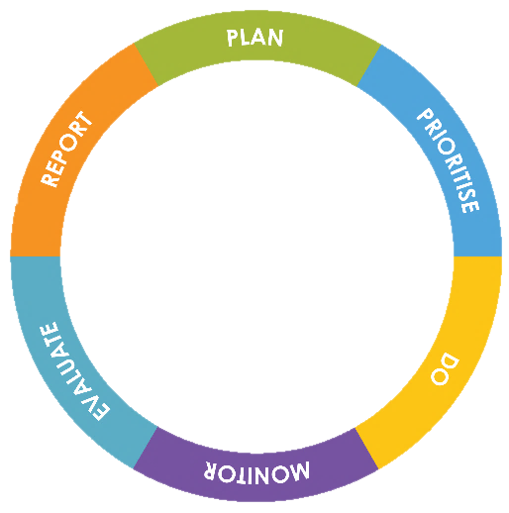
Queensland’s parks, forests and reserves are places we want to protect for future enjoyment and wellbeing. What makes these places special are the presence and diversity of natural, cultural, social and economic values. These areas experience natural cycles—they live and breathe—and therefore our management needs to be dynamic too. The Queensland Parks and Wildlife Service and Partnerships (QPWS&P), within the Department of Environment and Science (DES), applies a contemporary management process that is based on international best practice and targets management towards the most important features of each park: their key values.
VALUES-BASED MANAGEMENT FRAMEWORK
The Values-Based Management Framework (VBMF) is an adaptive management cycle that incorporates planning, prioritising, doing, monitoring, evaluating and reporting into all areas of our business. This enables the agency to be more flexible and proactive and to improve management effectiveness over time.
By assessing the condition of an area’s key values, QPWS&P can prioritise management efforts, balancing the importance of values and threats with our custodial obligations. Monitoring the condition of values and evaluating our performance is integral to closing the loop on the adaptive management process.
Health Checks are tools for efficiently and routinely assessing the condition of key park values. They use simple visual ‘cues’ and require no specialist skills or equipment and have been designed to work state-wide. Health Checks are the basis for the evaluation of the condition of historic values through time for the majority of estate managed by Queensland Parks and Wildlife Service (hereafter ‘park’ regardless of tenure) (Fig. 1). Where highly significant values require management intervention on a high priority park, detailed, targeted monitoring may be warranted (Melzer 2015), and is identified in the Historic Cultural Heritage Strategy (HCHS) or Monitoring and Research Strategy.
The key historic values on which to undertake Health Checks are selected and defined¹ during the Key Values Assessment workshop (QPWS&P, 2019). The current² condition and desired condition for the historic value is determined along with the strategic direction for its management. Health Checks are subsequently undertaken during park inspections by local staff³. Health Checks are undertaken annually on our ‘Top 50’ priority parks; elsewhere their frequency is guided by the park’s Levels of Service (i.e. management standard) and magnitude of the greatest risk to the key value from threats (Fig. 2), and observations and outcomes of recent Health Check assessments. Over time the information from Health Checks will provide a good indication of the trend in condition, and hence alignment with the stated desired condition for the value, and so help determine whether the current management approach is appropriate. The trend in condition (‘health’) for the key historic value/s on a park are ‘rolled up’ for high level management evaluation and reporting purposes (e.g. State of the Parks Report).
Health Checks provide a critical opportunity for the management unit to regularly review the effectiveness of their management in maintaining or recovering key values. The Health Checks must be reviewed by the management unit upon completion to determine whether, for example: current management actions are appropriate or need adjusting; urgent intervention is required; and additional funds are needed. In-line managers (to whatever level is appropriate) must be alerted to concerns about the condition of a value (whether at a specific site or across the whole park), or an emerging issue on the park, and a decision on a response – which may be to do nothing – must be made and documented. Relevant results should be discussed in forums such as the Fire and Pest Referral Group meetings.

1. What constitutes the key value must be defined clearly in the Values Assessment. For example: is the entire homestead complex the key value or only the primary dwelling; is the whole graveyard the key value or specific graves.
2. If the current condition of the value is not known it should, if at all possible, be determined soon after the Values Assessment workshop.
3. Members of local bushwalking clubs or historical societies and the like may also be willing/keen to undertake Health Check assessments in locations that are time consuming to access but are part of the clubs program of activities. Appropriate training and oversight by QPWS&P staff is required.
This document provides: a) guidelines for undertaking Health Checks for historic values; b) descriptions of the Health Check Indicators (Attachment 1) and: c) a record sheet (Attachment 2). Note that the Heath Check component of a Monitoring and Research Strategy must be developed prior to undertaking Health Checks. This enables questions about timing and site selection (e.g. number of sites, location) to be workshopped and appropriate guidance (or specifications) to be documented in the Strategy, as well as approval by line managers.
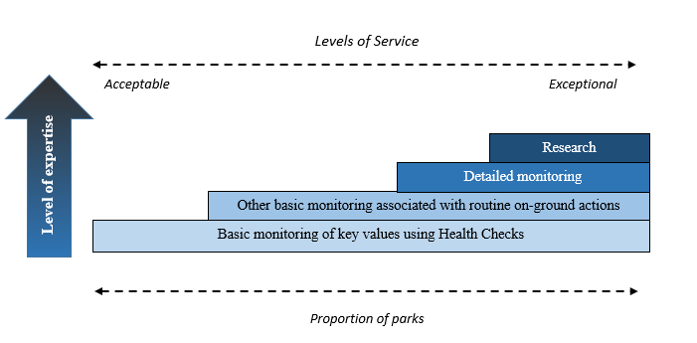

Figure 1. Hierarchical framework for monitoring and research on QPWS&P estate.

 | Highest overall threat rating
Level of Service | Low | Moderate | High | Very High
Exceptional | Every 3 years | Every year | Every year | Every year
Very high | Every 3 years | Every year | Every year | Every year
High | Every 3 years | Every 2 years | Every year | Every year
Medium | Every 5 years | Every 2 years | Every 2 years | Every year
Acceptable | Every 5 years | Every 3 years | Every 2 years | Every year

Figure 2. Risk matrix used to guide the minimum frequency of Health Checks. Note that Health Checks are undertaken annually in our ‘Top 50’ priority parks.

How to do Health Checks and complete the record sheets
- Determine the most appropriate time period/season of the year to assess the condition of the key value. Endeavour to undertake the assessment in the same time period/season each year. Note that where important, the timing for Health Checks is specified in the Historic Cultural Heritage Strategy (HCHS) or Monitoring and Research Strategy (M&RS). During or soon after a peak visitation period may to be most informative.
- The inspection should ideally be undertaken by at least two observers. It may be advantageous, but is not mandatory, for one of the observers to have participated in the previous year. A copy of the previous year’s Health Checks, including photographs from permanent sites, should be carried with you for reference.
- Selecting sites
The number and location of sites, particularly permanent sites, are best determined during development of the HCHS or M&RS.
For many key historic values there will be little, if any, choice when it comes to selecting a site/s because the value is unique (e.g. Pallarenda quarantine station) or only occurs in a small number of locations (e.g. two stone huts located in different parts of the park).
Where the value is extensive (e.g. convict built road), or there are many examples (e.g. a dozen wells), access as much of it or as many examples as possible to get an ‘overview’ of the condition but also select ‘representative sites’ at which to undertake the assessments. A site should be relatively ‘uniform’ in terms of usage, management intent and factors such as topography. For example: a portion of convict built road that is frequently accessed by visitors and one that is rarely accessed would be assessed as two separate sites; and a portion subjected to flooding would be assessed separately from a portion that never gets flooded.
- Defining your site
Determine what constitutes your site (if this has not already been specified in a HCHS or A&MS). For example, if your key historic value is a homestead complex your site would usually include all of the infrastructure that constitutes the complex and the associated grounds. If part of the key value has a different management intent from the rest then a separate Health Check is required. For example, if a whole pastoral property is on the Qld Heritage Register but it has been determined that some assets (e.g. homestead) will receive more attention/resources than others (e.g. outbuildings) then a Health Check must be undertaken for the homestead separate to the one for the outbuildings. Seek advice prior to going in the field if you are at all uncertain. Define your site as clearly as possible on the first page of the record sheet (Attachment 2).
The size of each ‘representative site’ (i.e. the area of the value that you include in your inspection) must be recorded on the record sheet as a quantitative measure (e.g. 10m², 20x40m) unless the Site Id. clearly defines the area encompassed in the assessment (e.g. all buildings and grounds within the perimeter fence; all built infrastructure and the orchard).
- It is not mandatory to go back to exactly the same site/s each year if you are dealing with a value that has plenty of representative sites from which to choose (e.g. many wells) but in that case it will usually be highly beneficial to revisit at least some of the same sites each year. However, for most historic values there will be one or few options (e.g. the historic homestead complex; two stone huts) and you will be returning to the same sites each year.
- It is advisable to incorporate standard photo-monitoring points into your Health Checks.
- A record sheet (Attachment 2) has to be completed for each key value. The standard record sheet allows up to five sites per key value (Table 2.1, Attachment 2). If more than five sites are required to get an adequate representation of condition (only likely for extensive key values with complex management issues) add extra columns.
- Health Check Indicators (described in Attachment 1) are used to assess the condition of the key value. They are based on disturbance/damage and features that provide a good indication of the condition. Table 1.1 lists Health Check Indicators appropriate to various types of key values – every Health Check Indicator that applies to your value MUST be used in your assessment.
Use the tables in Attachment 1 to determine the Condition Class, from Good to Critical, for each Health Check Indicator. Ensure that you read the information and instructions provided for each Health Check Indicator every time! Do not assume you’ve remembered them correctly from last time!
NOTE: The assessment is based on visual inspection only. There must be no destructive interference with the value.
- For each Health Check Indicator, the Condition Class that you determine for each site must be recorded on the record sheet.
- Your general impression of the condition of the key value across the park for each Health Check Indicator is also recorded (unless the value occurs only at one site). Note that this general impression IS NOT an ‘average’ of the Condition Classes you recorded at each site. It IS your considered opinion about the state of the key value across the park based on the site results AND your observations as you drive, walk, paddle or fly between sites!
- Where it is relevant (refer box 1), provide information in Table 2.3 of your record sheet on factors contributing to the Condition Class assigned to the value at an inspection site, and in Table 2.4 for your general impression for a Health Check Indicator.
- When you have completed your inspection of a key value (i.e. assessments at all Health Check sites and your general impression across the park) record the Overall Condition Class (Table 1.2; note that this table is repeated on the record sheet for your convenience as Table 2.2) based on all of the Health Check Indicators.
Make sure that you make this decision on the day of the inspection or at least within a few days of it. It is intended to be a ‘considered opinion’ guided by the site results and your other observations.
Make notes (refer box 1), in the space provided below Table 2.4 on the record sheet, about your decision especially if you assign an Overall Condition Class of Significant Concern or Critical.

Box 1 Make good use of notes!
Notes are important! Ask yourself, for example – “Will it be obvious to someone reading this record sheet (or to me in 12 months’ time) why I have assigned a ‘General Impression’ of Significant Concern to the Health Check Indicator Vertebrate animal damage; or why I have assigned Significant Concern as the Overall Condition Class for the value?” If it’s not – then make some detailed notes on Table 2.4 of the record sheet.

Table 1.1 List of Health Check Indicators and the types of Key Values (ecosystems) to which they are applied¹.
Indicator | Key Values (ecosystems)
1.Vertebrate animal damage | All except values with the strategic management direction (SMD) – ‘let nature take its course¹.’
2.Invertebrate animal damage | Values composed of timber, fibre, stone, brick or rock.  Do not include plants (e.g. historic plantings) – invertebrate impact on plants is covered by indicator 10 Tree/Shrub health & dieback.  Do not include values with the SMD – ‘let nature take its course.’
3.Vegetation – direct mechanical damage | All that consist of constructed/made fabric².  Do not include values with the SMD – ‘let nature take its course.’
4.Vegetation – increased fire risk | All that are flammable or that can be damaged by heat (e.g. stone, mortar) including historic plantings.  Do not include values with the SMD – ‘let nature take its course.’
5.Vegetation – invasion | All except values with the (SMD) – ‘let nature take its course¹.’
6.Ground surface modification (e.g. erosion, subsidence, compaction, altered drainage) | All except values with the (SMD) – ‘let nature take its course¹.’
7.Damp (rising/falling) | All that consist of built, or human modified, fabric regardless of construction material.  Do not include values with the SMD – ‘let nature take its course.’
8.Weather events & weathering – exposure to water, wind, sun | All except values with the (SMD) – ‘let nature take its course¹.’
9.Fire damage | All that are flammable or that can be damaged by heat (e.g. stone, mortar) including historic plantings.  Do not include values with the SMD – ‘let nature take its course.’
10. Tree/shrub health & dieback | Historic plantings; heritage listed plants.  Do not include values with the SMD – ‘let nature take its course.’
11.Visitor impacts including vandalism, theft and other inappropriate behaviour | All
12. Visitor safety/restricted access | All
13. Inappropriate management | All
1. Values for which the strategic management direction is ‘let nature take its course’ are often actively managed for public safety. If the deterioration of the value is such that there is a risk to public safety this must be recorded as an emerging issue in Table 2.5. A decision on a response must be made and documented.
2. Fabric as defined by the Burra Charter (2013) means all the physical material of the place including elements, fixtures, contents, and objects. It includes building interiors and sub-surface remains, as well as excavated material.

Table 1.2 Overall Condition Class – what the categories mean.
(from IUCN 2012 & Osipova et al. 2014)
Good | The Key Value is in good condition and is likely to be maintained for the foreseeable future, provided that current conservation measures are maintained.
Good with some concern | The Key Value is likely to be essentially maintained over the long-term with minor additional conservation measures to address existing concerns.
Significant concern | The Key Value is threatened by a number of current and/or potential threats. Significant additional conservation measures are required to preserve the value over the medium to long-term
Critical | The Key Value is severely threatened. Urgent additional large-scale conservation measures are required or the value may be lost.

New or emerging issues noticed (anywhere on the park) while undertaking an inspection
When you are undertaking the inspection you may notice localised disturbances (point source or linear), breaches (e.g. in the weather tightness of a building; damage that permits unauthorised entry), issues that require attention to prevent degradation and significant resource input in the future (e.g. graffiti at a cultural site; pollution event; erosion; tree-fall across a track resulting in new tracks; a new infestation of an ecosystem-changing weed), or pose risk to life and property, or significantly impact on visitor experience (e.g. overcrowding, excessive noise, conflict amongst user groups). Table 2.5 is provided as part of the record sheet to note relevant information.
Your in-line manager/s must be alerted to the issue as soon as possible after the inspection and a decision made about the management response to be undertaken.
This table must be taken on future inspections so that the effectiveness of the management response can be evaluated.

References
(References used in the Guidelines and Attachment 1)
IUCN 2012. Conservation Outlook Assessments - guidelines for their application to natural World Heritage Sites
Version 1.2 (final).
Melzer R. 2015. QPWS Monitoring Framework. Ecological Assessment Unit, Operational Support, Queensland Parks and Wildlife Service, Department of National Parks, Sport and Racing.
Osipova E, Shi Y, Kormos C, Shadie P, Zwahlen C & Badman T. 2014. IUCN World Heritage Outlook 2014: A conservation assessment of all natural World Heritage sites. Gland, Switzerland: IUCN. 64pp.
Queensland Parks and Wildlife Service & Partnerships (QPWS&P) 2019. Planning User Guide: Values-Based Management Framework Version 2 Planning Unit, Parks Services, Queensland Parks and Wildlife Service & Partnerships, Department of Environment and Science, Queensland Government.
The Burra Charter: The Australia ICOMOS Charter for places of cultural significance, 2013.

.

Attachment 1 Health Check Indicators

1. Vertebrate animal damage
Livestock, native fauna (e.g. macropods, possums, birds) and feral animals (e.g. pigs, brumbies and camels) can threaten historic cultural heritage sites. Places such as graves, historic vegetation and dwellings can be damaged by animals digging, rubbing, licking (to obtain salt) nesting, displacing roofing and otherwise making physical contact with vulnerable structures. Items in historic tips can be displaced or broken.
Level of invasion | Description | Condition Class
None | No deterioration/damage/disturbance evident. | Good
Minor | - Damage/disturbance is minor and temporary/repairable.  - Structural integrity (‘soundness’) is not impaired/threatened. | Good with Some Concern
Moderate | - Damage/disturbance is substantial but all/largely reversible/repairable if addressed promptly.  - Structural integrity (‘soundness’) is at risk. | Significant Concern
Major | - Damage/disturbance is substantial and some or all is permanent.  - Substantial funding and urgent attention required to redress the damage and prevent collapse/loss of original fabric.  - Value is at risk. | Critical

2. Invertebrate animal damage
Visually inspect your value for damage caused by invertebrates such as termites (‘white ants’), borers and mud wasps. Termite infestations can also sometimes be detected by listening!
Termites perhaps present the greatest risk to the long-term viability of historic structures, in particular, timber-framed structures. Contact with soil, vegetation, or damp conditions can expose structures to risk of termites.
Level of impact | Description | Condition Class
None | No deterioration/damage evident. | Good
Minor | No signs of termites but signs of minor damage from other invertebrates and:  - Damage is minor and temporary/repairable.  - Structural integrity (‘soundness’) is not impaired/threatened. | Good with Some Concern
Moderate | Signs of early/limited termite infestation and/or:  - Damage from other invertebrates is substantial but all/largely reversible/repairable if addressed promptly.  - Structural integrity (‘soundness’) is at risk. | Significant Concern
Major | Signs of established/extensive termite infestation and/or:  - Damage from other invertebrates is substantial and some or all is permanent.  - Substantial funding and urgent attention required to redress the damage and prevent collapse/loss of original fabric.  - Value is at risk. | Critical

3. Vegetation – direct mechanical damage
Vegetation can damage cultural values by direct mechanical means such as rubbing or root/limb penetration. Strangler figs and robust vines can cause major structural damage. Vines and creepers can have deleterious effects on mortar or cement.
Use the descriptions to get the ‘best fit.’
Level of impact | Description | Condition Class
None | No deterioration/damage evident and no apparent risk of it occurring. | Good
Minor | Vegetation that has the potential to cause damage is present but no damage is apparent or:  - Damage is minor and temporary/repairable.  - Cause of damage easily redressed.  - Structural integrity (‘soundness’) is not impaired/threatened. | Good with Some Concern
Moderate | - Damage is substantial but all/largely reversible/repairable if addressed promptly.  - Cause of damage may be costly to redress.  - Structural integrity (‘soundness’) is at risk. | Significant Concern
Major | - Damage to cultural fabric is substantial and some or all is permanent.  - Substantial funding and urgent attention required to redress the damage and prevent collapse/loss of original fabric.  - Cause of damage very difficult and costly to redress.  - Value is at risk. | Critical

4. Vegetation – increased fire risk
The encroachment of flammable vegetation types or accumulation of plant litter around historic places can increase the risk and severity of damage by fire.
Use the descriptions to get the ‘best fit.’
Level of impact | Description | Condition Class
None | - No build-up of fuel or vegetation at or near the site that poses a fire risk.  - Fuel-reduced zones (e.g. fire control lines), if present, are maintained. | Good
Minor | - There is light vegetation or fuel build up near the cultural fabric such that it is possible for a fire to occur.  - The vegetation/fuel is sufficiently minor that it can be removed during a routine patrol.  - Fuel-reduced zones (e.g. fire control lines), if present, are maintained at least prior to the fire season or require minor maintenance. | Good with Some Concern
Moderate | - There is enough fuel sufficiently close to, or in contact with, the fabric of the place that it is possible or likely that a fire will occur  - Clean up requires more time than available on a routine patrol.  - Fuel-reduced zones (e.g. fire control lines), if present, are poorly maintained. | Significant Concern
Major | - There is enough fuel sufficiently close to, or in contact with, the fabric of the place that it is likely or almost certain that a fire will occur.  - Clean up requires a major, coordinated effort and/or heavy equipment.  - Fuel-reduced zones (e.g. fire control lines), if present, will be completely ineffective if a fire occurs under ‘normal’ conditions. | Critical

5. Vegetation invasion
Historic places, including cemeteries, roads/trails and historic plantings (e.g. gardens, orchards, arboreta, experimental plots and plantations) can be overgrown by native and/or non-native plants.
Note: The term pest is used in the table below to describe any plant that is not part of an original (or restored) planting or is otherwise ‘in the wrong place’. The term damage refers to overgrowth not mechanical damage to a structure. The latter is covered under Vegetation – direct mechanical damage.
Use the descriptions to get the ‘best fit.’
Level of impact | Description | Condition Class
None | - There is no invasion by pest plants that have the potential to damage the historic place. | Good
Minor | - Scattered individual pest plants that have the potential to damage the historic place are present.  - They can easily be removed and have done no permanent damage. | Good with Some Concern
Moderate | - Invasion by pest vegetation is such that expert advice and a coordinated effort are required to remove it.  - The types of pest plants present, and the extent of invasion, pose significant risk to the integrity/survival of the historic place if not removed.  - Substantial damage has occurred and/or remediation will be time consuming/costly but is possible for most or all the historic place. | Significant Concern
Major | - Invasion by pest vegetation is extensive and/or has caused severe damage some, or much, of which may be irreversible or soon will be.  - A restoration program designed/informed by experts will be required.  - A funding submission will be required. | Critical

6. Ground surface modification
Water runoff, soil erosion, compaction, subsidence and/or altered drainage can threaten the integrity of structures and sites.
NB: Abbreviation > means ‘greater than’
Use the descriptions to get the ‘best fit.’
Level of impact | Description | Condition Class
None | - Little or no (0-5% of site) evidence of runoff, altered drainage, soil movement or compaction, and;  - No deterioration/damage/disturbance evident. | Good
Minor | - >5-15% of site impacted by runoff, altered drainage, soil movement or compaction.  - Damage/disturbance is minor and temporary/repairable.  - Structural integrity (‘soundness’) is not impaired/threatened. | Good with Some Concern
Moderate | - >15-25% of site impacted by runoff, altered drainage, soil movement or compaction.  - Damage/disturbance is substantial but all/largely reversible/repairable if addressed promptly.  - Structural integrity (‘soundness’) is at risk. | Significant Concern
Major | - >25% of site impacted by runoff, altered drainage, soil movement or compaction.  - Damage/disturbance to cultural fabric is substantial and some or all is permanent.  - Substantial funding and urgent attention required to redress the damage and prevent collapse/loss of original fabric.  - Value is at risk. | Critical

7. Damp (rising/falling)
The impact from rising or falling damp on a building or other built fabric (e.g. grave/road markers) can be significant, and can threaten the structural integrity. Falling damp usually arises where guttering or flashings fail. Rising damp may occur when a damp proof course/membrane fails and/or there is direct impact from a watering system or a garden/vegetation abuts the structure.
Signs/symptoms include: mouldy smell; corrosion; fungal/algal growth; rot; crumbling brickwork and mortar.
Use the descriptions to get the ‘best fit.’
Level of impact | Description | Condition Class
None | No deterioration/damage evident. | Good
Minor | - There are some early signs of damp.  - Damage is minor and temporary/repairable  - The cause is able to be readily redressed (e.g. repair overflowing guttering).  - Structural integrity (‘soundness’) is not impaired/threatened. | Good with Some Concern
Moderate | - Damage is substantial or will become so without urgent remedial intervention.  - Damage all/largely reversible/repairable if addressed promptly.  - Likely cause of damage is not easily repaired; repairs will be costly (e.g. failure of a damp proof course).  - Structural integrity (‘soundness’) is at risk. | Significant Concern
Major | - Damage to cultural fabric is substantial and some or all is permanent.  - Substantial funding and urgent attention required to redress the damage and prevent collapse/loss of original fabric.  - Value is at risk. | Critical

8. Weather events & weathering – exposure to water, wind and /or sun
Total or partial loss of critical structural elements such as the roof, wall cladding and guttering greatly accelerates the deterioration of structures. Exposure to water promotes rot and erosion. Gaps allow strong winds to enter structures and damage them. Wooden buildings, in particular, are susceptible to damage from wind and water.
Severe weather events such as cyclone or floods can result in damage to historic plantings as well as historic structures.
Also use this indicator to ‘pick up’ general ‘wear and tear’ if it is not caused by factors addressed in other indicators. Record details in the record sheets.
Use the description to get the ‘best fit.’
Level of impact | Description | Condition Class
None | - No deterioration/damage evident.  - Structural elements necessary for maintaining the place in good condition are in place and in an appropriate condition. | Good
Minor | - Damage is minor and temporary/repairable.  - Damage is minor; planting will recover/regrow; pre-event appearance will soon be restored; little or no supplementary planting required.  - Structural elements necessary for maintaining the place in good condition are in place and mostly in an appropriate condition.  - Structural integrity (‘soundness’) is not impaired/threatened. | Good with Some Concern
Moderate | - Damage is substantial but all/largely reversible/repairable if addressed promptly.  - Damage is substantial; planting will partially/mostly recover/regrow though may take months/years to resemble pre-event appearance; supplementary planting may be required.  - Structural elements necessary for maintaining the place in good condition are missing in places and/or are in poor condition  - Structural integrity (‘soundness’) is at risk. | Significant Concern
Major | - Damage is substantial and some or all is permanent.  - Planting largely killed; little recovery expected.  - Substantial funding and urgent attention required to redress the damage and prevent collapse/loss of original fabric.  - Structural elements necessary for maintaining the place in good condition are missing or have failed.  - Value is at risk. | Critical

9. Fire damage
Fire is often the greatest threat to heritage structures. Most at risk are wooden structures (e.g. buildings, bridges, fences), historic plantings, blazed trees and survey markers. The impact can be direct (e.g. burning, scorching) or indirect (e.g. smoke damage, heat damage).
Use the description to get the ‘best fit.’
Level of impact | Description | Condition Class
None | No damage evident. | Good
Minor | - Damage is minor and temporary/repairable;  - Damage is minor; planting will recover/regrow; pre-fire appearance will soon be restored; little or no supplementary planting required.  - Structural integrity (‘soundness’) is not impaired/threatened. | Good with Some Concern
Moderate | - Damage is substantial but all/largely reversible/repairable if addressed promptly  - Damage is substantial; planting will partially/mostly recover/regrow though may take months/years to resemble pre-fire appearance; supplementary planting may be required.  - Structural integrity (‘soundness’) is at risk. | Significant Concern
Major | - Damage is substantial and some or all is permanent.  - Planting largely killed; little recovery expected.  - Substantial funding and urgent attention required to redress the damage and prevent further degradation.  - Value is at risk. | Critical

10. Tree/shrub health & dieback
Dieback is the premature & relatively rapid decline in vigour that may end in the death of trees and shrubs. It can be caused by a wide range of factors which are often interacting. Examples include insect attack, pathogens, salinisation, freshwater intrusion (e.g. mangroves), nutrient enrichment, soil acidification, over-browsing by arboreal mammals, changes in the water table (water logging or water deficit), drought, herbicide overspray & soil-borne pathogens (e.g. phytophthora).
Death, or epicormic regrowth occurring in response to the loss of branches/crowns, caused by storm, cyclone or intense fire is not dieback.
When assessing your historic planting or plant, be aware of deciduous (winter or dry season) tree species & of understorey species that appear dead in some seasons (e.g. Cycas spp.).
Note: the term ‘canopy’ in the table is referring to the canopy of the planting OR the canopy of an individual tree. The term ‘leaves’ is used for true leaves, phyllodes (e.g. acacia) & branchlets (e.g. casuarina, cypress). ‘Large’ is relative to the canopy species dominating your community (e.g. a large branch in an acacia forest would be small in a eucalypt forest).
Use the description to get a ‘best fit’ – not all parameters may be relevant or exactly ‘fit’ your site especially during recovery. Refer to the diagrams to determine the extent of branch death & epicormic growth throughout the canopy.

Health | Description | Condition Class
Very healthy | - No or very few dead small or large branches or branchlets in the canopy.  - For eucalypt communities – nil to slight epicormic growth in the canopy.  - No obvious insect or pathogen damage to foliage (i.e. you have to ‘look’ to notice it); few dead or discoloured leaves; little or no honeydew or sooty mould.  - No obvious defoliation; the canopy looks ‘leafy.’  - No ‘unusual’ deaths in the understorey (e.g. dead or yellowing grass trees, macrozamias, Proteaceae). | Good
Healthy | - Very few dead trees (no more than you’d expect).  - No or very few dead large branches. Some dead branchlets & small branches present here & there throughout the canopy; they may be obvious but don’t give the impression that there is any significant effect on the canopy.  - For eucalypt communities – slight epicormic growth in the canopy.  - Some obvious insect or pathogen damage, honeydew or sooty mould, may be present but overall impression is of a healthy canopy; few dead/ discoloured leaves.  - No obvious defoliation; the canopy looks ‘leafy.’  - No or rare ‘unusual’ deaths in the understorey (e.g. dead or yellowing grass trees, macrozamias, Proteaceae). | Good with Some Concern
Unhealthy | - Dead trees present (more than you’d expect).  - Dead large branches as well as small branches & branchlets are common.  - For eucalypt communities – moderate epicormic growth in the canopy; some may be present on stems.  - Insect or pathogen damage, honeydew or sooty mould, widespread & conspicuous; foliage may appear ‘tatty’; leaf death &/or discolouration may be common.  - Some to considerable defoliation; the canopy looks sparse to very sparse AND/OR  - ‘Unusual’ deaths in the understorey (e.g. dead or yellowing grass trees, macrozamias) are common in patches or widespread | Significant Concern
Very unhealthy | - Dead trees are common.  - Many large branches are dead.  - For eucalypt communities – severe epicormic growth in canopy &/or stems.  - Insect or pathogen damage is widespread & severe; may be heavy honeydew ‘rain’ &/or abundant sooty mould; leaf death widespread & very common to complete.  - Canopy severely to completely defoliated AND/OR  - Most or all individuals of understorey taxon group (e.g. grass trees, macrozamia, Proteaceae) are dead or dying. | Critical

Crown diagrams (from Grimes 1978)
1a-d Extent of dead branches; 2a-d Extent of epicormic regrowth
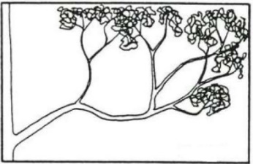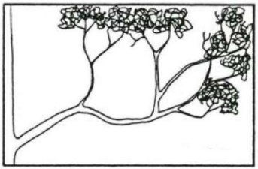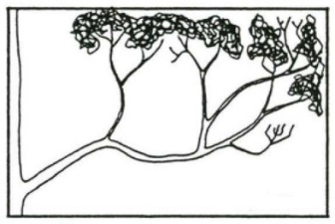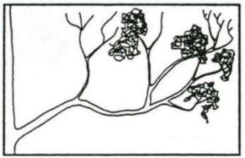
1a. No dead branches 1b. Branchlets dead 1c. Small branches dead 1d. Main branches dead
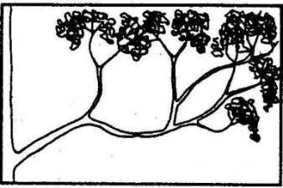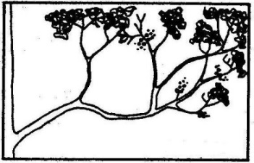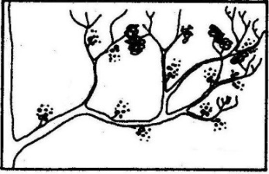
2a. None 2b. Slight 2c. Moderate 2d. Severe

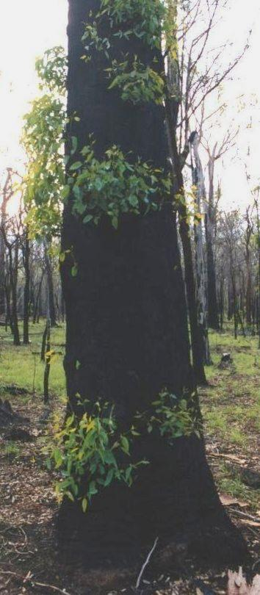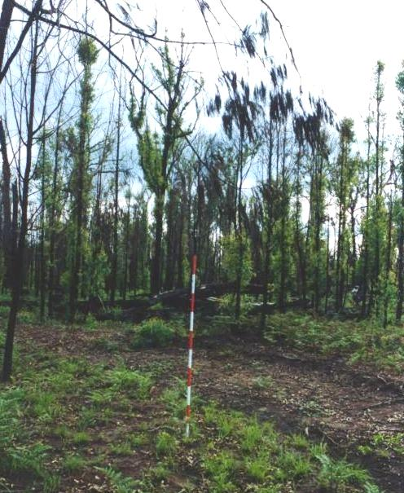

Examples of epicormic shoots. The shoots grow from buds that are protected deep within the bark of trunks, stems and branches. They usually remain dormant unless the actively growing shoots at the top of the plant are damaged or lost. (Photographs: R. Melzer)

11. Visitor impacts including vandalism, theft and other inappropriate behaviour
Vandalism is a serious threat for many historic heritage places. It includes graffiti, littering, dumping, property damage and arson. These can damage the historic place and may put visitors at risk (e.g. broken glass).
All isolated cultural heritage sites such as artefact scatters, bottle dumps, crash sites, mine sites, tip sites, machinery, homesteads are at risk from theft (includes so-called ‘souveniring’ and ‘scavenging’). Historic bottle and coin collecting are popular pastimes. Heritage values are seriously threatened by theft.
Inappropriate visitor behaviour such as: camping in heritage structures; driving through sites or on historic roads/tracks; making new access tracks to heritage sites; and winching off historic trees or markers can lead to direct damage and expose the place to threats such as accidental fires or human interference.
An inventory for the site and/or photographs from standard photopoints will be very useful in determining the level of impact – in particular from theft.
Use the description to get the ‘best fit.’
Level of impact | Description | Condition Class
None | No visitor impact evident. | Good
Minor | Some visitor impact evident; amenity little impaired:  - Damage is minor and temporary/repairable.  - Theft inconspicuous/difficult to detect.  - Visitor safety unimpaired if appropriate behavior/precautions taken (e.g. suitable footwear). | Good with Some Concern
Moderate | Conspicuous visitor impact evident; amenity and/safety impaired:  - Damage is substantial but all/largely reversible/repairable  - Loss from theft is obvious but does not threaten structural integrity nor the ability to ‘tell the story’ of the place. | Significant Concern
Major | - Extensive visitor impact evident; amenity and/safety significantly impaired  - Damage is substantial and some or all is permanent – substantial funding and urgent attention required to redress the damage.  - Loss from theft is substantial; may include structural elements and significantly impacts on the ability to ‘tell the story’ of the place. | Critical

12. Visitor safety and restricted access
Access to historic heritage places is often an expectation from the visiting public. Public access to sites that have been closed or restricted can present serious safety risks to visitors, encourage further inappropriate visitation/access to the site, and cause detrimental impacts to the historic value.
Note: new or emerging issues must be noted in Table 2.5 and escalated to the in-line manager for action.
Use the description to get the ‘best fit.’
Safety/access issues | Description | Condition Class
None | - No safety concerns  For closed/restricted access areas:  - Safety/access signage is in place and  - barrier fencing is in place and structurally sound. | Good
Minor | - Visitor safety is unimpaired if appropriate behavior (e.g. warning signs are followed) and/or precautions are taken (e.g. suitable footwear)  For closed/restricted access areas:  - There is no safety/access signage is in place but  - barrier fencing is in place and is structurally sound. | Good with Some Concern
Moderate | - Visitor safety is impaired even if appropriate behavior and/or precautions are taken  For closed/restricted access areas:  - Safety/access signage is in place but  - there is no barrier fencing. | Significant Concern
Major | - Visitor safety is significantly impaired even if appropriate behavior and/or precautions are taken  For closed/restricted access areas:  - There is no safety/access signage in place and  - there is no barrier fencing | Critical

13. Inappropriate management
Operational activities such as planned burning, earthworks, road/track construction and maintenance, fence construction, vegetation removal, off-road driving, mustering and weed control can threaten some heritage values.
Use the description to get the ‘best fit.’
Level of impact | Description | Condition Class
None | - No evidence of adverse impacts from operational activities. | Good
Minor | Minor disturbance/damage is evident.  - Damage is superficial or temporary/repairable.  - Remedial action (changing management practices) and prevention of further damage is readily achievable. | Good with Some Concern
Moderate | - Disturbance/damage is conspicuous.  - Damage is substantial but all/largely reversible/repairable if addressed promptly and management practices causing the damage cease.  - Potential for further degradation is high if management practices remain unchanged. | Significant Concern
Major | - Disturbance/damage is substantial and some/all is permanent  - Substantial funding and urgent attention required to redress the damage.  - Management practices causing the damage must cease if there is to be any chance of redressing/preventing further damage.  - Value at risk. | Critical

Attachment 2 Record sheet: Historic Values Health Checks
Park name (& section):
Recorder/s:
Value¹:
Site Details (for permanent and non-permanent sites):
Site Id. |  | GPS Location  (Datum: ) | Permanent site & photo point established (Y/N) | Approx. site area | Date assessed  (d/m/y)
1
2
3
4
5
Site & photo point definition
In many cases it will not be necessary to precisely define the boundary of your site in order to ensure that the next time you (or a colleague) do the Health Check you use exactly the same area…..a few metres either side will not be a problem. However, in some circumstances the definition of your site will be important (e.g. Are all of the buildings associated with the homestead complex included in the site or only some?). Is it likely that someone else coming to do the Health Check in future could be confused about what might or might not be included in the site you are establishing? If the answer to the last question is yes, then provide clear details about your site and its boundary below.
Details about why you chose the site and why you included some components but not others (e.g. shearing shed but not shearer’s quarters) may also be useful.
For permanent sites describe how the photos are to be taken each time. Record photo numbers here also.
Site 1
Site 2
Site 3
Site 4
Site 5

1. Use the name provided in the management plan/statement (or Values Assessment if there is no plan)
Condition class summary
Record: the Condition Class that you determine for the value at each inspection site for each Health Check Indicator (HCI); your general impression of the condition of the value across the park (if there is more than one example of the value) for each HCI (based on site results and other observations – note that the Condition Class you record as your general impression IS NOT an ‘average’ of the Condition Classes at each site. It IS your considered opinion about the state of the value (across the park if relevant) based on the site results and your observations); and the overall condition of the value (across the park if relevant) based on the IUCN definitions (Table 2.2).
Where it is relevant, provide information on factors contributing to the Condition Class assigned to an inspection site {e.g. be specific about which component (e.g. stable, homestead, store shed) of the value has been damaged} in Table 2.3. Details relevant to your determination of the General Impression and Overall Condition Class can be recorded in Table 2.4 and the notes field below Table 2.4, respectively.
Table 2.1 Record of the Condition Class for a key historic value.
Key: G = good; GC = good with some concerns; SC = significant concern; C = critical; NA = not applicable.
Health Check Indicator | Condition Class |  |  |  |  |  | General impression
 | Site 1 | Site 2 | Site 3 | Site 4 | Site 5 |  | Not an ‘average’!
- Vertebrate animal damage
- Invertebrate animal damage
- Vegetation – direct mechanical damage
- Vegetation – increased fire risk
- Vegetation – invasion
- Ground surface modification (e.g. erosion, subsidence, compaction, altered drainage)
- Damp (rising/falling)
- Weather events & weathering – exposure to water, wind &/ sun
- Fire damage
- Tree/shrub health & dieback
- Visitor impacts including vandalism, theft & other inappropriate behaviour
- Visitor safety/restricted access
- Inappropriate management
Overall Condition Class (refer Table 2.2)

Table 2.2 Overall Condition Class – what the categories mean
Good | The Key Value is in good condition and is likely to be maintained for the foreseeable future, provided the current conservation measures are maintained.
Good with  some concern | The Key Value is likely to be essentially maintained over the long-term with minor additional conservation measures to address existing concerns.
Significant concern | The Key Value is threatened by a number of current and/or potential threats. Significant additional conservation measures are required to preserve the value over the medium to long-term.
Critical | The Key Value is severely threatened. Urgent additional large-scale conservation measures area required
Trigger for management response: |  | Maintain effort | Minor attention required | Requires prompt decision &/or planned course of action | Requires urgent decision re course of action

Table 2.3 Information, including key issues/threats, relevant to determining the condition of the value at Site/s ______
Health Check Indicator | Notes  If you don’t use a separate notes page for each site then record the relevant site number below against each set of notes
- Vertebrate animal damage
- Invertebrate animal damage
- Vegetation – direct mechanical damage
- Vegetation – increased fire risk
- Vegetation – invasion/encroachment
- Ground surface modification (e.g. erosion, subsidence, compaction, altered drainage)
- Damp (rising/falling)
- Weather events & weathering
- Fire damage
- Tree/shrub health & dieback
- Visitor impacts including vandalism, theft & other inappropriate behaviour
- Visitor safety/restricted access
- Inappropriate management

Table 2.4 Information relevant to the determination of the General Impression for a Health Check Indicator.
Health Check Indicator | Notes  If you don’t use a separate notes page for each site then record the relevant site number below against each set of notes
- Vertebrate animal damage | Vertebrate animal damage
- Invertebrate animal damage | Invertebrate animal damage
- Vegetation – direct mechanical damage | Vegetation – direct mechanical damage
- Vegetation – increased fire risk | Vegetation – increased fire risk
- Vegetation – invasion/encroachment | Vegetation – invasion/encroachment
- Ground surface modification (e.g. erosion, subsidence, compaction, altered drainage) | Ground surface modification (e.g. erosion, subsidence, compaction, altered drainage)
- Damp (rising/falling) | Damp (rising/falling)
- Weather events & weathering | Weather events & weathering
- Fire damage | Fire damage
- Tree/shrub health & dieback | Tree/shrub health & dieback
- Visitor impacts including vandalism, theft & other inappropriate behaviour | Visitor impacts including vandalism, theft & other inappropriate behaviour
- Visitor safety/restricted access | Visitor safety/restricted access
- Inappropriate management | Inappropriate management

Notes relevant to the determination of the Overall Condition Class:
New or emerging issues noticed (anywhere on the park) while undertaking an inspection
Make a note in Table 2.5 of localised disturbance, breaches (e.g. in the weather tightness of a building; damage that permits unauthorised entry), issues that require attention to prevent degradation and significant resource input in the future (e.g. graffiti at a cultural site; pollution event; erosion; tree-fall across a track resulting in new tracks; a new infestation of an ecosystem-changing weed) or pose risk to life and property, or significantly impact on visitor experience (e.g. overcrowding, excessive noise, conflict amongst user groups).
Determine, with your in-line managers and QPWS&P Heritage Officer, an agreed management response and desired outcome – record these in Table 3 (or in a separate project plan if warranted). During future inspections evaluate the effectiveness of the management response in achieving the stated desired outcome – use the ratings below to do so.
Effectiveness of management response | Rating
Desired outcome achieved | 1
Heading towards desired outcome | 2
Situation static | 3
Heading away from desired outcome | 4
Table 2.5 Details of localised disturbances/issues requiring attention and effectiveness of management response.
Y = yes; N = no; P = partially
ISSUE 1
Date of initial record (d/m/yr): |  | GPS location (including datum):
Issue & current condition:
Agreed management response (AMR):
Desired outcome:
 | Follow-up inspections
Date (d/m/yr)
AMR implemented (Y/N/P)
Rating:
ISSUE 2
Date of initial record (d/m/yr): |  | GPS location (including datum):
Issue & current condition:
Agreed management response (AMR):
Desired outcome:
 | Follow-up inspections
Date (d/m/yr)
AMR implemented (Y/N/P)
Rating:
ISSUE 3
Date of initial record (d/m/yr): |  | GPS location (including datum):
Issue & current condition:
Agreed management response (AMR):
Desired outcome:
 | Follow-up inspections
Date (d/m/yr)
AMR implemented (Y/N/P)
Rating:

