Supplementary Online Material 4 - Laljhadi-Mohana conceptual model and threat ranking, 2012
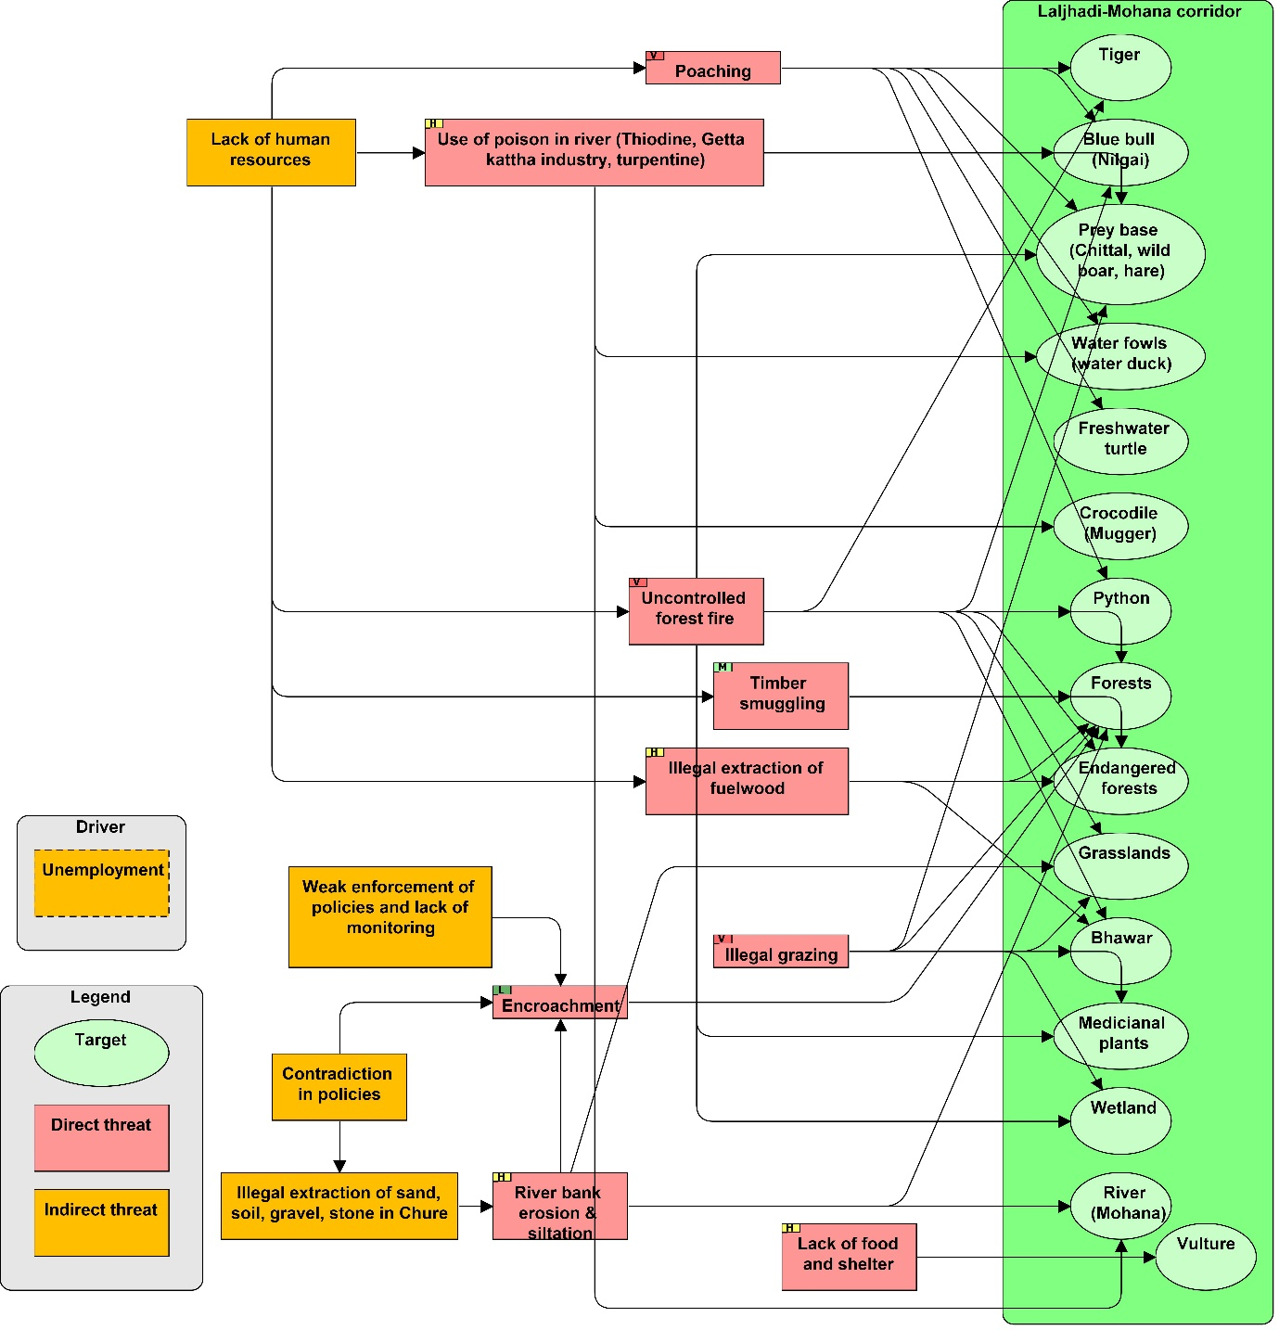
Conceptual model of Laljhadi-Mohana Corridor Conservation Targets and threats
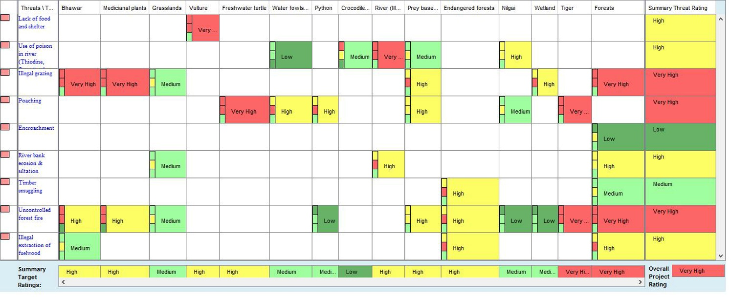
Ranking of threats in the Laljhadi-Mohana Corridor in 2012

