Supplementary Online Material 3 - Basanta conceptual model and threat ranking, 2012
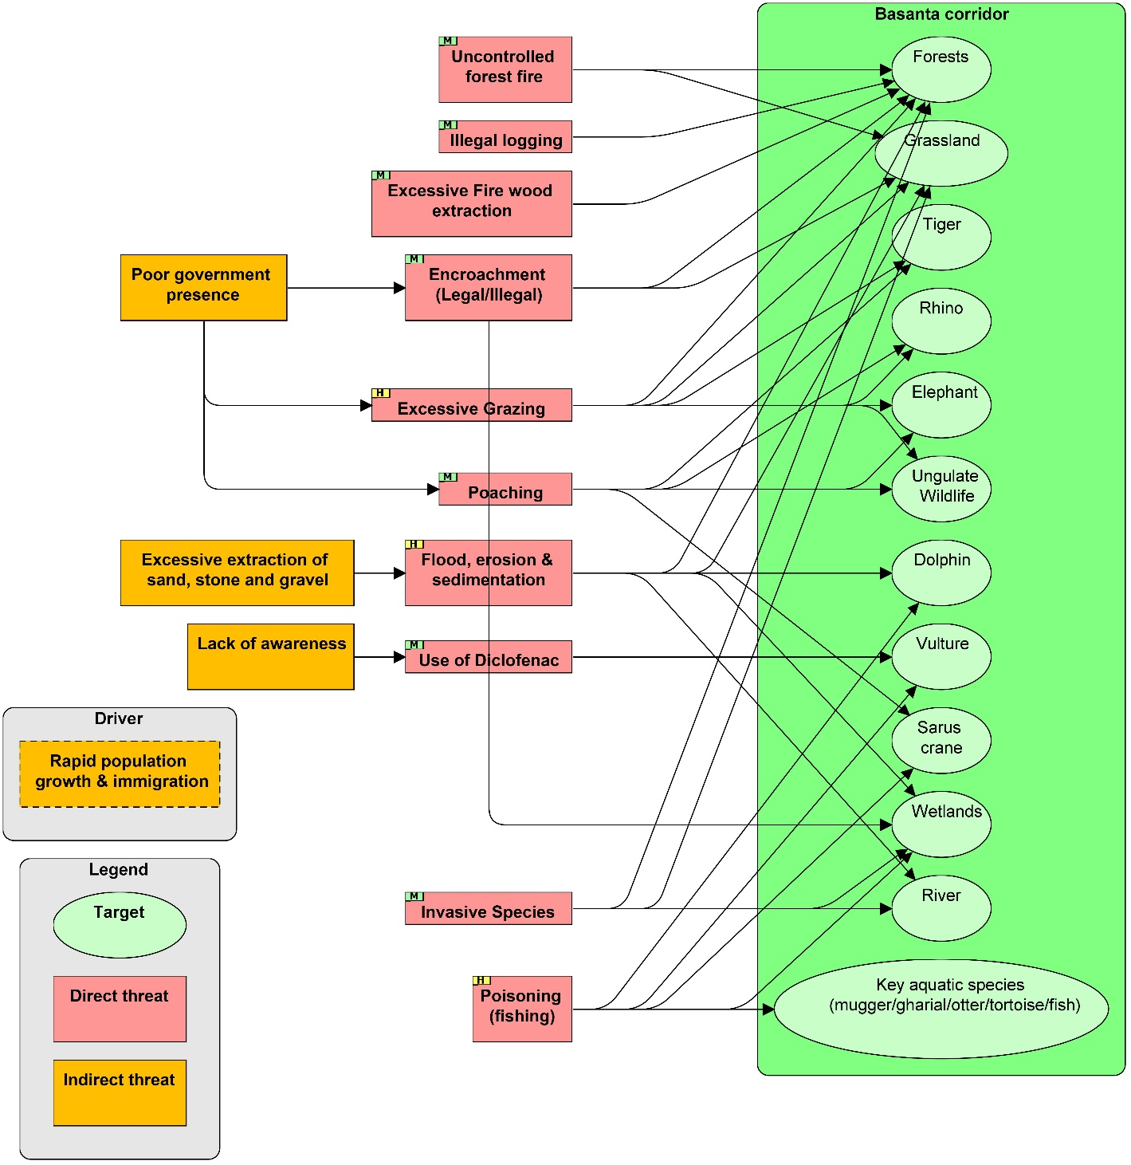
Conceptual model

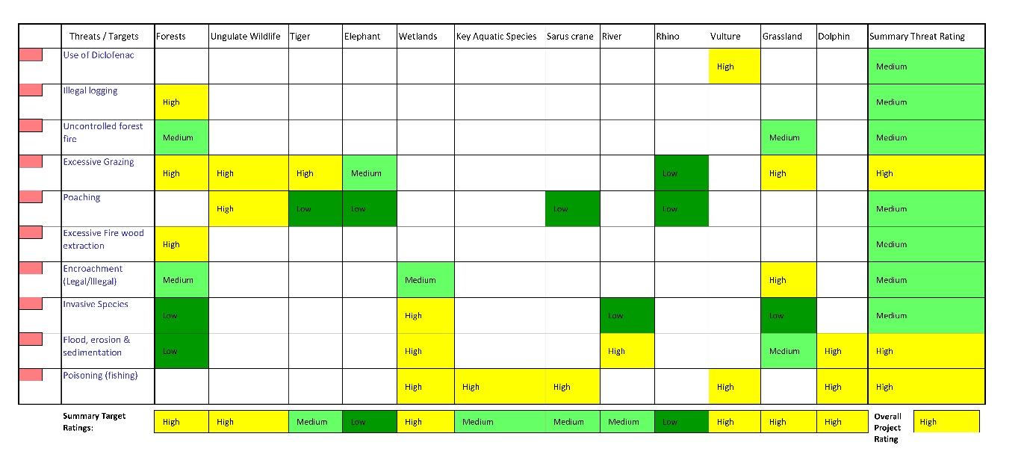
Threat ranking

