Supplementary Online Material

Box 1
Improved Water management regime in U Minh Thuong National Park
The improved water management scheme that mimics the natural and hydrological cycle has been applied in the Park since 2010. It is based on the water level equilibrium that combines data collected on the amount of evaporation, water leaking from the dykes, rainfall in five dry months (from middle of November to middle of April), and water in the top soil or peat layer (from 0–50 cm) from 2002–2009. Due to uneven topography, two water level management regimes have been applied to the canals in the three sub-zones of the Park through a system of these sluice gates, dykes and canals. The water management procedure has been described in Quynh (2011) and Huong (2011) as follows:

1. Open the gates to flush acidic water from early May
From May the total amount of rainfall is higher than that of natural evaporation. Thus, sluice gates are opened to release remaining flood and acidic water out of the Park and assist vegetation, particularly melaleuca trees to grow. These gates remain open until early October.

2. Closing the gates to maintain water from early October
Sluice gates need to be closed in early October to maintain the depth of water in the canals in the peat forest at a level of 310–320 mm. If the non-rainy season has a delayed onset, the control gates can be kept open until the middle of November to ensure that the water level in the Park is not higher than the optimal flooding level of 310–320 mm.

3. Pump additional water into the Park for fire prevention in dry and hot years
In dry and hot years when the water level in the Park is lower than the minimum height level, water needs to be additionally pumped from outside the Park to reduce the fire risk. Additional pumping only applies in March to peatland forest and in April to other vegetations and habitats.

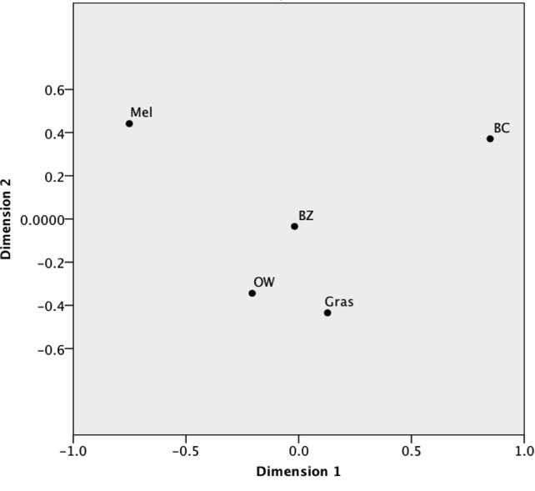
Figure S1. Multidimensional scaling following the presence and absence of bird species in 5 different habitats (Mel: Melaleuca forest, Gras: Grassland, OW: Open wetland, BZ: Buffer Zone, BC: Bird colony) showing that OW, BZ and Gras share a large number of species while BC and Mel have quite different species composition

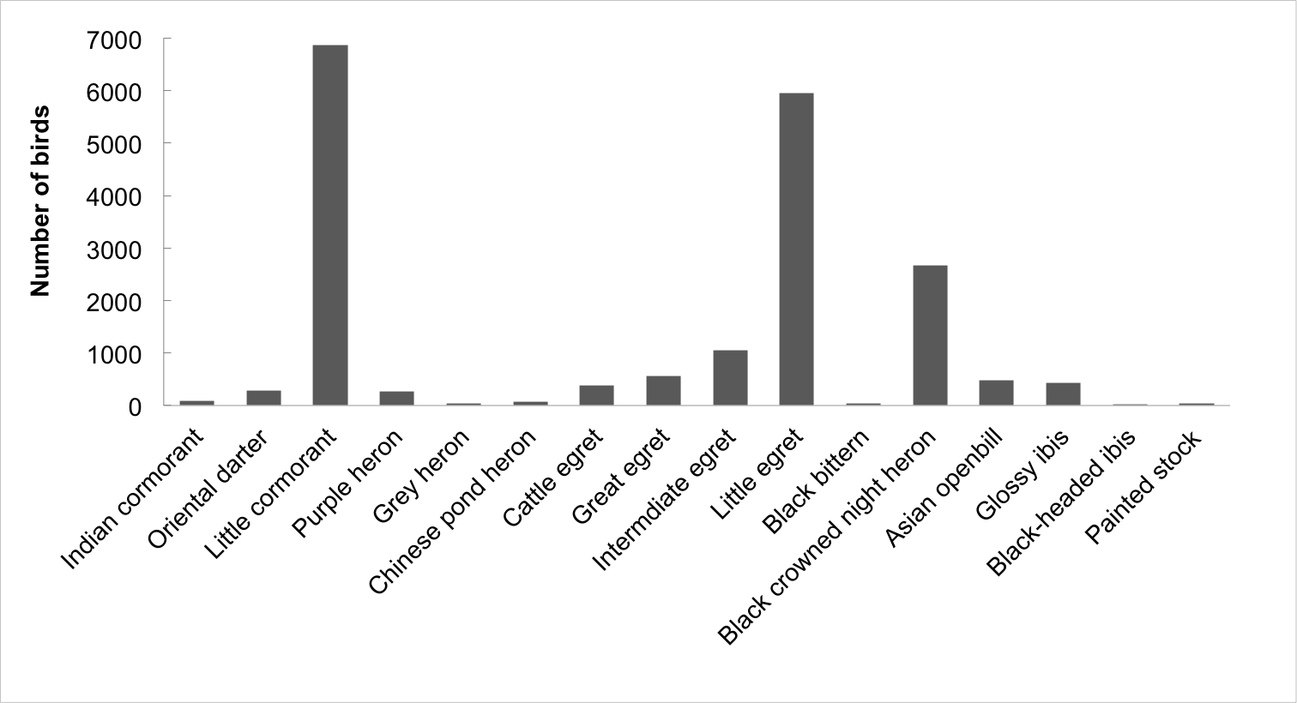
Figure S2. Number of significant bird colony waterfowl species present at the peak in May 2013

Table S1. Bird species of conservation importance in U Minh Thuong National Park
No | English name | Scientific name | Habitats | Conservation Status
 |  |  |  | IUCN 2012 | VN Red Book 2007 | CITES*
1 | Painted stork | Mycteria leucocephala | OW, BC | NT | VU
2 | Asian openbill | Anastomus oscitans | Gras, OW, BC |  | VU
3 | Lesser adjutant | Leptoptilos javanicus | Mel, Gras, OW, BC | VU
4 | Black-headed ibis | Threskiornis melanocephalus | OW, BC, BZ | NT | VU
5 | Glossy ibis | Plegadis falcinellus⁺ | OW, BC, BZ
6 | Black bittern | Dupetor flavicollis⁺ | Gras, OW, BC, BZ
7 | Purple heron | Ardea purpurea⁺ | Mel, Gras, OW, BC
8 | Great egret | Ardea alba⁺ | Mel, Gras OW, BC
9 | Intermediate egret | Egretta intermedia⁺ | OW, BC, BZ
10 | Spot-billed pelican | Pelecanus philippensis⁺ | OW, BC | NT | VU
11 | Little cormorant | Phalacrocorax niger⁺ | Gras, OW, BC, BZ
12 | Oriental darter | Anhinga melanogaster | Gras, OW BC, BZ | NT | VU
13 | Osprey | Pandion haliaetus | Mel, Gras, OW |  |  | IIB
14 | Black baza | Aviceda leuphotes | OW, BZ |  |  | IIB
15 | Black-winged kite | Elanus caeruleus | Gras, OW, BZ |  |  | IIB
16 | Black kite | Milvus migrans | OW, BZ |  |  | IIB
17 | Brahminy kite | Haliastur indus | Mel, OW, BZ |  |  | IIB
18 | Grey-headed fish eagle | Ichthyophaga ichthyaetus | Mel | NT | VU | IIB
19 | Western marsh harrier | Circus aeruginosus | Gras, OW, BZ |  |  | IIB
20 | Hen harrier | Circus cyaneus | Mel, Gras, OW, BZ |  |  | IIB
21 | Pied harrier | Circus melanoleucos | Gras, OW, BZ |  |  | IIB
22 | Shikra | Accipiter badius | Mel, Gras |  |  | IIB
23 | Greater spotted eagle | Aquila clanga | Mel, OW | VU | EN | IIB
24 | Black-tailed godwit | Limosa limosa | OW | NT
25 | Asian golden weaver | Ploceus hypoxanthus | OW | NT

Mel: Melaleuca forest, Gras: Grassland, OW: Open wetland, BC: Bird Colony, BZ: Buffer zone
IUCN (INTERNATIONAL UNION FOR NATURE CONSERVATION) Red list 2012: VU: Vulnerable, NT: Near threatened.
Vietnam Red Book 2007 (Ministry of Science and Technology, 2007): EN: Endangered, VU: Vulnerable,
CITES*: The Convention on International Trade in Endangered Species of Wild Fauna and Flora and Vietnamese Government Decree 32/2006/ND-CP (Government of Vietnam, 2006) which implements this Convention (IIB: Limited exploitation and trade).
⁺Species that has a population exceeding the estimated Southeast Asia and the world population (Wetlands international, 2002)

