Supplementary Online Material 6 – Pairwise threat ranking, Laljhadi-Mohana, 2014
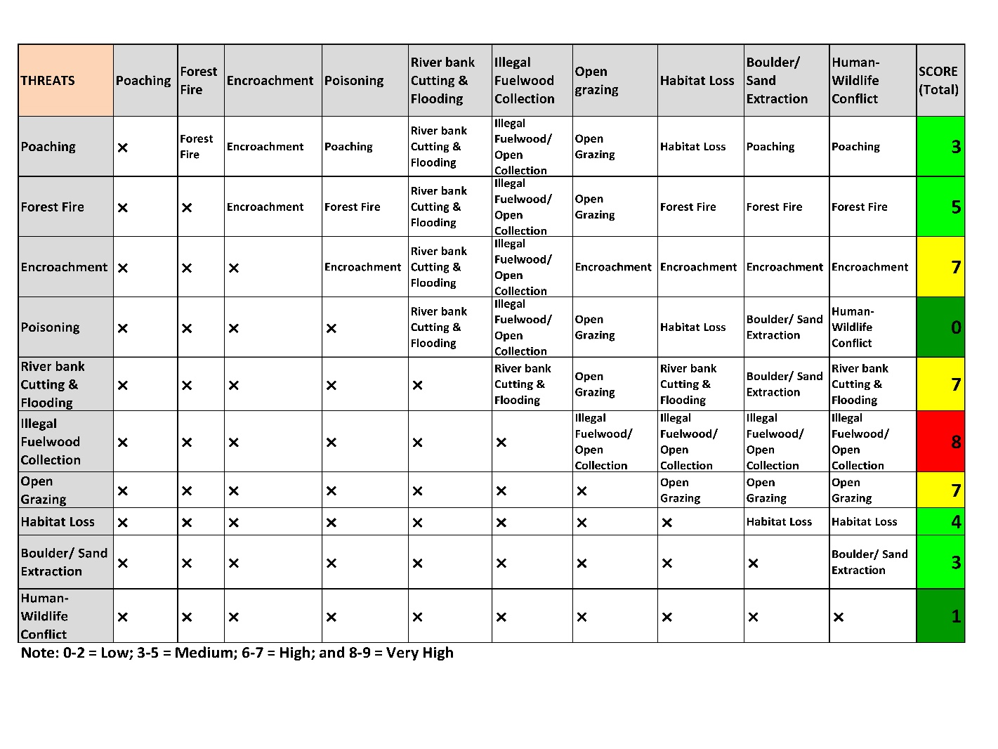
Threat ranking of Laljhadi-Mohana corridor in 2014

