Supplementary Online Material – Pairwise threat ranking, Basanta, 2014
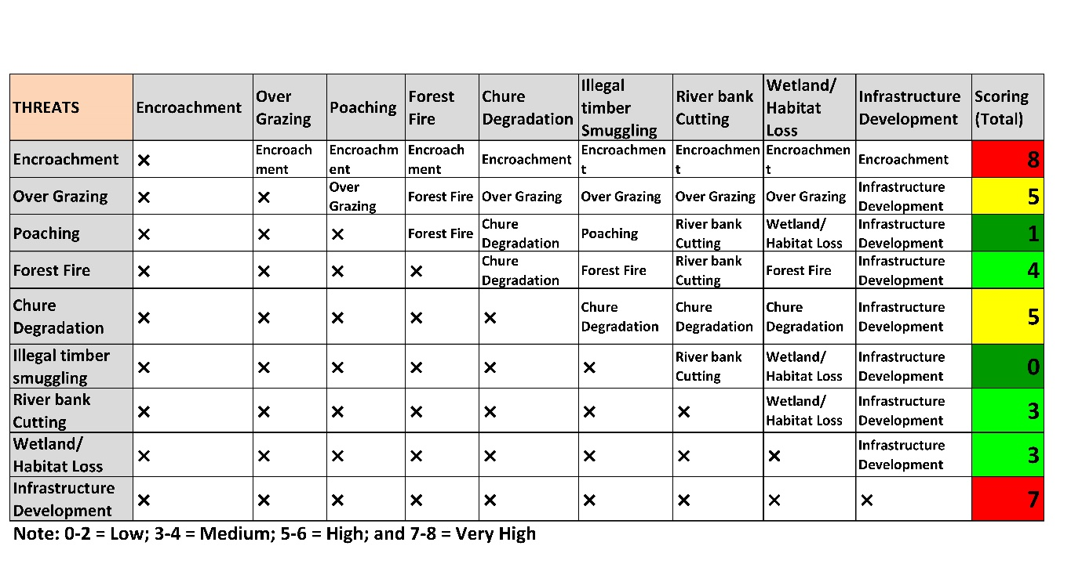
Ranking of threats in Basanta corridor in 2014

